God Revealed Joyful Truths to
Moses and Joshua
Almighty, eternal God, help the children to know you and to appreciate your holiness and majesty.
Choose activities that fit needs, time available, and the children’s maturity.
- An older child or teacher reads from Exodus 3:1-15 how God spoke to Moses
from a burning bush.
Then, assign to children the questions below, to ask adults during worship time.
Each child should know the answer to their question.
[Answers appear after the questions.]
- What was strange about the bush? [It burned but was not consumed.]
- What did Moses hear from the bush? [His name being called.]
- Who called Moses by his name? [The God of Abraham, Isaac and Jacob.]
- Why did Moses take off his shoes? [He stood on holy ground.]
- What did God tell Moses to do?
[Go to Pharaoh the king and bring God’s people out of slavery in Egypt.]
- What did God say was His name? [I AM.]
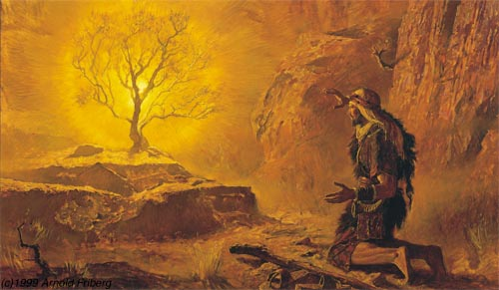
The LORD God spoke to Moses through a burning bush.
- An older child or teacher reads or tells from memory Joshua 3:14 – 4:7,
about crossing Jordan River.
It tells how the people remembered the great things God had done for them.
Ask these questions. [Answers appear after each question.]
- Which Israelites went into the Jordan River first? [Read Joshua 3:14]
- What happened when the priests carrying the ark stepped into the river? [3:15]
- What did the twelve leaders take from the middle of the river? [4:3]
- What was the purpose of the stones? [4:6]
- Where did the leaders put the stones from the river? [4:8]
- Dramatize parts of the 2nd story above (#2) about crossing the Jordan River.
- Arrange with the adult worship leader to have the children present this brief drama. Let older children help younger ones prepare it.
- Older children or adults play these parts: Joshua, Narrator
Younger children play these parts: Israelites, Leaders, Priests. Carry something representing the ark, which was a large box.
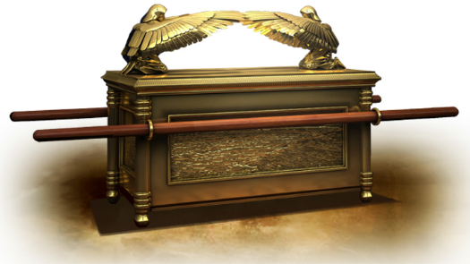
Narrator Tell the first part of the story from Joshua 3:14-17. Then say,
“Hear what Joshua says.”
Joshua “We are going to cross the Jordan River.
It is flooding, but God will let us pass on dry ground.
Watch what He does.
Priests, take the ark and step into the water.”
Priests: Carry the ark and stop half-way through the ‘river.’
(One says) “Look! The river water has stopped flowing!”
Israelites: Go all the way across the ‘river’ and pass beyond the priests.
(One says) “Look! Our feet are dry.”
(Others say) “We walked on dry ground!”
Narrator: Tell the second part of the story from Joshua 4:1-7. Then say,
“Hear what Joshua says.”
Joshua: Cross to where the Israelites are and say,
“We have crossed the river!
Let a leader from each tribe pick up a stone from the middle of the river
to be a memorial to remind our children of what God did for us this day.”
Leaders: Go to where the priests are standing. Pretend to pick up and carry very heavy stones to where Joshua is. One says,
“This stone is heavy. It will make a good memorial.”
Joshua: “When our children ask, ‘What is the meaning of this pile of stones?’
We shall tell them about this day.
We shall remember God’s great works.”
Narrator: Thank everyone who helped with the drama.
- If the children present this drama to the adults, then let them also ask the adults
the questions under #2 above about crossing the Jordan River.
- Let the smaller children draw pictures of a pile of stones.
They can show their pictures to the adults at the next worship time and explain that this illustrates how we use songs, stories and other things to recall what God has done for us.
Some children might like to copy or colour the picture found at the end of this lesson.
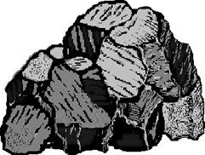
- Ask in what other ways, besides making a pile of stones as a monument, can we Christians remember God’s works.
Let the people discuss examples.
- Let four children each recite a verse from Psalm 145:4-7 for the other children,
and for the adults during worship.
- Memorize:
Smaller children memorize Philippians 4:4:
“Rejoice in the Lord always; again I will say, rejoice!”
Older children memorize Deuteronomy 8:3.
“He humbled you and let you be hungry, and fed you with manna which you did not know, nor did your fathers know, that He might make you understand that man does not live by bread alone, but man lives by everything that proceeds out of the mouth of the Lord.
- Older children write poems or songs about great things that God has done
that we should remember.
- Have an older child pray:
“Dear Father, you have done so many wonderful things for us! Help us to remember them and praise you for them always. Help us to tell other children about them. Give us practical ways to help them remember your goodness.”

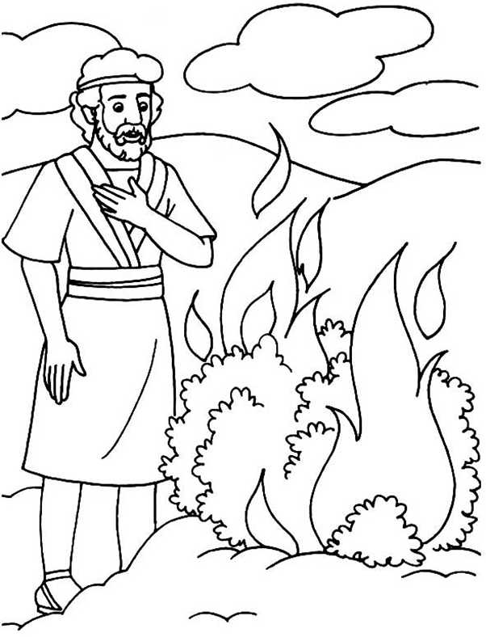
The LORD God spoke to Moses through a burning bush.

