Teach Children the Way God Requires
Anchor command. “Let the children come to me; do not hinder them, for to such belongs the kingdom of God.” Mark 10:14
Anchor story. Jesus blesses little children. Mark: 10:13-16
Anchor verse. “He established a testimony in Jacob and appointed a law in Israel, which He commanded our fathers that they should teach them to their children.” Psalm 78:5
Learning goal. Grasp what Scripture teaches about dealing with children.
Growth goal. Adopt God’s profound concern for children.
Skill goal. Mobilize children to take part actively in worship and activities of the body of Christ.
Outcome goal. Believers instruct their children in God’s way.

Basic Study
Learn from the story of Jesus with the children, Mark 10:13-16.
- What did the disciples do at first when people brought their children to Jesus? Verse 13
- What did Jesus say to those who wanted to keep the children away? 14-15
- What did Jesus do with the children? 16
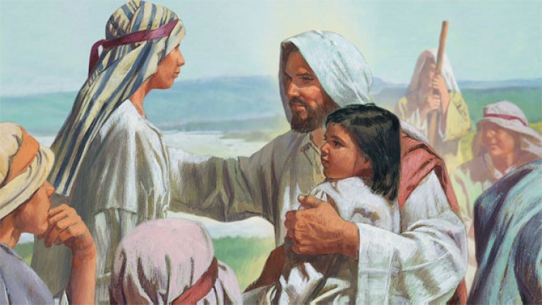
Jesus received and blessed children and youth; and he still does so.
During the week visit parents to show them how to teach their children at home.
During worship…
- Tell the story of Jesus with the children, Mark 10:13-16, and ask the questions above.
Let the believers discuss the answers.
- Ask the children to present what they have prepared,
- Memorize together Ephesians 6:4

Advanced Study
- Who should teach children?
- Mainly parents should train their children to follow Christ, teaching and disciplining them. Christian families should have a daily family devotional time, like Job did, to pray and talk with the children about the Word of God.
- What does Ephesians 6:4 tell fathers to do?
- What does Proverbs 23:13 tell parents to do?
- Children also often teach other children effectively.
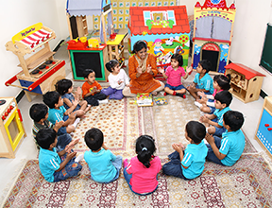
- Christian friends and relatives should help train children during the week, telling Bible stories to them, praying with them and listening to them tell what they have been doing.

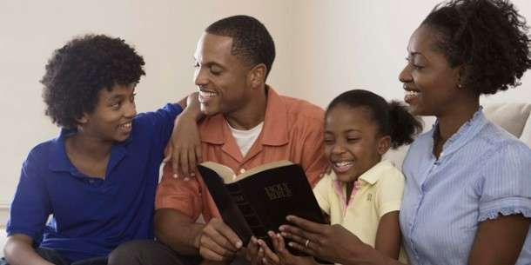
- Shepherds can provide Paul-Timothy Children’s Studies to teachers, and arrange time before the main worship for children to prepare what they will present.
- Guidelines for teaching children.
- Give children Christian instruction and discipline. Let fathers of children provide most of their training, Ephesians 6:4.
- Hold daily prayer and Bible study with children, Deuteronomy chapters 6 & 7.
- Pass God’s Word on to your children, from one generation to another, Psalm 78:3-7.
- Teach children directly from the Word of God Deuteronomy 31:12.
- Tell them Bible stories. Let tiny children do actions. For example, to tell about Noah, let them play animals; rabbits hop; lions roar, etc.
- Small children pay attention only for a short time: do not force them to follow long stories.
- Let older children teach the younger ones. Avoid always grouping children of the same age.
- Let older children create things and act out Bible stories and play games.
- Let children join adults to pray for very serious things, Ezra 10:1; 2 Chronicles 20:12-13.
- Let children join adults in sacred ceremonies and celebrations, Nehemiah 12:43.
- Let children join adults to praise God in serious worship, Psalm 148:13-13; Matthew 21:15-16.
- Let children join adults to listen to Jesus’ teaching, Matthew 14:21.
- When children act badly, correct them with love, not in anger, Proverbs 23:13; Hebrews 12:6-11.
- Avoid angering children. Hating parents or children brings a curse, Ephesians. 6:1-4; Malachi 4:6.
- Avoid causing innocent children to do offensive things, Matthew 18:1-6.
- Assure children of Jesus’ love and forgiveness, Mark 10:13-16.
- Serve as a shepherding elder only if you also correct your children, 1 Timothy 3:4-5.
- Prepare well ahead of time.
- Tell stories, and let the children act them out.

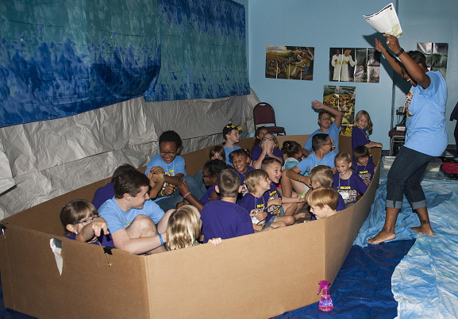
- Pray for each child. God cares about children. Scripture mentions them often.
- Include children in congregational worship, like Moses, Joshua and Ezra did, not only as listeners but also by doing things together with adults.
- Children love holidays and events when believers gather for sports, parties, birthdays, etc. They enjoy learning why we celebrate holidays. The Lord established holidays and memorials, so children would not forget His great works, Joshua 4:1-7; Exodus 12:24-27.
- Keep children busy doing things that interest them. They like to make things.
- Teach children both to fear and love God (Deuteronomy 4:10; 6:4-7; Psalm 34:11; 111:10).
- When the Holy Spirit convinces children of their sin, encourage them to receive Christ’s forgiveness by faith.
- Children, especially the smaller ones, like repetition, action and noises. For example, if you tell them that Isaac’s bride Rebecca came to him riding on a camel, you might say, “Hear the camel’s hooves as it walks along. ‘Clop!’ ‘Clop!’ ‘Clop!’ ‘Clop!’ Now bob your heads up and down, because camel riders go up and down, up and down!”
- Teachers should develop a good relationship with children’s parents.
- Discipline children gently but firmly.
- Praising children for doing things well keeps better order than does scolding them.
- Dramatize Bible stories to make worship more meaningful for children.
Why acting out Bible stories is important, and how to make it very easy:
- Many house churches around the world have more children than adults, but worship often engages only the adults. Some Paul-Timothy studies for children have links to Bible stories that are scripted, to act out. These brief drama’s give everyone who is present a part, including small children; those who do not have one of the main parts are Echoes who simply repeat a prompter's brief words,
- People recall far more of what they have acted out, and apply it more easily.
- Most skits that are linked from the Paul-Timothy studies for children are brief, less than five minutes, and require no costumes.
- No one has to memorize their parts, as the aim is to relive key Bible events, not to perform.
- Most of the skits that have links in the Paul-children’s studies engage even the tiny children: they are “Echoes” who simply repeat a Prompter’ brief phrases.
- Guidelines to present briefly scripted Bible stories linked from the Paul-Timothy studies.
- Simply read the lines; the aim is not to perform but to relive key Bible events.
- Keep skits simple and brief, and do them often.
2. Avoid costumes and props; they can distract from the spiritual message.
3. Skits take only two to five minutes, unless noted otherwise.
4. Everyone takes part, children and adults. You need no audience: those who receive no script are Echoes who repeat a prompter’s brief words.
5. Let tiny tots be trees with arms held out as limbs, or as wind that howls, etc.
6. Let older kids prepare the younger.
7. Women can take men's parts and vice versa, if necessary.
8. Modify the scripts to fit your time limitations and occasions.
9. If you prefer simply to narrate a story, subtitles tell where to find it in Scripture.
10. Ask discussion questions afterwards, such as:
♦ What did you learn about God?
♦ What did you learn about people?
♦ What will you do about it this week?
♦ To whom will you repeat the story?
♦ What did you do last week to apply last week’s lesson?
♦ To whom did you repeat last week’s story?
- Plan with co-workers additional activities to do during the week
- If believing parents do not yet have a family devotional time with their children, then visit them and help them to start doing so.
- Visit believers who might serve as teachers, and explain these guidelines to them.
- Train new teachers by having them work with a more experienced teacher, if possible. Instruct those who teach children, using these guidelines.
- Invite non-Christian families to let their children join in doing activities that they will enjoy.
- Plan with co-workers additional, optional activities for the upcoming worship.
- Tell Jesus’ parable about soils from Mark 4:1-20. Explain that to learn God’s Word in God’s way we must…
1) Receive it with our eyes or ears
2) Let it take root in our souls
3) Let it bear fruit.
Ask the believers to recall the things that Jesus said would hinder receiving God’s word in one’s heart.
- Explain why parents should teach their children.
- To introduce the Lord's Supper, read Deuteronomy 6:4-7. Explain that we are to teach children to obey Jesus’ commands, including the breaking of bread together.
- Talk together for a few minutes in groups of two or three persons. Pray for one another, and make plans to provide more teaching activities for the children.
- Dramatize parts of the story of the Israelites crossing the Jordan River.
Adults play the parts of…
Narrator,
Joshua
Stone Carriers.
(Stone carriers have large rocks ready, placed in the center of the acting area.)
Children play the parts of…
Israelites (any number of children)
four Priests (Priests carry a large box, or pretend to).
See the script on the last page of this study.
- Discuss other examples of ways that we remember God’s work. Let the believers give examples.
- Let believers tell testimonies about how teaching their children at home has been a blessing.
- Form groups of two or three people to pray, confirm plans for teaching the children at home and during meetings, and to encourage one another.

Script
Jesus’ parable about soils from Mark 4:1-20

Narrator: Tell the first part of the story (from Joshua 3:14-17). Then say,
“Hear what Joshua says to the Israelites who are about to enter the Promised Land.”
Joshua: We will cross the Jordan River. It is flooding, but God will let us pass on dry ground. Watch to see what He will do. Priests, take the sacred container with God’s law. Step into the water.”
Four Priests: Walk toward the stones carrying the box together above your heads.
Say, “Look upstream! The water is heaping up!
(Go past the stones, across the ‘river’.)
Israelites (Any number: Follow the Priests across the river.)
Look, the ground is dry! We can walk on dry ground!
Stone Carriers and Joshua:
Follow the children across the river. Do not pick up the stones yet. Say things like, “God holds back the river!” “It is a miracle!” “God is helping us!”
Narrator: Tell the second part of the story from Joshua 4:1-7. Then say,
“Hear what Joshua says to leaders of the twelve tribes of Israel.”
Joshua: Now that everyone has crossed, choose twelve strong men to pick up large stones from the middle of the river. These stones will help our children to remember what God did today.”
Stone Carriers: Get the stones. Act like they are heavy. Pile them near where the Priests stand.
Israelites: What is the meaning of this pile of rocks?
Joshua: Children will ask this same question. The stones are to remind our children of what God did for their fathers today.
Narrator: Explain that the drama is over and thank those who helped.

