Jesus Healed a Man, and Sent him
Home to Tell about it
Dear Lord, please use this study to help the children and their teachers to tell other people about you in a way that is easy to understand.
Choose any of these children's learning activities that fit their ages and current needs.
- An older child or teacher reads or tells by memory about a man whom demons were tormenting, Luke 8:26-39.
Jesus healed the man and sent him home to tell his family and friends what God did for him.
After telling the story, ask these questions. [Answers appear after each question.]
- What did the demon-oppressed man do when he saw Jesus? [See verse 28]
- Why did the man say his name was Legion? [Verse 30]
- Where did the demons go after leaving the man? [Verse 33]
- What happened to the pigs? [Verse 33]
- Where did Jesus send the man after he freed him from demons? [Verse 39]
- What did Jesus tell the freed man to do? [Verse 39]
IMPORTANT NOTE
A good way to teach people about God is simply to tell them, in your own way, what Jesus has done for you. Tell it in the same way that you would tell any good news, such as finding a very precious pearl.
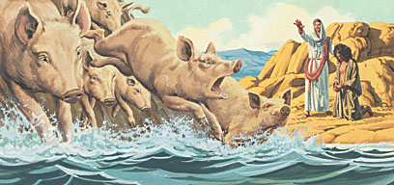
Jesus drove out of a man several demons that then drove swine into a lake.
- Dramatize parts of the story of the man that Jesus freed from demons and sent home.
- Arrange for the children to present this drama to the adults.
You do not have to use all the parts.
- Use your time with the children to prepare the drama.
Let older children help to prepare it.
- Older children or adults play these parts:
Healed Man
Wife
Narrator. Summarize the story and help children recall what to say and do.
Younger children play the part of Family & Friends

If there are not enough children to play all the parts in any of the dramas, then ask neighbor children to help, or have the Narrator say who the person is in the story and read that part.

Narrator Read Luke 8:26-31 or tell the story by memory. Then say,
“Hear what the freed man says.”
Healed Man “My family and friends, I have come home to tell you
what great things Jesus of Nazareth did for me!”
Family & Friends Run and gather around the man.
(Some say) “Look, he is in his right mind!”
(Others say) “He is dressed correctly!”
(Others say) “He can talk normally!”
(Others ask) “Who did it?”
Wife “Husband, you were crazy! You slept among the tombs!
You cut yourself!”
Family & Friends (One says) “Father, what happened?”
(Another says) “They called you ‘Legion,’ because many demons entered you!”
(Another says) “We thought we would never see you again.”
(Others say) “We missed you!”
Healed Man “Jesus of Nazareth came and sent the demons away!
They went into a large herd of pigs.
Then the pigs ran over a cliff into the sea and drowned.”
Wife “I want to go see Jesus!”

Healed Man “He did wonderful things for me.
I wanted to go with him, but he sent me home
to tell you about Him. He loves you, too.”
Narrator Thank everyone who helped.

- If the children present this story to the adults, then let them also ask the adults the questions under #1 above.
- Ask children to tell other things that Jesus has done for us that we can tell other people.
- Draw a simple picture of someone reading a newspaper, and let the children copy it.
Some children might like to copy or colour the picture found at the end of this lesson.
They can show their pictures to the adults at the next worship time
and explain that this illustrates that we have good news to tell,
that Jesus conquered all the forces of Satan, including demons and death.
- Memorize Romans 5:8:
“God demonstrates His own love toward us, in that while we were yet sinners, Christ died for us.”
- Three children each recite one or two of the verses from Psalm 8:1-5.
- Older children write songs or poems about telling our family and friends
about Jesus’ salvation.
- Have an older child pray:
“Dear Lord, we praise you for loving us and saving us from evil and death. Help us to tell other children about you in a way that is clear to them.”
A more detailed drama, dealing with Jesus sending his followers to announce his Good News:
http://biblestoryskits.com/015a-jesus-equips-harvesters-to-announce-his-kingdom/

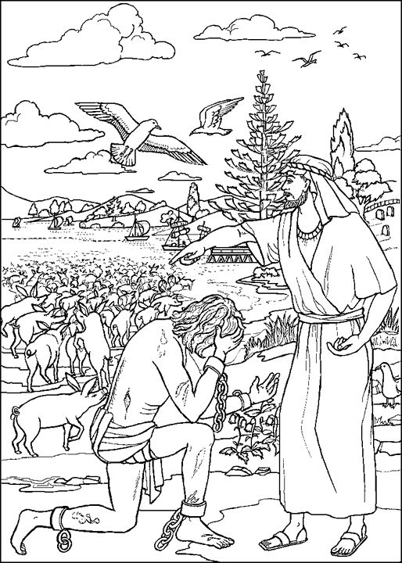
Jesus drove evil spirits out of a man, then sent him home to his village.

