Free from Satan in Jesus’ Name

Anchor command. “Put on the full armor of God, so that you will be able to stand firm against the schemes of the devil. For our struggle is not against flesh and blood, but against the rulers, against the powers, against the world forces of this darkness, against the spiritual forces of wickedness in the heavenly places.”
Ephesians 6:11-12
Anchor story. Jesus casts a legion of demons out of a miserable demoniac. Mark 5:1-20.
Anchor verse. “He healed many who were ill with various diseases, and cast out many demons; and he was not permitting the demons to speak, because they knew who he was.” Mark 1:34
Learning goal. Be aware of what God teaches about Satan and demons, and how to resist them.
Growth goal. Discover the power that we can wield in the name of Jesus to disarm evil spirits.
Skill goal. Cast out demons, and resist Satan and his demonic agents in the name of Christ.
Outcome goal. All believers employ the whole armor of God in spiritual warfare.
Lord Jesus, you have gained the victory over the world, the flesh and the devil, through your death and resurrection. Please, allow us to enter into your victory whenever people, devils or systems oppose you. Amen.
Basic Study
Learn how Jesus healed a miserable man with an unclean spirit, Mark 5:1-20.
- In what morbid place did the demon-possessed man live? Verse 3
- Why had no one been able to subdue him? 4
- What had demand been doing to himself day and night? 5
- What did he beg Jesus not to do? 6-7
- Why did he call himself ‘Legion’? 9
- What happened to the demons after Jesus drove them out the man? 12-13
- What was the reaction of the people who saw this happen? 14-17
- What did Jesus tell the healed man to do? 18-20
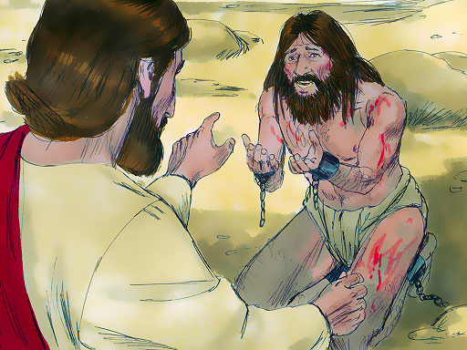
Jesus chased demons from men with a word of command.
During the week you and your coworkers visit anyone who has been oppressed or possessed by demons, and heal them, calling on the powerful name of Jesus.
During worship…
- Tell the story of the demoniac, Mark 5:1-20, and ask the same questions as above. Urge believers to discuss the answers.
- Pray in the name of Jesus for any people who are present who have been inflicted in some way by the devil or his evil agents.
- Ask the children to present what they have prepared.
- Memorize together 1 Peter 5:8. “Your adversary, the devil, prowls around like a roaring lion, seeking someone to devour.”
Advanced Study
- Know how to wage spiritual warfare victoriously.
- Find in Matthew 17:15-20 what to do in the face of demonic opposition. (Exorcism)
- Find in Matthew 26:38-45 what to do in the face of mortal opposition. (Martyrdom)
- Find in Acts 4:23-31 what to do in the face of political opposition. (Courage)
- Find in Acts 13:6-12 what to do in the face of religious opposition. (Power encounter)
- Find in Acts 16:16-26 what to do in the face of economic opposition. (Praise)
- Find in Ephesians 6:10-13 what to do in the face of spiritual opposition. (Stand firm)
- Find in James 4:1-7 what to do in the face of internal opposition. (Humility)
- Enter into spiritual battles together with your co-workers.
When you are experiencing opposition to what Jesus has called you to do, together with your co-workers discern the kind of opposition and to take action that the Bible recommends. This will often entail some of the following steps.
- Agree on which aspects of the opposition are demonic. Opposition can also be political, economic, spiritual, internal or social, or a combination of several aspects.
- Agree to resist the devil—then do so.
- Pray together, appealing to the Lord Jesus Christ who died to free people from the devil, rose to life to live with us believers and sent his Holy Spirit to give us holiness and power to obey his commandments.
- If attacks come from believers from another congregation, then ask their leaders whether they approve of their personnel’s actions, citing only facts about what they have done.
- Adjust your plans where past actions caused unnecessary offence.
- Show love to your enemies in ways that honor Jesus.
- Discern and avoid non-biblical myths and errors about spiritual warfare:
False: Naming local spirits will give you power over them.
False: Binding demons makes people become Christians.
False: Placing of symbolic objects will weaken local spirits.
False: By commanding Satan, spirits or angels, you will always get the results that you want.
False: Evil spirits can ‘possess’ a person or ‘own’ someone’s soul. (When Satan oppresses a person, the Bible says that the person has a demon, an evil spirit or an unclean spirit.)
- If believers hold any of these false assumptions, then review with them the biblical principles and promises concerning spiritual warfare that you have learned. Emphasize that Jesus is Victor and our faith is the victory.
- Lead the believers in a time of questions and answers about spiritual warfare, not dwelling on popular, non-biblical ideas and opinions that some may express.
- Instances in Scripture of people being freed from demons.
Find in Matthew 15:21-28 how Jesus healed a demonized gentile girl.
- Who sought help from Jesus in behalf of her daughter? See verse 22
- What did Jesus’ disciples try to do about the woman? 23
- Was the woman righteous and deserving of help? 23-27
- What quality in the mother did Jesus commend? 28
- Of what did Jesus assure the woman? 28
- How long did it take for the girl to get well? 28
Find in Matthew 17:14–21 how Jesus delivered a young boy from a demon.
- Who sought help from Jesus in behalf of his son? See verse 14
- What things was a demon doing to the boy? 15
- What did Jesus’ disciples fail to do for the boy? 16
- What kinds of people have the most trouble with evil spirits? 17
- What did Jesus say and do to the demon? 17 & 18
- Why had Jesus’ disciples not been able to chase away the demon? 20
- What must we do in order to chase away evil spirits? 21
Find in Luke 10:17–20 what Jesus’ disciples learned about power over Satan.
- By what authority were the disciples able to free people from demons? 17
- How did Jesus describe the authority that his disciples have? 18
- Who are stronger, believing disciples or evil spirits? 20
- What truth makes believers rejoice more than having authority over spirits?
Find in Acts 16:16–19 how apostles Paul and Silas chased a spirit from a girl.
- What kind of spirit oppressed the girl? See verse 16
- How did people exploit the girl with the spirit?
- Did the spirit know who Paul and his co-workers were? 17
- How did Paul get rid of the spirit? 18
- How soon did it leave the girl? 18
- What did the girl’s masters do? 19-21
Find in Acts 19:11–20 how the apostle Paul delivered a community from evil spirits.
- What kind of authority did Paul have over spirits? 11 & 12
- What happened when unbelievers tried to use the name of Jesus? 13-16
- What name must we invoke over spirits to chase them away? 17
- When people are delivered from spirits, what must they do about their magical practices and magical objects? 18-19
- What message must we share wherever we deliver people from spirits? 20
- Plan with co-workers the next week’s activities.
- Discuss together the kinds of spirits that trouble people in your community.
- Find out whether one of your co-workers or one of the believers has been guided by the Lord to pray for the oppressed and see them delivered.
- Ask the Lord to lead you to folks for whom you should pray that they may be delivered from demonic oppression.
- Agree together that you will not make a public show of chasing demons, but will publicly announce the good news about Jesus and deal with oppression only when somebody needs it.
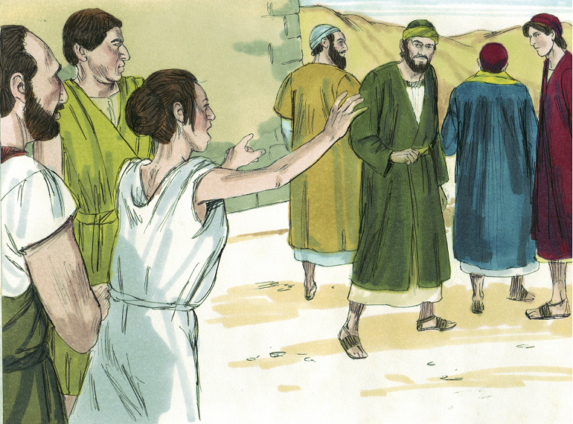
Paul drove a spirit from a slave woman who was shouting at the apostles.
- Additional activities to do during the upcoming worship…
- Share with xxxx6timonials about past victories in spiritual warfare.
- Introduce the Lord’s Supper with Hebrews 12:1-3:
- Read or tell from memory stories about how Jesus and his apostles freed people from demonic oppression.
- Let believers tell about demonically-oppressed persons who were delivered.
- Explain key facts about demonic oppression:
- Most illness is allowed by God and does not come from demons or the devil.
- People’s sinful behavior comes from their heart, not from demons.
- Satan and demons deceive people into fearing that they have more power than God.
- All believers have authority to pray for demonically-oppressed people to be freed.
- When demons disrupt teaching of the gospel, we should command them to leave.
- To introduce the Lord’s Table, read John 13:21-27. Explain that Judas broke bread with Jesus deceitfully during the most sacred Last Supper and Satan then entered into Judas.
- Form groups of two or three persons. Pray and encourage one another, and make plans.
- Those who teach children should read study #95 for children.

