Jesus Healed a Boy who was Tormented by Demons
Dear Lord, help our children to trust you to save them from bad spirits, by Jesus’ authority and mercy.
Choose any of these children's learning activities that fit their ages and needs.
- Older child or teacher: Read or relate how Jesus healed a boy, from Mark 9:14-29.
This story shows how Jesus has power over all the forces of Satan.
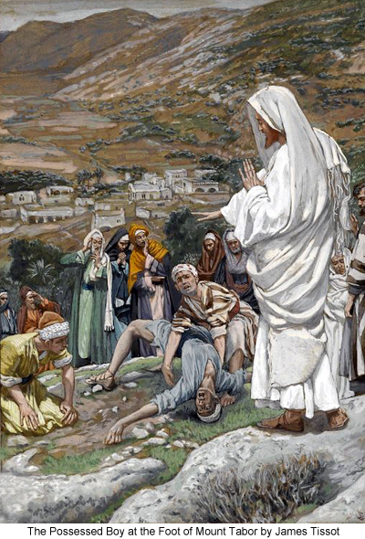
After telling the story, ask these questions. [Answers appear after each question.]
- What were the disciples doing when Jesus arrived?
[Answer: They were arguing instead of praying. See verse 14.]
- What were demons doing to a boy? [See verses 17-18 & 22]
- What must we do, to stand against Satan’s power? [Faith. See verse 23]
- Who helps us to believe in God? [See verse 24]
- In whose power can we stand against Satan? [In God’s power through prayer. See verse 29]
- Dramatize the story about how Jesus overpowered demon that tormented a boy.
- Arrange for the children to present this drama to the adults.
- Use your time with the children to prepare them.
Let the older children help the younger ones prepare.
- You do not have to use all of its parts.
- Older children or adults play these parts:
Narrator. Summarize the story and help children remember what to say and do.
Father
Younger children play these parts:
Boy
Mother
Brothers and Sisters.

Narrator Tell the first part of the story from Mark 9:14-21. Then say,
“Hear what the father of a tormented boy says to his family.”
Father “Family. I am home with our son. Look at him!”
Boy “Jesus healed me! I wish you could all meet Jesus!”
Mother “Husband! Is it true?
Our son has been tormented by a demon since he was a baby!”
Brothers and Sisters (One says) “We remember how terrible it was.”
(Another says) ”He foamed at the mouth and fell on the ground!”
(Another says) ”Sometimes he fell into fire or water!”
(Another says) ”He almost died!”
(Another says) ”It made me weep!”
(Others say) Terrible!
Father “No one could help him. I asked Jesus’ disciples,
but they could do nothing.”
Narrator Tell the second part of the story, from Mark 9:23-29. Then say,
“Hear what the father says.”
Father “When I asked Jesus himself to help, He did.”
Mother “What did Jesus do to heal our son?”
Father “First He told me that everything is possible for those who believe.
But my faith was weak. So I asked him to help me believe.”
Boy “The devil threw me down and shook me.
It made me shriek. They said I was dead.”
Mother Hug the boy. Then say,
“Oh, you poor child!”
Boy “Jesus told the devil to go and never return.
Jesus took my hand and raised me up.”
Mother “Praise God!”
Boy “I can talk plainly now!”
Mother “Why could the disciples not heal you?”
Father “Jesus said they were not trusting God’s power
and were not praying!”
Brothers and Sisters (One says) “We want to believe in Jesus.”
(Another says) “We want to ask him to make our faith strong.”
(Another says) “Jesus has more power than all the evil spirits.”
(Others say) “Praise God!”
Narrator: Thank everyone who helpedwith the drama.

- If the children dramatize this story for the adults then let them ask the adults the questions under #1 above.
- Ask the children or adults to cite other examples of ways in which Jesus has freed people from the power of Satan.
- Draw a picture of a person praying, and let the children copy it.
- Let each child show their picture to the adults during the worship time and explain that it illustrates how we stand against the power of Satan with Jesus’ power.
- Some children might like to copy or colour the picture found at the end of this lesson.
- Older children might draw a tomb, coffin or grave, or another symbol of death,
and explain that Jesus conquered not only Satan and evil spirits, but also death.
- Let older children write poems, songs or dramas about how Jesus frees us from Satan.
- Let three children each recite one of the verses from Psalm 3:3-5
- Memorize James 4:7b: “Resist the devil and he will flee from you.”
- Have an older child pray:
“Dear Lord, only you are all-powerful. You free us from the forces of Satan. Nothing can keep us from your love. We love you. Help us to tell our friends about you.”
A more detailed drama, dealing with Jesus defeating Satan, from the Book of Revelation:
http://biblestoryskits.com/031-jesus-destroys-satan-and-creates-a-new-heaven-and-earth-2/
Everyone was glad when Jesus healed a boy who was tormented by a demon.
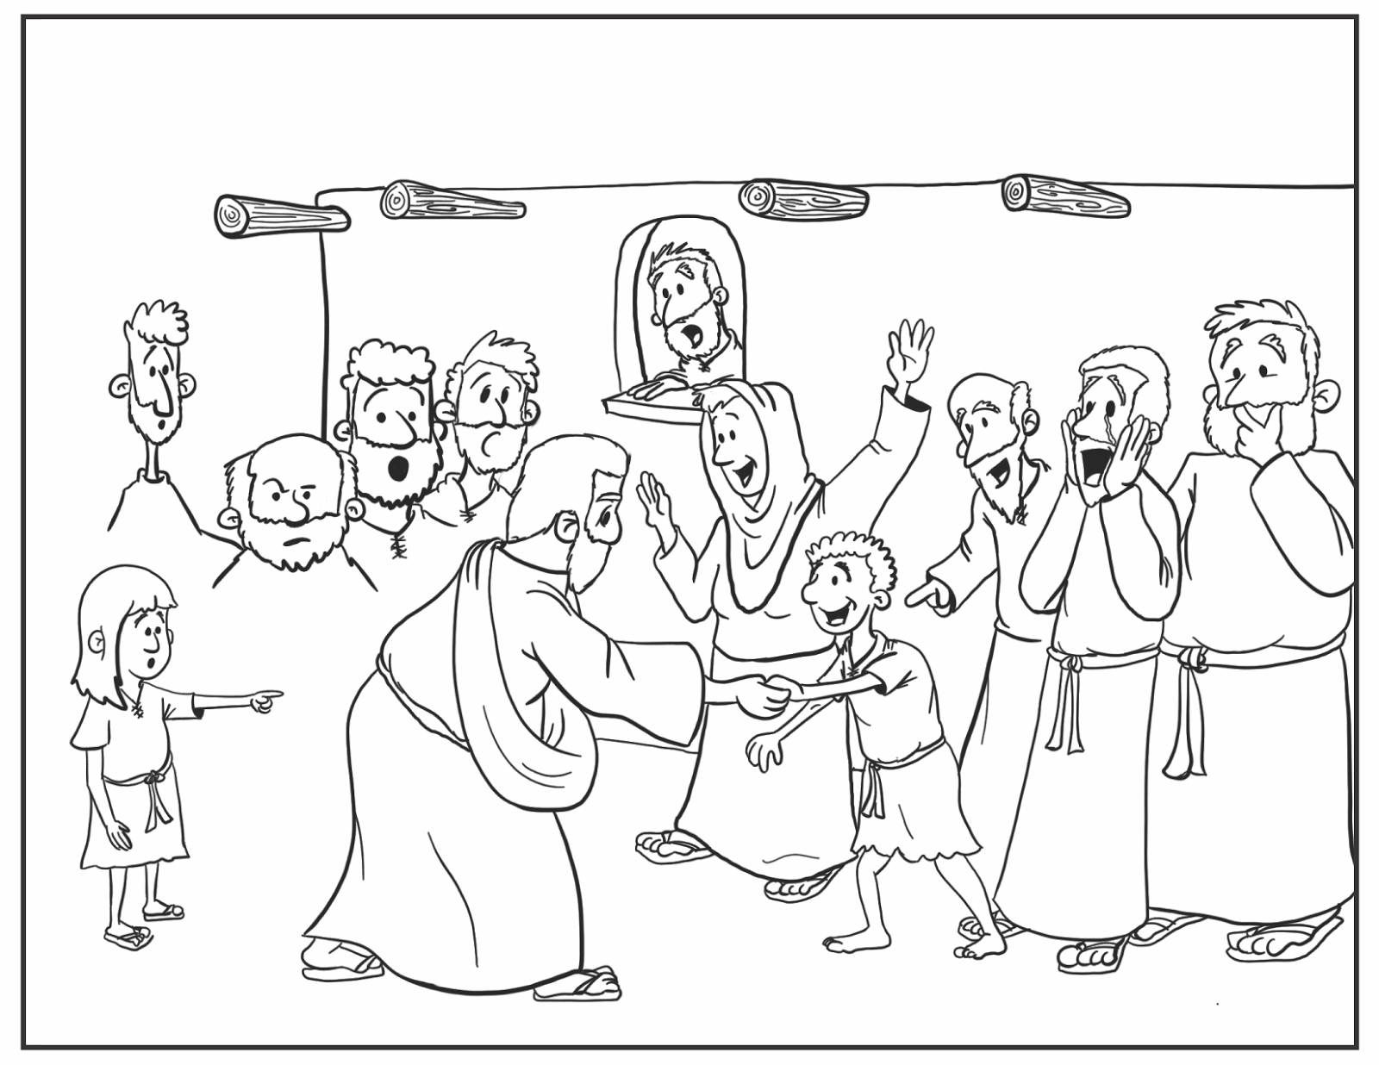http://mattsketchpad.blogspot.com/

