Put your Faith into Action
Anchor command. For by grace you have been saved through faith; and that not of yourselves, it is the gift of God; not as a result of works, so that no one may boast; for we are His workmanship, created in Christ Jesus for good works, which God prepared beforehand so that we would walk in them. Ephesians 2:8-10. (Notice that we are saved not by works but for them)
Anchor story. Abraham fights five kings by faith, Genesis 14.
Anchor verse. “Faith, if it has no works, is dead, being by itself”. James 2:17
Learning goal. Find what God teaches about saving faith and what it produces.
Growth goal. Believers are more fervent in prayer, and in serving through faith.
Skill goal. Convince believers in the power of the Holy Spirit to put their faith into vigorous action.
Outcome goal. Believers continually increase their works of faith, serving Christ and others.
Dear God in heaven, please use this study to help my flock grow in faith like Abraham did, so that they will both hear and do your Word and not be hearers only. Help us to obey the things that we believe.

Basic Study
Learn from Abraham’s defeating five Kings by faith to rescue lot and his family, Genesis 14
- Background: five pagan kings attacked and looted Sodom and carried off Abraham’s nephew Lot and his family, along with a very large amount of booty. Genesis 14:1-12.
- Abraham heard the news. How many of his armed servants did he lead in pursuit to defeat a much larger army? 14:14-15
- When the exhausted but victorious fighters were returning with all the rescued captives and recaptured goods, what important person came out to give them bread and wine? 14:18
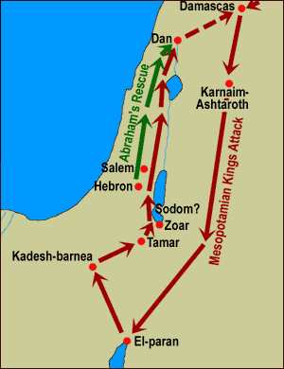
Map of Abraham’s route to rescue Lot and others from four Mesopotamian kings.
During the week…
- If any of the believers are struggling with weak faith, then go, visit them and tell them about Abraham, the man of faith.
- Tell them also your own testimony of why you believe.
- Demonstrate your God-given faith by serving needy neighbors in a practical way.
- Pray with those who struggle with weak faith.
During worship…
- Tell how Abraham defeated five Kings and rescued the captives, Genesis 14. Ask the above questions, and let the believers discuss how Abraham’s victory showed great faith in God.
- Ask the children to present what they have prepared.
Memorize James 1:22, “Prove yourselves doers of the word, and not merely hearers who delude themselves.”

Advanced Study
- Learn from Abraham about active faith.
Paul said Abraham is our example of faith, Galatians 3:6-9. Abraham had weaknesses the same as we do, and he made mistakes. However, when God promised to multiply his descendants as many as the stars in the sky, He believed God. God saw his faith and declared him to be righteous, Genesis 15:1-6.
Let us also believe God’s promises and do our part to help thousands of unbelievers to become spiritual sons of Abraham by believing as he did.
Find in Genesis…
In 12:2-3 what God promised Abram (before changing his name to Abraham, 17:5).
In 15:1-6 what Abram believed so that God counted him as righteous.
In 15:7-21 how God affirmed His promise to Abram. Was it only because of Abram’s effort in sacrificing and in keeping away the birds? (Answer: God was fully in control.)
In 16:1-16 Abram’s attempt by his own effort to fulfil God’s promise.
In 18:1 through 19:29 how Abraham’s faith saved his nephew Lot and Lot’s daughters.
In 22:1-18 how God tested Abraham’s faith, and what God promised to all believers because Abraham trusted God.
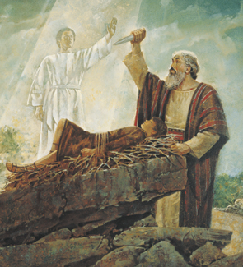
When Yahweh saw Abraham’s obedience, an angel kept him from harming Isaac.
Take a moment to remember how your own faith came to you. From the testimony of friends? The Word? A dream or vision? The quiet assurance of the Holy Spirit? Through prayer? Because of a miraculous healing in the name of Jesus?
- Plan with your co-workers additional, optional activities to do during the week.
Encourage believers by doing in their homes some of the worship activities under #3 below.
- Plan with your co-workers additional activities for the upcoming worship time.
Dramatize parts of Abraham’s story.
Explain these truths:
- God told Abraham to leave his relatives and go into a foreign land. By faith he obeyed. He took his wife and servants, and travelled hundreds of kilometers.
- While Abraham was in that land, God spoke again, promising him many descendants. Abraham believed God’s promise, and God reckoned his faith to be righteousness.
- God promised that He would bless all nations through one of Abraham’s descendants.
- Abraham did not know how the promise could be fulfilled, as he had no son to be his heir.
- God then told Abraham to prepare a sacrifice. God always required sacrifices to establish a covenant with humans. Jesus said the Lord's Supper is our covenant in His blood.
- Abraham tried to scare the vultures away, but he grew tired and fell into a deep sleep. He saw a vision of God walking through the midst of the sacrifice, while Abraham did nothing.
- Abraham still did not understand that it was God alone who would fulfil his promise.
- Later, Abraham’s wife Sarah suggested that he have a son with her slave girl, Hagar, to beget his heir. Abraham’s foolish effort has caused much misery. One of Hagar’s descendants later introduced Islam.
- At age 100, Abraham saw the promise of a son fulfilled, when Sarah gave birth to Isaac. It was not Abraham’s sacrifice or effort that fulfilled the promise, but God’s power alone.

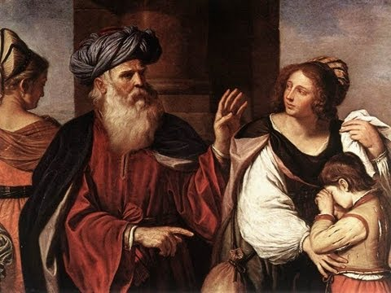
Abraham sent away the slave Hagar and her son Ishmael. Thus, Isaac
was reckoned Abraham’s only son and heir.
If believers live near Muslims…
- The Coran does not tell then name of the son whom Abraham offered; only the Torah tells the boy’s name. He was Isaac, not Ishmael.
- Explain that Abraham had two sons. His first son was born to Abraham’s wife’s slave girl, Hagar. His name was Ishmael, who became the ancestor of the Arabs. Ishmael was not the heir that God promised to give to Abraham through his wife.
- Abraham’s second son was born to his wife, Sarah. His name was Isaac, who became the ancestor of the Jews. God revealed to Abraham that God’s promises would bring blessing to the world through Isaac and the Jews.
- When Jesus was born, He was a Jew, a descendent of Isaac. Thus, the promises made to Abraham brings blessing to all those who put their faith in Jesus. Muslims, too, need to believe in Jesus.
Ask for testimonies of how God’s power has changed the lives of new believers, and how God has answered prayers or kept his promises.
- To introduce the Lord’s Supper, briefly recount from Genesis 15 Abraham’s sacrifice and how God showed His presence. Explain that God confirms His promises with a sacrifice. Abraham chased vultures away from the sacrificed meat. Birds in Jesus’ parables signify Satan’s lies. Sacrifices are very important to God. We confess our sins before eating the Lord’s Supper, to chase away Satan’s ‘birds’ as we partake of Christ’s body.
Poem: “The Enemy of Faith”. [If you translate this poem, you do not have to make it rhyme.]
The hungry dragon likes to yell,
“Some men desire to come to hell!”
He cries, “Oh look! It’s plain to see
how wicked some men want to be.”
He hates the truth but still admits,
“Not every man with half my wits
Is fooled in full by my deceit,
unless my lies they want to eat!
Form tiny groups of two or three to counsel and pray for each other and confirm plans.
Those who teach children should read study #93 for children.

