Him Jesus Healed a Blind Man who
Had Faith in God
Dear God, help us to believe in you as Bartimeus did, and to have strong faith in your power to heal and to forgive our sins.
Choose any of the children’s learning activities.
- Find in Mark 10:46-52 how Jesus healed a blind man who had faith.
Before telling the story, tell the children to listen and find how Jesus healed Bartimeus.
After telling the story, ask the children:
- What did Bartimeus do, when he found out that Jesus was coming?
- What did the people around Bartimeus say to him?
- What did Jesus do when he heard Bartimeus calling?
- What did Jesus ask Bartimeus?
- Why did Jesus heal Bartimeus?
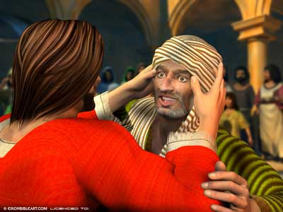
When Bartimeus crid out to Jesus, the Lord call him and gave him his sight.
- Blindfold some children who pretend to be Bartimeus.
Then ask them, “What does it feel like?”
Let other children pretend they are the people around Bartimeus. Ask:
- What things would they say to try to make Bartimeus be quiet?
(Answer: They might say things like:
“Jesus is too busy.”
“Jesus does not know you.”
“Your blindness is a punishment for your own sin.”
“You are not important to Jesus.”)
- What kinds of answers would you reply to people who said such things?
(Let the children answer.)
- Dramatize Jesus healing Bartimeus, Mark 10:46-52.
- Older children or adults play these parts:
Jesus,
Bartimeus. Wear an old cloak (any old rag). Sit at first with eyes closed.
Narrator.
Younger children play the part of People.
Narrator Read Mark 10:46-52.
People “Look! Jesus is coming! God’s promised Savior!
(Walk along behind Jesus.)
Bartimeus (Shout) “Jesus, Son of David, have mercy on me!”
People (Shout) “Be quiet! Do not bother that great man!”
“Hush! We want to listen to what Jesus says!”
Bartimeus “Son of David, have mercy on me!”
Jesus “Stop!” (Stop walking)
People (Stop walking.)
Jesus “Call him here.”
People “Take courage, stand up! He is calling for you.”
Bartimeus (Throw down the old cloak.)
One of the people:
(Lead Bartimeus by the hand to Jesus.)
Jesus “What do you want me to do for you?”
Bartimeus “Great Teacher, I want to regain my sight!”
Jesus (Pretend to touch Bartimeus’ eyes.)
“Go; your faith has made you well.”
Narrator “Immediately, Bartimeus regained his sight and followed Jesus on the road.”
(Thank everyone who helped with the drama.)
- If the children present the drama to the adults then let the children ask the adults the questions under #1 above.
Present anything else that the children have prepared.
- Draw a face with blank eyes, and have the children copy it. Next, draw complete eyes.
(If a picture of a head looks bad, then draw a whole person.)
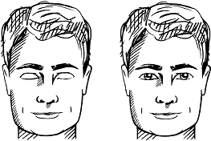
- Older children help younger ones.
- Some children might like to copy or colour the picture found at the end of this lesson.
- Have the children show to the adults the pictures they have drawn and explain that the closed eyes illustrate what our lives are like when we do not have faith in the power of Jesus.
- Older children write a poem or song, or give a testimony about what they have seen happen
that shows how Jesus heals people today.
- Let two children each recite a verse from Isaiah 53:4 & 5.
Surely he took up our infirmities and carried our sorrows,
yet we considered him stricken by God,
smitten by him and afflicted.
But he was pierced for our iniquities;
the punishment that brought us peace was upon him,
and by his wounds we are healed.
- Memorize Luke 11:9:
“I say to you, ask, and it will be given to you; seek, and you will find; knock, and it will be opened to you.”
- Have an older child pray:
“Dear Lord, we thank you that you have opened our spiritual eyes and ears to hear and believe what you say. We praise you for being powerful to heal and to save us from our sins. Help us to have faith in your power and to keep calling to you for help, as Bartimeus did.”
A more detailed drama, dealing with Jesus healing a blind man on the Sabbath, causing an uproar:
http://biblestoryskits.com/017-jesus-heals-a-blind-man-on-the-sabbath-causing-an-uproar-2/

