God’s Shepherds Do What the Apostles
Told Elders to Do
Anchor command. “I exhort the elders among you… shepherd the flock of God among you … proving to be examples to the flock.” 1 Peter 5:1-3
Anchor story. Elders settle a serious disagreement among churches and believers, Acts 15.
Anchor verse. “He gave some as apostles, and some as prophets, and some as evangelists, and some as pastors and teachers, for the equipping of the saints for the work of service, to the building up of the body of Christ.” Ephesians 4:11-12
Learning goal. Discover God’s instructions for church leaders.
Growth goal. Leaders put into practice their New Testament duties and Spirit-given virtues.
Skill goal. Engage believers in God’s work; let them serve actively in loving harmony.
Outcome goal. Believers live holy lives and serve Christ actively by using their different spiritual gifts.
Dear Lord, please help us elders to shepherd the flock that you entrusted to our care. Help us to do so willingly and not for money, not by lording it over others but by serving humbly as examples, the way in which you and your apostles showed us.

Basic Study
Learn from the account of elders settling a sharp disagreement among churches and believers.
Acts 15:1-29.
- What question caused a serious debate among Christian brothers? 1-5
- Who came together to discuss the disagreement? 6
- What was the main point of Peter’s reply to legalistic Jews? 7-11
- The apostles spoke against burdening Gentiles (non-Jews) with Jewish laws, by citing texts from the Old Testament. The assembly agreed with them and they sent a letter to the gentile churches. What were its only requirements for Gentiles? 28-29.
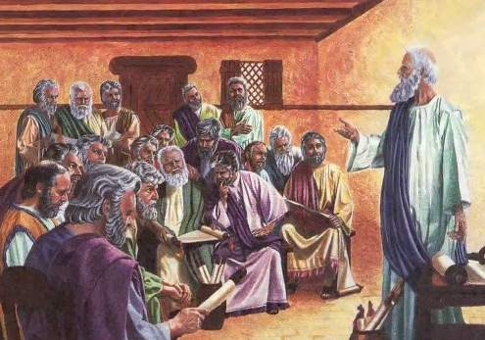
The Apostles and Elders agreed with Scripture, with one another,
and with the Holy Spirit.
During the week meet with shepherding elders and potential elders, to discuss their duties.
During worship…
- Relate how the elders settled the debate in Jerusalem, Acts 15:1-29, and let believers discuss it.
- Ask the children to present what they have prepared.
- Memorize together Jeremiah 3:15.

Advanced Study
- Prepare with God’s Word to do a biblical shepherd’s duties.
Find in Acts 20:17-38 what Paul instructed elders to do, by his word and example:
- In what two places did the elders teach? Verse 20
- What are elders to declare? Verse 27
- Why must elders be alert? Verses 28-29
- Where can wolves appear? [Verses 30-31]
- How Paul earned his living in Ephesus. [Verses 33-35]
- How elders showed love for their mentor. [Verses 36-38]
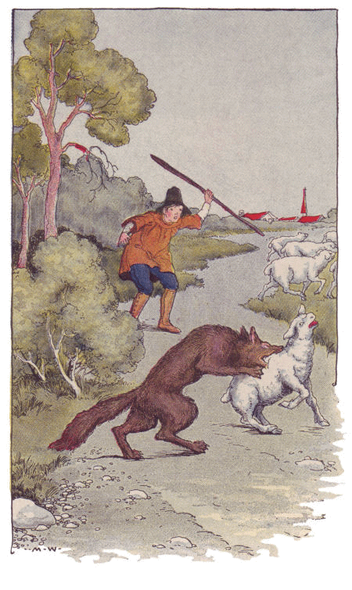
The important tasks of shepherds include defending sheep
against predators, such as wolves.
Find in Titus 1:5-9 reasons for naming elders and their qualifications:
- What was Titus to do in every city of Crete? [Verses 4-5]
- What are the qualifications of Elders? [Verses 6-9]
- Prayerfully review Paul’s list of character virtues that shepherds should have:
“For this reason I left you in Crete, that you would set in order what remains and appoint elders in every city as I directed you, namely, if any man is above reproach, the husband of one wife, having children who believe, not accused of dissipation or rebellion. For the overseer must be above reproach as God's steward, not self-willed, not quick-tempered, not addicted to wine, not pugnacious, not fond of sordid gain, but hospitable, loving what is good, sensible, just, devout, self-controlled, holding fast the faithful word which is in accordance with the teaching, so that he will be able both to exhort in sound doctrine and to refute those who contradict.” Titus 1:7-8
Select two or three of the above virtues that you need to develop more fully.

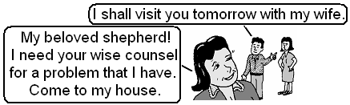
"An overseer must be above reproach... self-controlled...”

Find in Ephesians 4:11-12 several requirements for leaders.
- What must your teaching enable believers to do? Verses 11-12
- What is God’s purpose for your leading? 13
- What should be the result of your leading concerning doctrine? 14
- What should be the result concerning the way the believers talk? 15
- What should be the result concerning how believers treat one another? 16
Find in Matthew 18:15-17 how elders are to deal with reports of bad behavior.
- What should be done about a complaint before you deal with it?
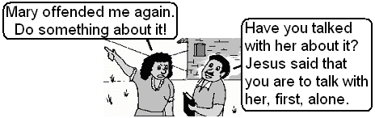
“An overseer must be able … to give instruction in sound doctrine.”

- Plan with co-workers additional, optional activities to do during the week
Pray for God’s help to do your shepherd’s duties.
Discern which ministries need attention in your flock, and plan to develop them:
Counsel, correct without attacking and restore troubled or straying sheep.
1 Corinthians 5; Galatians 6:1-2
Strengthen marriages and family life, Ephesians 5:21 through 6:4
Help believers to pray and to have daily personal and family devotional times, 1 Thessalonians 5:17
Pray for the sick, needy and victims of injustice. Genesis 18:20-33; James 5:14-15
Serve the needy within the church body and in the larger community. Acts 6:1-6;
Galatians 6:10
Give, as stewards of what God has given us, Luke 6:38; Matthew 25:14-30
Organize so that all serve with their spiritual gifts in harmony in the body, 1 Corinthians 12
Serve one another in the flock and with other flocks, 1 Corinthians 12; Ephesians 4:11-16; Romans 12:4-16
Develop loving fellowship among members of the flock, Romans 12:3-21; 1 Corinthians 13
Worship as a body, including the Lord's Supper. Matthew 26:26-28, Hebrews 10:25; Acts 2:46; 20:7
Tell people about Jesus, Luke 24:46-48; Acts 1:8; 2 Timothy 4:5
Make disciples who do what Jesus commands, Matthew 28:18-20 (example: Acts 2:37-47)
Use the Word to equip believers for ministries, 1 Tim. 3:16-17; James 1:22-26; Ephesians 4:11-12
Start new flocks wherever local folk are neglected. Acts chapters 13 & 14
Prepare and send ‘apostles’ to neglected, receptive peoples. Matthew 28:18-20; Acts 1:8; 13:1-3
Mentor novice shepherds and apostles who are apprentices, Mark 3:14; Titus 1:5; 2 Timothy 2:2
- Plan with co-workers additional, optional activities for the upcoming worship time. Perhaps:
- Tell about Paul’s meeting with the Ephesian elders, from Acts 20:17-38. Ask questions about what you found.
- Explain the qualifications and duties of shepherding elders.
- Announce and deal with the plans that you have made for ministries that need development.
- To introduce the Lord’s Supper, read John 10, verses 11-15 and 27-30. Explain that Jesus is the Good Shepherd who shed His blood for His sheep, who we are.
- Let the children present what they have prepared (always have children’s teachers use the Paul-Timothy Children’s Study of the same number and topic as the New Shepherd’s Study.)
- Meet in groups of two or three persons to pray, encourage one another and make plans.
- Those who teach children should read study #87 for children.

