Jesus Fed 5,000 People with a Boy’s Gift
Dear Lord, please use this study to show the children what a good shepherd does, so that they also will serve each other with loving care.
Choose any of these children's learning activities that fit their ages and needs.
- Explain how a boy gave Jesus five loaves of bread and two fish from which Jesus miraculously fed a huge crowd. (John 6:9)
- An older child or teacher reads or tells by memory the story about how Jesus,
our Good Shepherd, fed 5,000 hungry people with five loaves and two fish,
Mark 6:30-44.
- Pose these queries [Find answers in these verses cited from Mark chapter 6].
- How did Jesus feel about the hungry people? [34]
- What did Jesus tell his disciples to do for the hungry people? [37]
- How did the disciples arrange the people in order? [40]
- What did Jesus use to feed the crowd? [41]
- How much food did they have left over? [43]
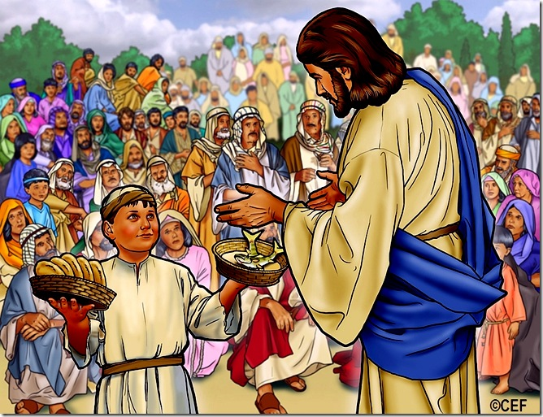
A boy offered his bread and fish to Jesus who multiplied it to feed 5,000 men.
- Dramatize parts of the story of Jesus feeding 5,000 people, Mark 6:30-44.
- Arrange with the leader of congregational worship for the children to present the drama.
- Use part of your teaching time with the children to prepare the drama.
- Let older children help the smaller ones.
- Older children or adults play these parts: Jesus, Narrator. Summarize the story and help children to remember what to say and do.
- Younger children play these parts: Hungry People, Disciples. Hold objects that represent food.
Narrator Tell the story briefly from Mark 6:30-44. Then say,
“Hear what the People say.”
People (Some say) “Let us follow Jesus”
(Others say) “I like hearing him teach.”
(Others say) “He is our Good Shepherd.”
Disciples (Some say) “Jesus, send the people away.”
(Others say) “They are hungry, and there is no food in this place.”
Jesus “You feed them.”
Disciples (Some say) “How can we feed them?”
(Others say) “We do not have enough money.”
(Others say) “There is no place to buy food, even if we had the money.”
Jesus “This boy is offering to give me his lunch!
Tell the people to sit in groups.”
Hungry People Sit in small groups.
Jesus Look up and say,
“Father, we thank you for this food.”
Disciples Pretend to give out the ‘food’ to the people.
Hungry People Pretend to eat.
(Some say) “Look! There is enough food for everyone.”
(Others say) “It tastes really good!”
(Others say) “A lot is left over!”
(Others say) “Twelve baskets full of food are left over!”
(Others say) “What a great miracle!”
Narrator Thank everyone who helped with the drama.
- If the children dramatize the story for the adults, then let them also ask the adults these questions:
- In what other ways does God take care of people?
(Let children and adults mention examples.)
- In what way do our shepherds feed God’s people, today?
[Answer: With God’s Word: …
- Jesus said, “Man shall not live on bread alone, but on every word that proceeds out of the mouth of God.” (Matthew 4:4)
- Explain that when the devil tempted Jesus to sin, Jesus always used the Word of God to answer the devil.]
- Draw a simple picture of a fish, and let the children copy it.
Older children might want to draw five loaves of bread and two fishes.
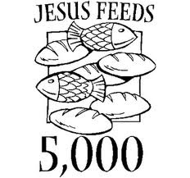
- Some children might like to copy or colour the picture found at the end of this lesson.
- The children can show their pictures to the adults at the next worship time,
and also to their parents at home.
- Let the children explain to the adults and to their parents that the picture illustrates
the way Jesus took care of the needs of the people.
- Let them explain also that in heaven we will never suffer from hunger or thirst.
- Memorize Jesus’ words, John 6:51:
“I am the living bread that came down out of heaven; if anyone eats of this bread, he will live forever; and the bread also which I will give for the life of the world is my flesh.”
- Let three children each recite two verses from Psalm 146:
(Verses 2 and 6, verses 7 and 8 and verses 9 and10.)
- Let older children write poems or songs about how people feast on God’s Word. T
They might do this during the week.
- Have a child say the Lord’s Prayer from Matthew 6:9-13.
A more detailed drama, dealing with Jesus feeding five thousand with a boy’s gift.
http://biblestoryskits.com/013-jesus-feeds-five-thousand-with-a-boys-small-gift-4/

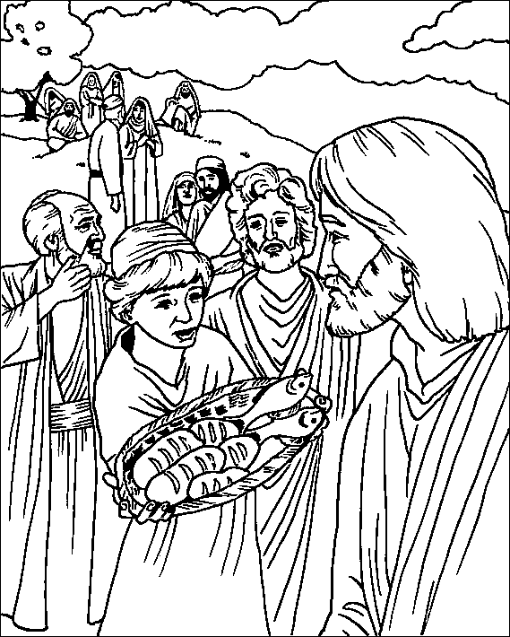
A lad offered his bread and fish to Jesus who multiplied it to feed 5,000 men.

