Regional Overseers of New Churches
Anchor command. “For this reason I left you in Crete, that you would set in order what remains and appoint elders in every city as I directed you.” Titus 1:5
Anchor story. The prophet Samuel anoints David to be Israel’s leader. 1 Samuel 16:1-13
Anchor verse. “If any man aspires to the office of overseer, it is a fine work he desires to do.” 1 Timothy 3:1
Learning goal. Find what God teaches in his Word about regional overseers.
Growth goal. Know and appreciate the ideal biblical character traits of overseers.
Skill goal. Serve effectively in the power of the Holy Spirit as a regional overseer.
Outcome goal. Regional overseers wisely name and instruct leaders of new congregations...

Basic Study
Learn from the account of choosing David as the leader of God’s people. 1 Samuel 16:1-13
- Israel’s first king, Saul, had disobeyed God. What did God tell the prophet Samuel to do? verse 1
- Why was Samuel afraid to go to Bethlehem and anoint David as King? 2
- What was Samuel to do? 3
- How do we know that the elders of Bethany held Samuel in awe? 4
- Which one of Jesse’s sons did Samuel mistakenly assume was the one to anoint? 5-7
- How many sons of Jesse did God reject? 8-10
- What was young David doing at that time? 11
- What came upon David from that day forward, after being anointed? 12-13
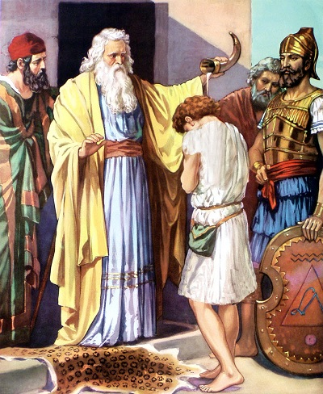
Samuel anoints young David who will one day become king of Israel.
During the week…
- Pray together for God's wisdom to name the right people to serve as overseers.
- Agree on who it is that oversees your congregations. It may be the ‘apostle’ who started them, or a leader who shows genuine concern for them. In the New Testament such apostles came from another region to start new congregations.
- Is the coordinator able to mentor newer shepherds?
If not, then they should name other coordinators, just as Paul named Titus and Timothy.
During worship…
- Tell the story of Samuel anointing David, 1 Samuel 16:1-13, and ask the same questions as above. Let believers discuss the answers.
- Pray for overseers in your area. Ask God to give them wisdom and vision.
- Ask the children to present what they have prepared.
- Read Mark 10:42–45 and memorize together verse 45: “For the Son of Man did not come to be served, but to serve, and to give His life a ransom for many.”

Advanced Study
- Verify what the New Testament teaches about overseers.
- Why do we need regional overseers? (Overseers may be called ‘bishop’ or some other useful term.)
[Answer: New flocks need someone to do for them what Titus did in Crete, which was to name and prepare new shepherds. New congregations are usually too immature to do this themselves. In his letters to Titus and Timothy, Paul explained the character and duties of coordinators and of shepherds. More mature flocks, such as Antioch in Acts 13:1–3, may name their own leaders.]
- Read Paul’s letter to Titus to learn what a regional overseer does.

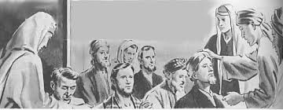
Apostles name elders or overseers in new churches.

Find in Titus 1:1–3:
- What was Paul's position in respect to the Lord Jesus?
- What had God entrusted to Paul?
Find in Titus 1:4–5:
- What was Titus’ relationship with Paul?
- Why did Paul leave Titus in Crete?
- What did Paul tell Titus, the regional coordinator, to do for new congregations in Crete?
Find in 2 Corinthians 2:12–13
- How much did Paul value the company of Titus, his ‘spiritual son’?
Find in 2 Corinthians 7:5–7:
- What did other people think about Titus?
- What was Paul willing to endure when Titus was with him?
Find in Titus 1:6–9
- The requirements for new shepherds (elders).
- What shepherding elder's family should be like.
- What the character of shepherding elder should be.
Find in Titus 1:10–16…
- The problem that these elders would have to be able to correct.
- In Titus 1:5 Paul had told Titus that some things had been left unfinished.
Find in Titus 2:1–10 what some of those things were that had to be straightened out.
- What was Titus to instruct older men to do?
- Older women?
- Young men?
- Bond slaves? (Roman law required bond slaves to serve their masters who were called ‘freemen.’)
Find in Titus 2:15 how strongly a regional coordinator must stress these things.
Find in Philippians 2:19–30 names of two coordinators who served in the region of Philippi.
- What kind of men were these two coordinators?
- What had they done with Paul for the churches?
- How much confidence did Paul have in them?
- Show new coordinators what they must do:
- Plan with co-workers the regional coordination with other congregations in the area.
- Visit, encourage, and write to new congregations, as Paul did.
- Take with him apprentices who learn from him to pass on instruction to others. 2 Timothy 2:2
- Arrange for shepherds to mentor newer elders until their congregation are doing the activities that the New Testament requires.

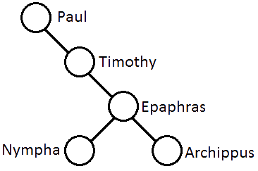
Apostles named regional coordinators who appointed leaders in new churches.

- When the movement is still small, the ‘apostle’ will himself serve as a regional coordinator (Acts 14:21–23). When the ‘apostle’ is ready to go serve elsewhere, he should authorize his apprentices to coordinate God’s work in that region (Phil. 2:19–24).
- Ensure that all shepherds who mentor newer shepherds have a supply of Paul–Timothy studies or of other suitable training materials.
- Help congregations to coordinate their work.
- Plan to affirm publicly apprentices who serve faithfully.
- Authorize them publicly by laying hands on them (2 Tim. 1:6, 1 Tim. 4:14).
- Instruct the churches to respect them (1 Cor. 16:10–11; Phil. 2:29).
- Avoid giving authority to people who may be sinning (1 Tim. 5:22).
- Arrange for an ‘apostle’ to show regional coordinators how…
- To talk with new shepherds to learn their congregations’ needs.
- To find out what members of their flocks are doing and should start doing.
- To look for men who are starting to meet the requirements of elders in Titus 1:6–9.
- Plan with your co-workers the upcoming worship time
- Tell about Titus from 2 Corinthians 2:12–13 and 7:5–7.
- Tell about Timothy and Epaphroditus from Philippians 2:19–30. Explain how the Lord Jesus blesses His servants through humble apprentice coordinators who are faithful and useful.
- Explain he need for regional coordinators and what they do.
- Let believers give testimonies about the blessings, good work and character of a coordinator whom they know.
- To introduce the Lord’s Supper read Numbers 9:1–5. Explain that God’s people ate the Passover lamb in the desert, recalling how God spared the firstborn of families that painted the blood of the lamb by their doors, and led them out of slavery in Egypt.
- Form small groups of two or three people, to pray, confirm plans and encourage one another.
- Those who teach children should read study #84 for children.

