Organize Members of Your Flock
to Serve Others
Anchor command. “Do not neglect doing good and sharing, for with such sacrifices God is pleased. Obey your leaders and submit to them, for they keep watch over your souls as those who will give an account.” Hebrews 13: 16-17
Anchor story. Jesus will judge the nations (parable of the sheep and goats), Matthew 25:31-46
Anchor verse. “And He gave some as apostles, and some as prophets, and some as evangelists, and some as pastors and teachers, for the equipping of the saints for the work of service, to the building up of the body of Christ.” Ephesians 4:11-12
Learning goal. Know what the New Testament teaches about organizing God’s people to serve.
Growth goal. Many members of the church develop and use leadership skills.
Skill goal. Coordinate God’s work so that all members are using their spiritual gifts.
Outcome goal. Believers work closely together to serve one another and others in the community effectively.

Lord, help us to respect other people’s gifts and not boast of ours.

Basic Study
Learn from Christ’s parable of separating “sheep” from “goats,” Matthew 25:31-46.
- When will Christ’s judgment of all peoples take place? 31-33
- What will Christ tell those whom he places on his right? 34-36
- What will those on his right asked him in response? 37-39
- In what way had those on Jesus’ right served him? 40
- In what way and those on Jesus left failed to serve him? 41-45
- What is a final destiny of both “sheep” and “goats”? 46
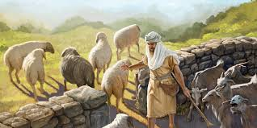
A shepherd separates sheep from goats.
During the week you and your coworkers visit and organize the believers so that each one is is actively serving others.
During worship…
- Relate Christ’s parable of the sheep and goats, and ask the same questions as above.
Let believers discuss the answers.
- Ask the children to present what they have prepared.
- Memorize together Mark 9:35: “Sitting down, He called the twelve and said to them,’ If anyone wants to be first, he shall be last of all and servant of all’.”

Advanced Study
- Leaders oversee God’s people wisely, as James did in Jerusalem.
- Find in 1 Corinthians chapters 12–14 how to use spiritual gifts:
For whose good does God give us spiritual gifts? 1 Cor. 12:4-7
Who decides which gifts a believer receives? 1 Cor. 12:8-11
To what are the gifts and their uses compared? 1 Cor. 12:12-31
What is the right motive for using our gifts? 1 Cor. 12:31; 13:1-13
How should believers correct excessive emphasis on one gift? Chapter 14
- God gives different gifts to believers, often more than one, so we will serve one another and our neighbors.
- The Holy Spirit harmonizes our different tasks in love, just as a body’s organs work together.
- Romans 12:4-8, 1 Corinthians 12 and Ephesians 4:11-16 list many spiritual gifts.
- 1 Corinthians 12:12 compares spiritual gifts to the different members of our bodies:

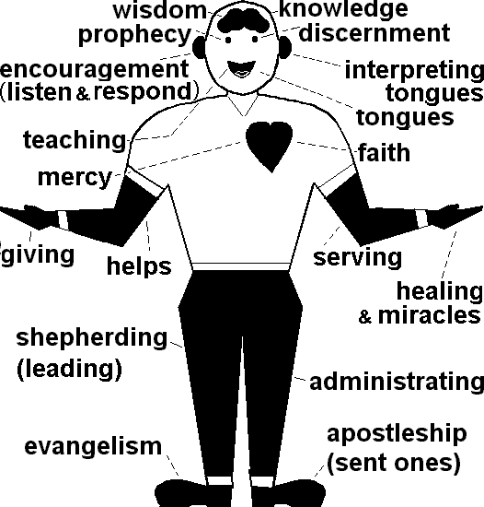
- Organize believers to do these tasks that God requires of every flock:
- Serve people who suffer (Matt. 25:31-46) and pray for them (John 16:24).
The task of prayer includes intercession and spiritual warfare against evil spirits.
- The two halves of the heart suggest the corresponding gifts of compassion (Rom. 12:8) and faith (1 Cor. 12:9). When these two gifts work together by faith, our salvation yields good works (Eph. 2:8-10). Jesus healed many who had faith, including a leper and a centurion (Matt. 8:1-13). Many Old Testament believers showed great faith by their deeds (Heb. 11).
- The brain’s two halves remind us of the corresponding gifts of wisdom and knowledge (1 Cor. 12:8). Solomon is an example (1 Kings 3:5-28). Admonish and help others to grow in Christ (Col. 1:28).
- God gives believers spiritual gifts to do these ministries:
- Comfort people (2 Cor. 1:3-7) and discern spiritual problems (1 Cor. 2:14). The two eyes correspond to the gifts of prophecy (which serves mainly to comfort and strengthen, 1 Cor. 14:2-3) and of discerning spirits (1 Cor. 12:10). Isaiah is an example of both (Isaiah 40:1-14).
- Prepare believers to edify their flock and to train leaders (Eph. 4:11-12). The mouth means the gift of teaching (1 Cor. 12:28). Ezra is an example (Neh. 8), also Paul (2 Tim. 2:2).
- Convince unbelieving foreigners by speaking their language (1 Cor. 14:22). The tongue means the gift of tongues (1 Cor. 12:10). The apostles on Pentecost did so (Acts 2:1-18).
- Keep believers and their leaders firm in the faith and doing their God-given tasks (1 Cor. 14:26; Acts 14:21-22). The two ears illustrate the gifts of encouragement (listen to people in order to exhort and serve them, (Rom. 12:8) and interpreting tongues (1 Cor. 12:10). Paul encouraged the Ephesian elders (Acts 20:17-38).
- Serve the body of Christ and care for the needs of others (Gal. 5:13; 6:10). The two arms correspond to the gifts of serving (Rom. 12:7) and of helps (1 Cor. 12:28). The first deacons in Jerusalem served the widows (Acts 6:1-6).
- Heal the sick (Luke 10:9), and give (Luke 6:38). The two hands recall the gifts of healing and miracles (1 Cor. 12:9-10), and of giving (Rom. 12:8). Paul healed Publius’ father (Acts 28:7-8) and Dorcas gave generously (Acts 9:36).
- Lead the way for others to follow (1 Cor. 11:1). The two legs display the gifts of leading (Rom. 12:8) and administration (1 Cor: 12:28). David did both (1 Sam. 23:1-5; 2 Sam. 5).
- Proclaim Christ (Luke 24:46-48; Acts 1:8). The two feet signify apostleship (missionaries) and evangelism (Eph. 4:11-12). Paul was an example of both (Rom. 15:20-21).
- Read Acts 15:1-31 to see how James and elders of different congregations (Jewish and non-Jewish) solved a serious dispute.

Background
James was a prominent shepherd in Jerusalem where there were two major cultures in the congregations.
The Jews for centuries had embraced the Old Testament law, which required animal sacrifices, marrying a dead brother’s wife if he left no heirs, killing people who worked on Saturday, worshiping only in Jerusalem, and many more detailed regulations.
Most Gentile (non-Jewish) believers in Christ knew nothing about those ancient Israelite laws. Even today, some believers bring the old law into the New Covenant instead of letting the Holy Spirit guide them.
Jesus said that we now fulfil the law of God by simply loving Him and our neighbor as we should (Matt. 22:37-40; Rom. 13:8-10). Love is a fruit of the Holy Spirit (Gal. 2:22). To learn how God has set aside the old covenant, read 2 Corinthians 3:6-18 and Hebrews 8:6-13.
Find in Acts chapter 15:
- What some Jewish believers thought one had to do to be saved. [Answer: See verse 1]
- What law believing Pharisees (a strict Jewish sect) where forcing non-Jews to obey.
[See verses 2-5. The Old Testament law was for ancient Israel, not for those who follow the New Testament.]
- Peter’s advice. [See verses 6-11]
- Among what people Paul and Barnabas had seen God work miraculously. [See verse 12]
- What James proposed that solved the problem. [See verses 13-21]
- The outcome. [See verses 22-31]
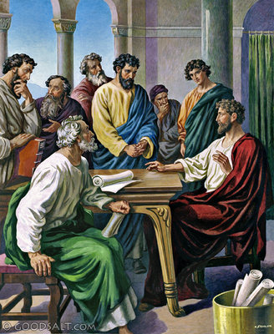
The apostles and elders discussed, consulted Scripture, and heard from the Holy Spirit
- Plan with co-workers additional activities to do during the week
Visit believers who do not yet serve others, and help them to do so. Begin any of the tasks listed above that your flock lacks.
- Plan additional activities for the upcoming worship time, to meet current needs.
- Describe the tasks that God requires of every congregation and their corresponding gifts of the Spirit.
- Explain how James and others kept harmony among believers (#4 above). Ask the questions listed above.
- Let the children present what they have prepared.
- To introduce the Lord’s Supper, read John 17:18-24. Explain that Jesus prayed for our loving unity when He instituted this sacrament.
- Meet in groups of two or three to talk about spiritual gifts, plan and pray for one another.
- Those who teach children should read study #83 for children.

