We Work Together to Serve God
Dear God, help the Children to renew their faith by turning from sin to serve you.
Choose any of these children's learning activities that fit their needs and ages.
- Let an older child or teacher read or tell about King Hezekiah, from 2 Chronicles chapter 30.
This story shows how a king sent teachers to his people, and brought revival to his people.
After telling the story, ask these questions. [Answers appear after each question.]
- Who invited all the people to come worship God, celebrating the Passover feast in Jerusalem? [Verse 1.]
- How did the king send out this invitation? [Verse 10. He sent messengers.]
- How did some of the people respond? [Verse 11.]
- Who gave some of the people their desire to respond well? [Verse 12.]
- In what way did the people do what they had heard from God’s Word? [Verse 14.]
- Under what other king’s reign had they last celebrated the Passover this way? [Verse 26.]
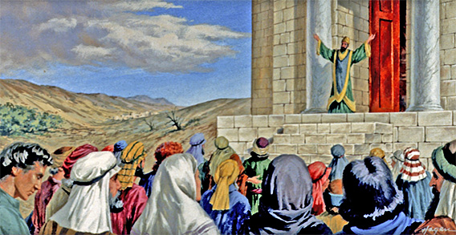
When enemy armies threatened his country, King Hezekiah called everyone to return
and worship the LORD.
- Dramatize parts of the story of King Hezekiah who brought renewal to his people.
- Arrange with the main worship leader to present this brief drama.
- Use your time with the children to prepare it.
Let the older children help the younger.
- Older children or adults play these roles:
Narrator. Summarize the story and help the children remember what to say and do.
King Hezekiah. Have papers in your hands.
Younger children play these roles:
King’s messenger
Scoffer
People (who heed the message)
Priest
Narrator Tell the first part of the story, 2 Chronicles 30:1-12. Say,
“Hear what King Hezekiah commands.”
King Hezekiah “Messengers, go to all the towns of Israel.
Give them this message.
‘Come to Jerusalem to celebrate the Passover feast.
We all need to repent and receive God’s blessing’.”
King’s messenger Walk up to different persons in the audience. Say,
“All of you, repent and come to Jerusalem for the Passover!”
Scoffer “That is too far to go. We will not go!”
People “Yes. God will help us to repent. We will go!”
Narrator Tell the second part of the story, 2 Chronicles 30 13-27. Then say,
“Hear what the people say.”
People “We have come to Jerusalem for the Passover.
We want to serve the one true God.
Let us destroy all the idols and altars around here!”
King Hezekiah “I will provide all that we need for this great feast!
Let us be encouraged!
If we repent, then God will hear our prayers!”
Priest “It is good to rejoice together!
Let us celebrate a second week!
There has not been a revival like this since the time of King Solomon!”
Narrator Thank those who helped with the drama.

- If the children dramatize this story for the adults, then let them also pose to the adults the queries listed under #1 above.
- Also ask:
- What other people besides King Hezekiah have taken the message of repentance
to people who needed God?
- At what times do Christians gather to pray and celebrate together?
- Draw a picture of a letter with a message, for the children to copy.
- Let them show their pictures to the adults during worship or to parents at home, and explain that this illustrates how we take the message of repentance to others, so we can all pray and seek God together.
- Let the older children help the younger.
- Some children might like to copy or colour the picture found at the end of this lesson.
- Memorize Philippians 2:2-3.
- Let three children each recite one verse from Psalm 14:1-3.
- Let older children write poems, songs or dramas about people being renewed spiritually.
They can work together to do this; they can also do this work at home.
- An older child reads king Hezekiah’s exhortation to his people, 2 Chronicles 30:6-9:
“O people of Israel, return to the LORD, the God of Abraham, Isaac, and Israel, that he may turn again to the remnant of you who have escaped from the hand of the kings of Assyria.
Do not be like your fathers and your brothers, who were faithless to the LORD God of their fathers, so that he made them a desolation, as you see. Do not now be stiff-necked as your fathers were, but yield yourselves to the LORD and come to his sanctuary, which he has consecrated forever, and serve the LORD your God, that his fierce anger may turn away from you.
For if you return to the LORD, your brothers and your children will find compassion with their captors and return to this land. For the LORD your God is gracious and merciful and will not turn away his face from you, if you return to him.”
- Have an older child pray:
“Lord, we, too, have been stubborn and unfaithful like the people of Israel. We praise you that you always hear us when we repent. You bless us greatly, when we celebrate together.”
A more detailed drama: how Nehemiah got God’s people to work together to rebuild Jerusalem:
http://biblestoryskits.com/010-gods-people-rebuild-jerusalem-after-painful-exile/

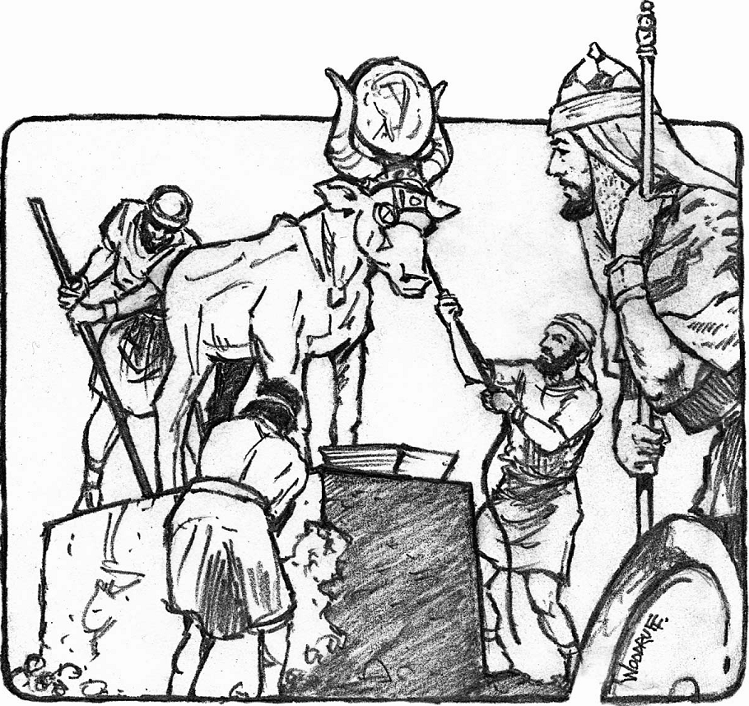

King Hezekiah sent soldiers and workmen to tear down idols to false gods.

