Let Small Groups to Serve One Another
Anchor command. “Shepherd the flock of God among you, exercising oversight not under compulsion, but voluntarily, according to the will of God.” 1 Peter 5:2-3
Anchor story. Moses’ father-in-law Jethro advises him to shepherd God’s flock. Exodus 18:13-36.
Anchor verse. “I left you in Crete, to set in order what remains and appoint elders in every city as I directed you.” Titus 1:5
Learning goal. Understand accurately God’s pattern to organize for action.
Growth goal. Discern and put to use the varied gifts that God has given to all members of the congregation.
Skill goal. Lead in a way that all believers know and exercise their spiritual gifts in an active way, in love.
Outcome goal. Believers serve each other and their neighbors; shepherds share responsibilities with other shepherds; and churches cooperate with each other.

Basic Study
Dear Lord, help us to organize in the way that Jethro advised Moses, so that all believers both serve and are served.
Learn from Jethro’s advice to Moses how to mobilize and coordinate many leaders, Exodus 18:13-36.
- What was Moses doing from morning to evening when his elderly father-in-law Jethro visited him, that showed that the people were still poorly organized? Verses 13-16
- What were the bad results from the way Moses had been leading? 17-18
- What did Jethro tell Moses to teach the people? 19-29
- How did Jethro advise Moses to organize the nation, so that all receive shepherding? 21-22
- Everyone received shepherding in small groups of ten households. Larger groups were for coordination and communication between group leaders and Moses.
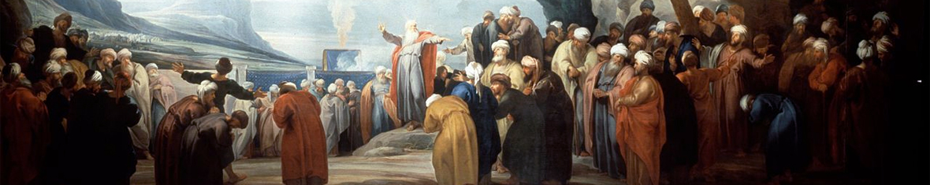
Moses and 70 elders were able to shepherd an entire nation by organizing 1000s of household groups.

During the week name leaders of small groups, if you have not yet done so, such that all believers receive face-to-face shepherding.
During worship tell or act out the story of Jethro and Moses, Exodus 18:13-36.
Ask the questions above, and let the people discuss the answers...
Ask the children to present what they have prepared.
Memorize together God’s rule for shepherds, 1 Peter 5:2-3.

Advanced Study

Review additional truths from Exodus chapter 18:10-27, about how God used Moses’ mentor, Jethro, to organise social groups among the Israelites.
- If you do not recall how Moses met Jethro, then, please read Exodus chapters 1 through 3.
- How did Moses make sure that every Israelite family received care from a spiritual shepherd?
- How many people did Jethro recommend to have in their smallest shepherding groups?
- God gave those new elders basic rules by which to govern His people (Ex. chapters 19 & 20).
Those laws were the Covenant between God and Israel, based on the Ten Commandments.
Those rules were the heart of God’s ancient law for Israel, which the Jews call ‘Torah.’
- The shepherding took place in the small groups of ten, in which everyone could receive attention.
A shepherd can hardly listen to more than about ten families, to care for them all properly.
- The leaders of the larger groups coordinated the administration of justice and government.

Balanced leadership combines four duties that four biblical leaders modelled:
1) Moses, a seer, saw into the future and inspired his followers with his vision of what God would do. | Vision | God gives to some leaders the ability to start flocks in new areas. They help shepherds to plan and to multiply these flocks.
2) Joshua, a fighter, carried out Moses’ vision in a practical way. He sometimes used military force. | Firmness | God gives courage to some organizers to keep serving Him even when people oppose them. They spur workers to persevere.
3) Aaron, a manager, was High Priest and made sure that other priests carried out the daily priestly duties. | Thoroughness | God gives to some organizers skill to manage accurately the details of a ministry, making the work easy for the other workers.
4) Barnabas, an encourager, was compassionate. He helped people to work together in harmony. | Kindness | God helps some organizers to make His work socially enjoyable. They assure and console, and enjoy dealing with people’s needs.

Good organizers balance these four strengths, often combining them in a team of leaders.
- Which of these four strengths for organizing do you do well? For which do you need help?
- A good organizer works closely with helpers who have spiritual gifts that he lacks.
- Rarely can an organizer attain well all four of these strengths by himself, like Jesus, David and Paul did.
Good organizers share leadership responsibilities. Jesus, David and Paul did not work alone.
Good organizers keep groups small enough so that every member can speak freely and receive attention from the leader.

Initiators start new congregations and projects, or they begin God’s work in new areas.
- A visionary leader sees in his heart what God will do, and shares this vision with others.
- They might mentor other leaders quietly, like Moses who let Aaron do the public speaking.
- Peter and others who organized new congregations in the book of Acts were initiators.
- A visionary leader, like Moses, knows clearly what God wants his flock to do. If no one provides such foresight, then shepherds cannot lead, because they do not know where to go. Teaching by itself is neither organizing nor leading. And simply enforcing rules leads nowhere.

Managers carry on the work in organizations that initiators start.
- Titus stayed in Crete to train shepherds for the new flocks that Paul had started (Titus 1:5).
- Good managers organize to do what God requires of a flock. Flocks are to tell about Jesus, pray, give, counsel, teach, serve the needy, develop fellowship, strengthen families, organize to serve, develop virtues, worship, start new flocks, train leaders and send missionaries.
- Which are you, an initiator or a manager? (Very few organizers do both well over a long time.)

Plan with your co-workers additional activities for the week.
- Meet with your co-workers and help them organize the way Jethro told Moses to do so.
- Visit believers who should serve as shepherding elders and help them to get started. If any leaders need to learn more about organizing correctly, then review this study with them.
- Play a game of ‘Wolves’ to compare bad organizing with good organizing
(do not do this during worship).

Wolf Game, Part 1
- Ask ten or more people to play sheep. Let them stand in a line without moving.
- Name three “wolves” and a shepherd. The wolves may move around.
- When you say ‘Go’ the wolves are to try to capture sheep.
If a wolf touches a sheep, it has to fall down.
If the shepherd touches a wolf, it has to fall down.
Stop when several sheep are ‘dead.’

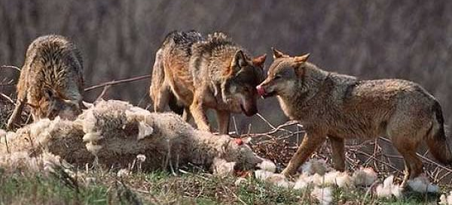
Wolves attack and devour sheep.

Wolf Game, Part 2

- The shepherd organizeshis sheep into small groups, with a new shepherd to guard each group from the wolves.
- Say “Go!” again and stop when the wolves are dead.
- Ask everyone:
“Which is more valuable, a sheep or a human soul?”
“Why did Jethro advise Moses to name shepherds for small groups?”
“Which is better, to have many shepherds leading many small groups of believers, or to have one shepherd leading one very large flock?”
- Discuss why God wants us to form small groups.

Plan with your co-workers additional, optional, activities for the upcoming worship time.
- Explain the leaders’ four duties from #2 above: vision, firmness, thoroughness and kindness.
Let believers give reports of help received from a group small enough to deal with their needs.
- Explain the need for both initiators and managers in God’s work.
- Sit in groups of two or three to pray, make plans and encourage one another.
- Before the Lord’s Supper tell how Jesus fed 5,000 men (Luke 9:12-17). They sat in groups of about fifty each, to make sure everyone was fed. We, too, may eat the Lord’s Supper in small groups, so all believers can join this ‘participation’ in the body and blood of Jesus (1 Corinthians 10:16-17).
- Those who teach children should read study #81 for children.

