Serving One Another in Love
Anchor command. “Through love, serve one another.” Galatians 5:13
Anchor story. Jesus washes his disciples’ feet. John 13:3-15
Anchor verse. “Speaking the truth in love, we are to grow up in all aspects into Him who is the head, even Christ, from whom the whole body, being fitted and held together by what every joint supplies, according to the proper working of each individual part, causes the growth of the body for the building up of itself in love.” Ephesians 4:15-16
Learning goal. See how God wants his people to serve one another in love.
Growth goal. Harmonize the use of the congregation’s different spiritual gifts, as a united body.
Skill goal. Leaders coordinate the body in the way that Scripture requires.
Outcome goal. All members of the congregation actively serve each other.
Basic Study
1. Learn from Jesus’ example to have a servant’s heart, John 13:3-15.
- What did Jesus do as part of his last Passover feast and the institution of the Lord’s Supper that shocked his disciples? Verses 3-5
- What did Jesus tell Peter when Peter tried to stop him from washing his feet? 6-10
- What was Jesus exemplifying for his apostles? 12-15
(Answer: to be humble servants)

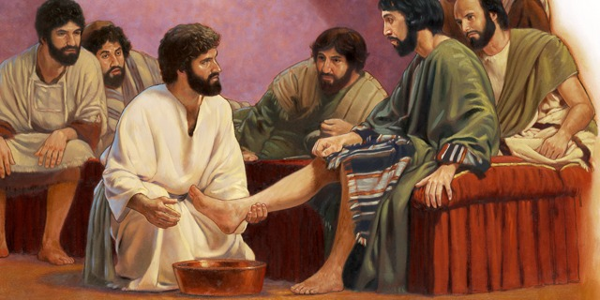
Jesus washes his disciples’ feet

2. During the week the believers take the time to serve people whom they would not normally have served, in some humble way.
3. During worship
- Read the story of Jesus washing his disciples’ feet from John 13:3-15, and ask the questions above. Encourage believers to discuss the answer.
- Pray for the type of humility and serving that Jesus portrayed.
- Ask the children to present what they have prepared
- Memorize John 13:34.
Advanced Study
1. Your congregation is called “the Body of Christ”, because …
Jesus is the Head of the body, Eph. 5:23
Those gifted to discern spirits are our eyes, 1 Cor. 12:10
Those gifted to teach are the mouth Eph. 4:11-12
The Holy Spirit places all believers in the
universal body of Christ, 1 Cor. 12:13, 27.

Those gifted for serving are our hands, 1 Cor. 12:5

Those gifted as evangelists and apostles are feet,
carrying the Good News to all people, Rom. 10:15, Eph. 6:15.

- Read Ephesians 4:11-16 and find the results that God wants our gifts to produce:
- When one uses the gift of teaching properly, what will be the result? 4:11-12
- If teachers simply passes on information, then they fail to help believers do the ministries that God uses to edify the body.
What is God’s final purpose of each one doing their ministry? 4:13
- If anyone fails to grow into the full stature of Christ, as God intends as the result of our ministries, then what will happen to the body? 4:14
- Rather than remaining infants who always chase after new fads, believers should work together, just as the different parts of our body serve each other. Who coordinates this interaction within the body? 4:15-16
- Believers must prepare themselves to serve one another under Christ’s coordination.
Read Romans chapter 12 and find out how they can prepare themselves to serve in the way the New Testament describes.
- What is it that believers must let God transform, in order to use their gifts in the right spirit? Romans 12:2
- Always practice the ‘one another’ commands, to serve one another mutually.
God commands believers over 60 times in the New Testament to serve ‘one another’ in various ways, teaching, strengthening and comforting one another, bearing one another’s burdens, correcting and forgiving one another, confessing faults to one another, and so on.
Read the following examples on the left and write its letter by the ‘one-another’ command to the right that corresponds to each example.
a. Genesis 33:1-10. Many years after Esau sought to kill his brother Jacob who had stolen their father’s blessing, Gen. 27.  b. Nehemiah 4:16-21. Jews who had returned from exile in • Babylon were rebuilding the walls of Jerusalem  c. Acts 18:24-28.  d. Colossians 1:1-4 and 4:2-4. | ___Teach one another, Col. 3:16  ___Work together with, 1 Cor. 3:9; 2 Cor 6:1  ___Pray for one another, James 5:16  ___Forgive one another, Eph. 3:13; 4:32; Col. 3:13
[Answers: a=Forgive. b=Work with. c=Teach. d=Pray]
- A list of over sixty ‘one another’ commands appears in the P-T study #80 titled “Serving One Another in God’s Family”.
- Plan how the believers will serve one another during the week. Suggested activities:
- Visit one another’s homes, to pray, counsel and serve one another.
- Show hospitality to others in your home. Some have entertained angels unaware (Heb. 13:2).
- Work together on projects that benefit the community.
- Provide time for young people to sing and discuss the Word following worship.
- Visit the sick or grieving and pray with them.
- Provide parties and occasional meals for people to build relationships.
- Take people on hikes or trips.
- Provide sports or indoor games, especially for youth.
- Help folks repair their houses or meet other needs.
- Help the believers serve one another during worship times.
We can help people serve one another during the worship time in many ways. Use ways that fit your group and the background of the people. Examples:
Form groups of two or three persons and let them pray one for another, counsel one another, plan their work together, and help each other to serve Christ.
Some congregations’ small groups meet at different times during the week, so that all can find a time to participate. Others have one long meeting once a week. In this case, they should include time for tiny groups to meet. During the main worship time, believers should give testimonies of how they came to know Christ, report healing, and relate other things of interest to the congregation.

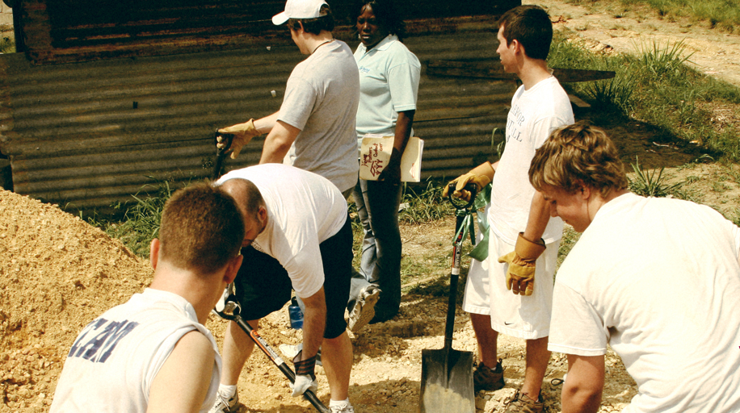
Serving one another in love
- With your co-workers, plan additional, optional activities for the upcoming worship time
- Explain…
Why we are called ‘the Body of Christ.’
What Ephesians 4:11-16 reveals about the results that God expects from all ministries.
The need to prepare for loving service, letting God transform our minds (Rom. 12:1-2).
The ‘one another’ interaction that God requires as we serve one another.
- Announce and prepare the activities that you planned to do during the week.
- To introduce the Lord's Supper, explain: Jesus’ most intimate fellowship with His disciples was during His last night with them before His death. They were eating the Jewish Passover, the most sacred feast of the Old Testament. We now celebrate this feast as the Lord’s Supper.
- Help one another in groups of 2 or 3. Let them pray, confirm their plans and encourage one another.
- Those who teach children should read study #79 for children.

