God Gives Us Shepherds
Our shepherds help us love and
serve one another
Our Father, we thank you for our friends who also love Jesus. Help us to serve you by serving other people. In Jesus’ name, Amen.
Choose any of these learning activities that fit current needs.
- Find in Luke 15:1–7 how Godly leaders care for people who are weak or lost.
A teacher or older child tells the story of the good shepherd, Luke 15:1–7.
Ask the children these questions, and let them answer before you tell the answer:
- Who were the people that liked to listen to Jesus talk?
(Explain that when Jesus lived on earth, the tax collectors were mostly bad people.)
- Who were the people that were jealous of Jesus and often said bad things about Him?
(Explain that the Pharisees were religious on the outside, because they wanted people to admire them, but on the inside, in their hearts, many of them were evil.)
- When the shepherd counted his sheep, how many were missing?
- What did the shepherd do about the one lost sheep?
- What did the shepherd do with his friends and neighbors after he found his lost sheep?
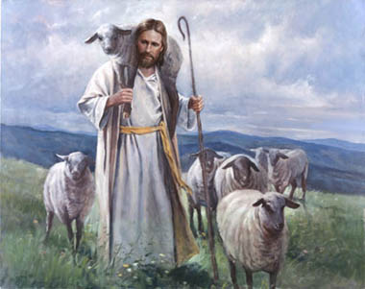
A good shepherd tends his flock and cares for each sheep.
- Dramatize the story of the lost sheep. Rehearse it and present it to the adults during the worship time.
An older child or adult plays the part of Shepherd.
Younger children play these parts:
Neighbors (two)
Sheep (any number)
Lost Lamb Make sounds like sheep, “Baaa!” and crawl on hands and knees.
Shepherd, Sheep and Lost Lamb:
Go slowly from one side of the room to the other.
Lost Lamb: Lag behind, then turn suddenly and quickly crawl out of sight.
Shepherd: Point at each sheep as you count them. Then shout:
“Oh no! One is missing!”
Look around, walk among the people, search behind chairs, and shout:
”Where are you?”)
Neighbors: (Shout) “What are you looking for?”
Shepherd: “I lost a little lamb. I must find it!”
Go out the way the Lost Lamb went, and bring it back (carry it if possible).
Say happily to Neighbors,
“The sheep hat I lost is found! Come celebrate with me!”
Neighbors: Cheer loudly, and walk away with Shepherd.
- If the children present the drama about the lost sheep to the adults then let the children also ask the adults the questions about this story under #1 above.
- Draw a picture of a sheep, and let the children copy it.
Children show their pictures to the adults and explain that we are God’s sheep,
and Jesus is the Good Shepherd who gave His life for us.
Some children might like to copy or colour the picture found at the end of this lesson.
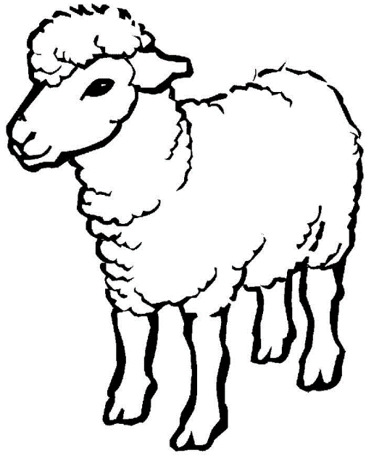
- Let four children recite or sing for the adults during worship these verses (Psalm 78:2, 4, 52 , 72):
I will open my mouth in parables;
I will utter hidden things, things from of old—
We will tell the next generation the praiseworthy deeds of the Lord,
His power and the wonders he has done.
He brought his people out like a flock;
He led them like sheep through the desert.
And David shepherded them with integrity of heart;
With skillful hands he led them.
- Demonstrate the parable of the lost coin.
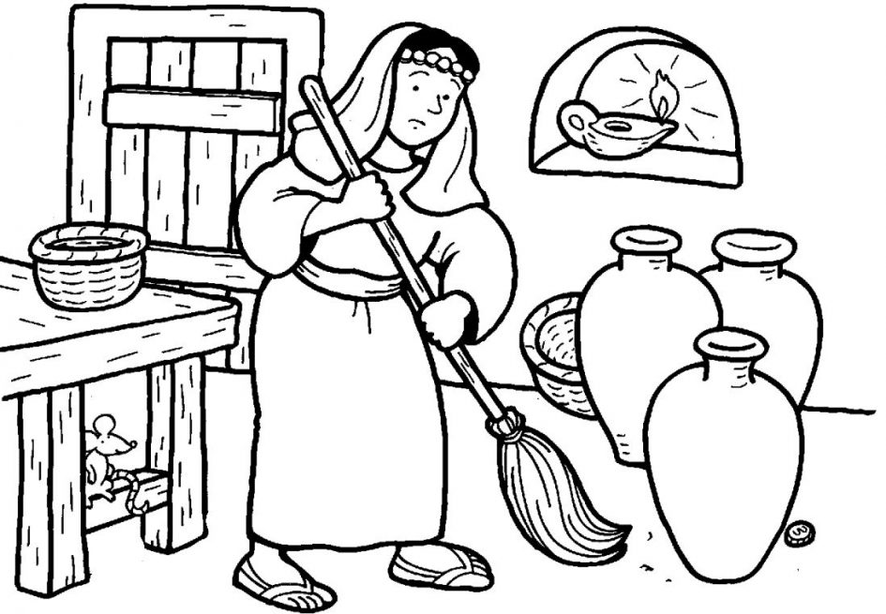
- An older child reads Luke 15:8–10.
At the same time, a girl walks around the room acting like she is looking for something she lost.
- When the reading is finished, the girl gets a broom and sweeps.
- Suddenly she finds the coin, drops the broom and skips for joy.
- : Memorize John 10:27-28:
“My sheep hear my voice, and I know them, and they follow me; and I give eternal life to them, and they will never perish; and no one will snatch them out of my hand.”
Younger children might memorize only verse 27:
“My sheep hear my voice, and I know them, and they follow me.”
- Let an older child pray:
“Father, help us to look after each other and care for one another like a shepherd cares for his sheep.”
A more detailed, 20-minute drama, about God’s shepherds letting his grace flow freely
http://biblestoryskits.com/gods-river-of-grace-cancels-religious-legalism/

