Jesus Opened Paul’s Eyes
Teach Children about Paul’s Vision for Missionary Work
Dear Lord, you gave to Paul a vision to take the gospel to all kinds of people. Please, give us that same vision. We also want to tell everyone about Jesus.
Choose any of these children's learning activities.
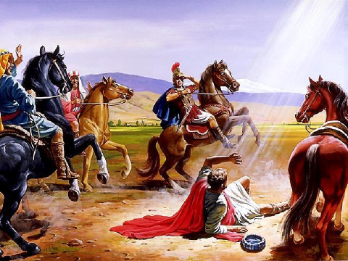
Paul sees a light come out of the sky and hears Jesus talk with him.
- An older child or teacher reads or tells by memory the story of Saul meeting Jesus,
Acts 22:1-22.
This shows how God sent Saul to people in other lands to tell them about Jesus.
After telling the story, ask these questions.
[Answers appears after each question.]
- Why did the people become quiet when they heard Paul speak? (Saul’s name was changed to Paul after his conversion.) [See verse 2. He spoke in their language.]
- What was Saul doing to Christ’s followers, before he met Jesus? [Verse 5]
- What made Saul blind? [Verse 11]
- What instructions did God give to Saul through Ananias? [Verses 15 & 16]
- To where did God send Saul? [Verse 21]
- What did the Jews think of Paul’s vision for missions? [Verse 22.]
- Dramatize parts of the story of Jesus speaking to Saul, Acts 9:1-21.
- Arrange with the main worship leader to let the children present this brief drama.
- Use your time with the children to prepare the drama.
You do not have to use all the parts.
- Older children help younger ones prepare.
- Older children or adults act as:
Narrator Summarize the story and help the children remember their lines.
Saul (later named Paul)
Jesus’ Voice
Ananias
Younger children act as:
Saul’s Companions
Jewish Priests
Jewish Crowds (in Jerusalem)

Narrator Tell the 1st part of the story (Acts 9:1-11), then say,
“Hear what Saul says.”
Saul Point to the priests and say,
“You are the ruling priests.
Give me documents so that I can arrest the followers of Jesus in Damascus.
God wants me to do this!”
Saul and companions
Walk forward.
Suddenly Saul covers his eyes, cries out and falls.
Jesus’ voice (Loudly) “Saul! Saul! I am Jesus, whom you are persecuting.”
Companions Take Saul by the hand and lead him. Say,
“The light blinded him!”
Narrator Tell the 2nd part of the story, Acts 9:12-21. Then say,
“Hear what Ananias says.”
Ananias “Saul! God has sent me to pray for you. Receive your sight!
You will be witness to the non-Jewish people.
Get up and be baptized.”
Saul “Oh! I can see now!
My physical eyes and my spiritual eyes are both open now.
Now I understand that God wants me to take the Good News
about Jesus to others!”
Jewish crowd (Some shout angrily) “Get rid of this traitor.”
(Others shout angrily) “He wants to help Gentiles who are our enemies!”
(Others shout angrily) “Away with him!”
Narrator Thank everyone who helped with the drama.
- If the children dramatize this story for the adults, then let them also pose to the adults the queries listed under #1 above.
- Explain that Paul obeyed his vision to tell people about Jesus, even when he was rejected.
Ask the children to give examples of ways that people try to stop us from obeying God.
- Draw a Picture of a world globe, and let the children copy it.
They can show their pictures to the adults at the next worship time and explain that it illustrates how God loves all the people of the world.
Some children might like to copy or colour the picture found at the end of this lesson.

- Explain that God sends us to people who do not yet know about Jesus,
just as he sent Saul to other kinds of people.
- The Holy Spirit opens our eyes to see the needs of other people, just like he opened Saul’s eyes.
- Jesus gives us a vision for starting congregations in other places, just as he gave this vision to Saul.
- Memorize Acts 1:8.
“You will receive power when the Holy Spirit has come upon you; and you shall be my witnesses both in Jerusalem, and in all Judea and Samaria, and even to the remotest part of the earth.”
- Explain how the four places of Acts 1:8 correspond to places we should go to now:
- Jerusalem corresponds to the community in which we live.
- Judea corresponds to other communities nearby.
- Samaria corresponds to communities of a different culture, nearby.
- The ends of the earth correspond to communities in distant lands.
- Three children each recite one of the verses from Proverbs 3:13-15.
- Older children write poems, songs or dramas about taking the gospel of Christ to neglected people, wherever they are.

A more detailed drama dealing with the perseut9r Saul meeting Jesus on the way to Damascus:
http://biblestoryskits.com/007-saul-finds-jesus-on-his-way-to-damascus-to-imprison-believers-2/

