Antioch Believers Send their
First Missionaries
Anchor command. “Thus it is written, that the Christ would suffer and rise again from the dead the third day, and that repentance for forgiveness of sins would be proclaimed in his name to all the nations, beginning from Jerusalem. You are witnesses of these things.” Luke 24:46-48
Anchor story. The Antioch believers send their first Christian missionaries. Acts 13
Anchor verse. “God be gracious to us and bless us, and cause your face to shine upon us, that your way may be known on the earth, your salvation among all nations.” Psalm 67:1-2
Learning goal. Find how the first missionaries were commissioned and sent, and what were their results.
Growth goal. Appreciate God’s compassionate plan to have people of all nations receive Christ.
Skill goal. Send workers or go as missionaries able to multiply congregations in the Holy Spirit’s power.
Outcome goal. Start a movement for Christ among a neglected people, in which new flocks will multiply.

Basic Study
Learn from the story of the Antioch church that sent the first missionaries, Acts Chapter 13.
- What did the Holy Spirit tell the leaders of the Antioch church to do? 13:1-3
- What happened in Paphos that caused the magistrate to believe? 4-12
- After summarizing Old Testament background for the coming of Christ, what did Paul announced to the Jewish people who lived there? 28-34
- After numbers of both Jews and Gentiles believed in Christ, some Jews refused to believe. What did Paul tell the unbelieving Jews that the apostles, would do as a result of their unbelief? 44-46
- What was the reaction of the Gentiles that heard the gospel? 47-49
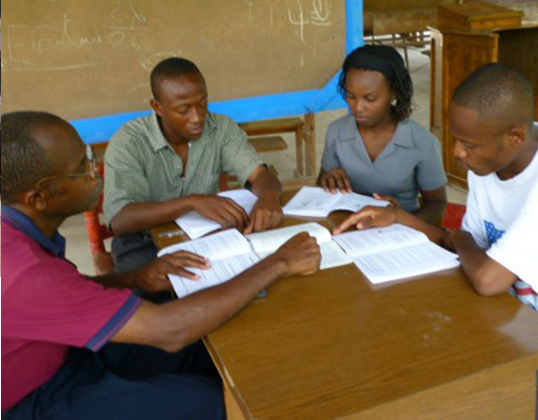
Workers prepare to go on mission to neglected communities.
During the week…
- Pray for a neglected people that your congregation chooses to reach.
- Meet with believers who desire to go to neglected fields, and begin preparing them. Help them immediately to begin practicing faith and needed skills listed in the advanced study, below.
Neglected people are near you and far from you, tribes, communities, cities, and neighborhoods where there are not enough Christians and churches to take the good news about Jesus to their population.
During worship
- Relate the account of the first missionaries sent from Antioch, and ask the same questions as above. Let the people discuss the answers.
- Ask the children to present what they have prepared.
- Memorize together Mathew 28:19-20.

Advanced Study

Find how New Testament churches fulfilled their missionary duty.
- Congregations in Jerusalem, Joppa, Antioch, Rome, Ephesus, Colosse and other cities in the New Testament sent workers to other places to make disciples.
Find in Acts 1:8 four places that Jesus told His followers to go and be witnesses for Him.
[Answer:
Jerusalem (corresponding to your own community, culture and language),
Judea (corresponding to nearby, neglected communities of the same culture),
Samaria (corresponding to other cultural groups nearby),
Ends of the earth (distant people groups with very different cultures).]
New congregations started their own daughter churches, resulting in a chain reaction:
- Find in Acts chapters 13 &14 things that Paul and Barnabas did to start new congregations.
- Find in Acts 14:26-28 what Paul and Barnabas did as soon as they returned to their sending congregation.
- Find in Luke 24:46-48 what things we believers are to proclaim as we do evangelism.

Workers whom you send need the following four missionary skills:
Skill 1. Adapt to another culture.
- Do not insist that new believers worship and do evangelism in the same way that your home congregation does.
- Respect cultural differences. Make no demands on new believers except to obey the commands of Christ and His apostles.
- Only use methods that new believers can imitate and pass on to others.
- Only use equipment that is available to new workers in new congregations.
- Bond with local people. Love them. Make friends among them.
- Workers may have to learn another language.
Skill 2. Evangelize in a way that lets the Good News ‘flow’ from family to family and from friend to friend.
- Tell stories about Jesus’ death and resurrection in a way that new believers can also tell them to their friends.
- Do not make use of equipment or methods that would be difficult for the new believers to obtain or to make use of (except for occasional special events).
Skill 3. Make Disciples of new believers by teaching them to obey the commands of Jesus. His basic commands are:
Repent and believe
Baptize
Celebrate the Lord’s Supper
Love God and others in a practical way
Pray and wage spiritual warfare
Give
Make disciples.
Skill 4. Introduce activities that the New Testament requires new churches to develop:
- Tell others about Jesus; baptize repentant believers, Acts 2:38
- Teach new disciples to obey Jesus’ commands, Matthew 28:18-20
- Worship as a body, and celebrate the Lord’s Supper, Matthew 26:16-28
- Intercede, and do spiritual warfare; families pray together, Eph. 6:10-18
- Cultivate loving fellowship and serve the needy, John 13:34
- Give, and practice Christian stewardship, Luke 6:38
- Teach believers how to serve each other and their community, Eph. 4:11
- Strengthen families, help with problems; correct offenders, 2 Tim. 3:16-17
- Let believers serve one another with different spiritual gifts 1 Cor. 12
- Start congregations nearby and among neglected people, Acts 1:8
- Train leaders in a way they can imitate and train newer leaders, 2 Tim. 2:2

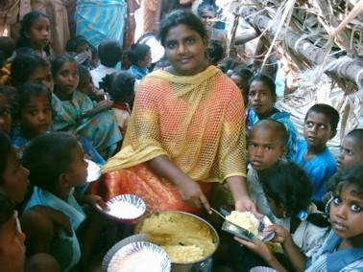
Christians everywhere serve the needy, as Jesus did.

Arrange with co-workers to send workers to neglected people groups.
- Learn which people groups still need congregations that reproduce, to which your workers could go.
- Pray for a neglected people group that your congregation chooses to reach.
- Begin preparing believers who desire to go to neglected fields. Help them immediately to begin practicing needed skills, above.
- Meet with believers who have shown interest in sending workers to neglected fields, and arrange for them to help you prepare and send the workers.
- Decide how the workers will be supported. Will they receive support from your congregation or other congregations? Or will they be self-supporting like Aquila and Priscilla, Paul and others in the New Testament? Plan accordingly.
- Arrange to have weekly prayer for your congregation’s missionaries and for the people that they plan to reach.
- Arrange for reports to be given regularly to the congregation about the progress and problems of the congregation’s missionaries’ work.
- Help shepherds of other flocks also to mobilize their congregations to send workers to neglected peoples.
- Cooperate with other congregations in your region to send workers.

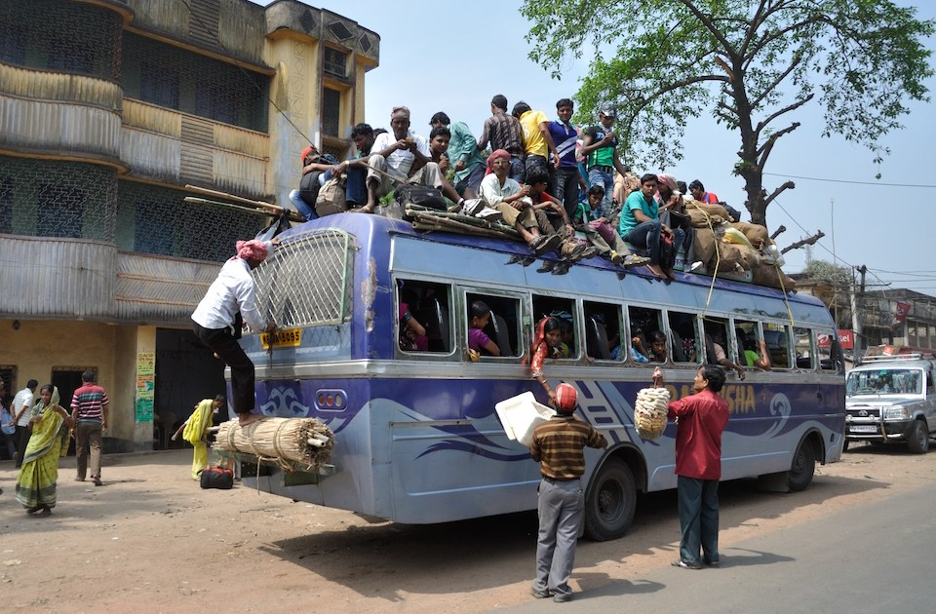
Workers travel on mission to neglected communities.

Prepare with co-workers the next worship.
- Explain how the Antioch believers sent Paul and Barnabas, and how they made disciples.
Explain your congregation’s plans to prepare and send workers.
- Review the skills that the workers who are sent will need to have.
- Let workers who have done mission work in other places tell about it.
- Before the Lord’s Supper, read Jeremiah 31:31-34. Explain that the prophet foretold a New Agreement based on Jesus’ blood that we celebrate when we break bread.
- Form groups of two or three, to pray and discuss a missionary plans.
- Those who teach children should read study #77 for children.

