A Slave Girl Helped her Master from
Another Country
Teach Children to love people who are different from them.
Dear Lord, please use this study to help children to love people who are different from them, including the blind, the deaf, and those from another culture.
Choose learning activities that fit the children’s ages, level of understanding and needs.
- Learn from Naaman the ancient Aramean (Syrian) army commander who had leprosy,
2 Kings 5:1-16.
It tells how a young girl helped her master to discover God’s love for him.
Let an older child read or tell the story from memory. Then ask these questions. [Answers appear after each question.]
What kind of man was Naaman, and what disease did he have? [See verse 1.]
Why was an Israelite girl living with an Aramean family? [See verse 2.]
How did the girl show love for her master, even though she was a slave? [Verse 3]
What did Elisha instruct Naaman to do to be healed? [Verse 10]
How did Naaman feel about Elisha’s instructions? [Verse 11]
How did Naaman expect to be treated by Elisha? [Verse 11. He expected Elisha to perform an impressive miracle, because Naaman was a rich and important person.]
Who persuaded Naaman to follow the instructions of the prophet? [Verse 13]
Why did Elisha not ask for payment for healing Naaman? [Verse 16. Elisha wanted Naaman to understand that God did not heal him because he was rich or important, but because he had trusted God and was obedient.]
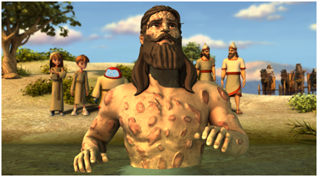
Naaman from Syria suffered with a skin disease, till he obeyed Elisha and bathed in the Jordan River.
- Dramatize the story of Naaman’s healing. If you need, do only parts of it.
Arrange with the main worship leader for the children to present this drama.
Let the older children help the younger ones prepare.
Older children or adults play these parts: Girl, Wife, Naaman. Hold a piece of paper.
Gehazi, King of Israel, Elisha, Narrator.
Younger children play the parts of Naaman’s Servants.
Narrator Tell the story from 2 Kings 5:1-16. Then say,
“Hear what the servant girl says to Naaman’s wife.”
Girl “Mistress, my master, Naaman, is sad because he has leprosy.
I want to help him. Please beg him to go see God’s prophet in Israel.”
Wife Go to Naaman and say,
“Husband, you have tried everything. Go find that prophet in Israel.
Maybe he can heal you!”
Naaman “I will ask our king of Aram to send a letter with this request.”
(Go with your Servants to the King of Israel. Bow and hand him the paper.)
Say, “Esteemed King of Israel!
Please read this request from my king of Aram. He asks you to cure my leprosy.”
King of Israel “Am I God, that I can cure leprosy?
Your king seeks a quarrel with me!”
Naaman and Servants
Walk sadly away, with heads down.
Some Servants say: “How sad!”
(Others say) “No one can cure the bad disease.”
Gehazi Go to Naaman and bow.
“Captain Naaman, my master Elisha the prophet
will show you the power of the One True God.
Come and see him!”
Naaman Say to your Servants,
“Now we will see someone use great power,
because I am a powerful man and I can pay much money for it!”
Gehazi “Naaman, my master said to tell you to go and
bathe seven times in the Jordan River.”
Naaman (Angrily) “No! I will not bathe in that muddy water!
Our rivers are cleaner!”
Servants (Some say) “If he had said to do something hard, you would have done it!”
(Others say) “Please go.”
(Others say) “Please do what the prophet of God says.”
Naaman Pretend to dip yourself seven times in the river.
Servants (Some say) “Look! His leprosy is gone!
(Others say) “He is cured!”
Naaman Go to Elisha and say,
“I will pay you well for this great miracle!”
Elisha “No! God needs no money.
He healed you, to show that he is the One True God.”
Naaman Go to the girl, bow and say,
“Thank you, little girl, for helping me to know the One True God.
You cared for me, even though I took you as a slave from your country.”
Narrator Thank everyone who helped with the drama. Thank the adults for listening.
- If the children dramatize this story for the adults, then let them also ask the adults the questions under #1 above.
- Let the children give other examples of people who are different from us, whom we can love and serve.
- Let three children each recite two verses from Job 42:1-6.
- Let older children write a poem or song that uses words or ideas from Psalm 67 about God’s love for people of all the nations.
They might do this during the week.
- Memorize Psalm 67:2-3.
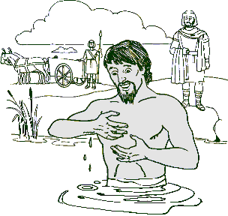
- Let the children copy a picture of a man in a river.
Let the children show their pictures to the adults during the worship time.
Let them explain that this shows that God uses the love of little children to help people know that He heals and forgives sin.
Some children might like to colour the picture found at the end of this lesson.
- Let an older child pray:
“Dear Lord, please help us to love people who are different from us. Help us to love the blind, the deaf, and folks of other cultures and religions.”
A more detailed drama, about another prophet, Elijah, defeating false, idolatrous prophets:
http://biblestoryskits.com/005-elijah-defeats-baals-prophets-on-mt-carmel-2/

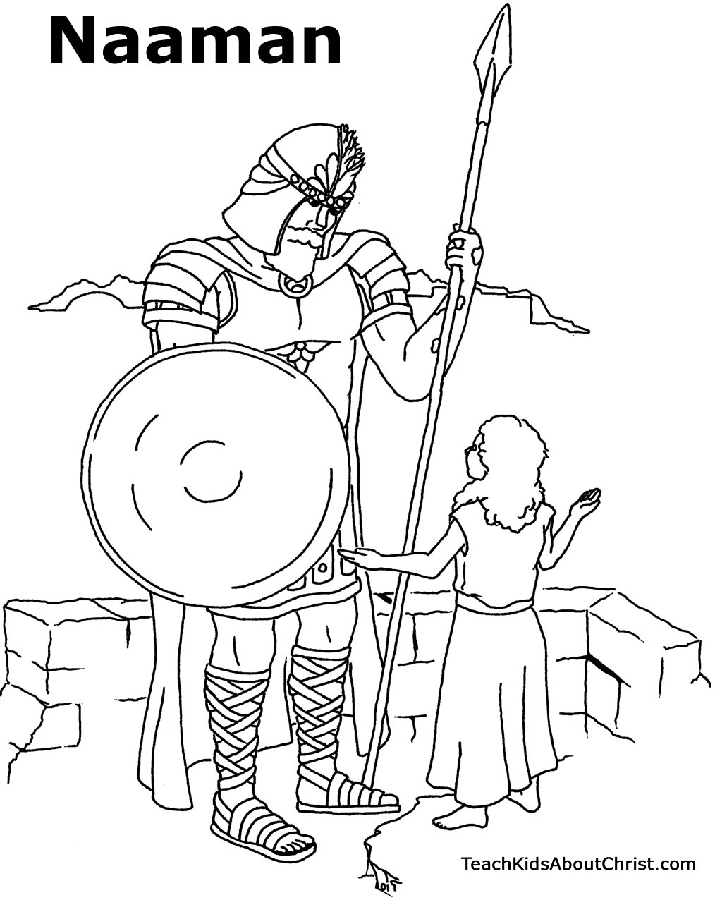
An Israelite slave girl told her Syrian captor about the LORD’s prophet, Elisha.

