Traveling Teams Reach Neglected Areas
Anchor command: Go make disciples. “I aspired to preach the gospel, not where Christ was already named, so that I would not build on another man's foundation.” Romans 15:20
Anchor story. Jesus sends workers to the villages of Israel. Luke 10:1-20
Anchor verse. “The Holy Spirit said, ‘Set apart for Me Barnabas and Saul for the work to which I have called them.’ Then, when they had fasted and prayed and laid their hands on them, they sent them away. Acts 13:2-3
Learning goal. Find how the apostles and their co-workers worked together to reach the lost.
Growth goal. Practice working as a team in all aspects of Christian ministry.
Skill goal. Form apostolic traveling teams and empower them to plant churches.
Outcome goal. Several new teams are multiplying churches.
Basic Study

Dear Lord, help us who believe to join our efforts and work as a team like Jesus and His apostles did.

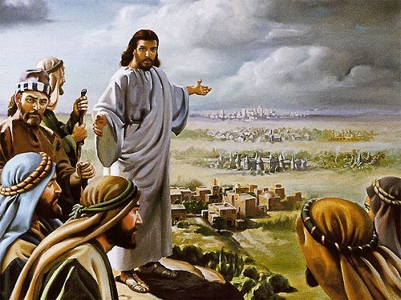
Jesus commissioned teams
Learn from the account of the seventy that Jesus sent to Israel’s villages, Luke 10:20.
- Why was it necessary first to pray to the Lord of the harvest for more workers?
Luke 10:1-2
- To what animal did Jesus come pair the dangers that they would face? Luke 10:3
- How much baggage allow them to take along? Luke 10:4
- In what type of home where they to stay? Luke 10:5-8
- What were the disciples to do and to proclaim? Luke 10:9
- What were they to do if the people resisted them? Luke 10:10-11
- What did Jesus tell them to rejoice about, when they returned to him, rather than the fact that demons were subject to them? Luke 10:17-20
During the week…
- Form teams of workers willing to go to neglected people.
- Send the teams with prayer for the power of the Holy Spirit.
- Have the teams report what God has done when they return.
During worship…
- Tell the story of Jesus sending out his disciples, Luke 10: 1-20, and ask the questions above. Encourage believers to discuss the answers.
- Lay hands on volunteer workers. Pray and commission them with God’s power.
- Let the children present what they have prepared.
- Memorize Proverbs 11:14.
Advanced Study

Prepare with God’s Word to help believers serve together in task groups,
as Barnabas did. He was a conscientious team worker.
- Barnabas cared for other people’s needs, and brought people together to work as a team. Find in Acts 4:34-37 what he did to provide for people in need.
- Find in Acts 9:26-29 how Barnabas helped believers in Jerusalem to accept Paul as a fellow worker.
- Find in Acts 13:2-5 who Barnabas’ two team members were, that the Antioch church sent.

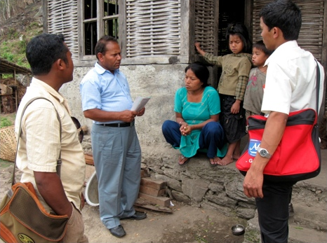
A gospel teams visits homes

- Teamwork rather than individual effort in Scripture
- Moses worked closely with the elders of the tribes of Israel, and God used him mightily. However, when he acted alone without other elders, he let the people annoy him and angrily hit the rock from which God had promised to produce water (Numbers 20:2-12) God punished him.
- King David worked closely with soldiers, priests and prophets, and God used him mightily. Acting alone, he took Uriah’s life and wife, and God punished him (2 Samuel, chapters 11–12). Acting alone, he unwisely counted the number of men of military age to compare the strengths of the northern and southern tribes of the united kingdom, and God punished him (2 Samuel 24).
- King Jehoshaphat consulted God’s prophets in ancient Israel to make decisions. He also sent officials to work as a team to teach the Word of God in the villages (2 Chronicles 17:7-9). However, other kings acting alone made foolish decisions, such as when Ahab told Jehoshaphat that he would hide his identity during the battle (1 Kings 22:30-38). He died a shameful death.
- The prophet Elijah normally worked with a task group of prophets whom he trained. However, when he was fleeing from the evil queen Jezebel he unwisely left his servant behind and went on alone. He began to feel disheartened and begged God to take his life (1 Kings 19).
- Jesus formed an apostolic team of twelve workers, of whom Peter later became leader. They scattered after Jesus’ arrest. Separated from them, Peter denied Jesus three times. (Mark 14:66-72).
- Paul, except when a prisoner, travelled with other workers. When his team mate Titus was absent, he felt sad (2 Corinthians 2:12-13). When Titus joined the task group again, he was greatly comforted (2 Corinthians 7:5-7).
- Christ and the apostles formed only temporary teams.
- The teams were task groups, focused on a specific task.
- When the task was done, they moved on, often with different team members.
- They trained their team members, and then let them form their own teams.
- An example of a temporary team as the Antioch team, Barnabas, Paul and, for a brief time, John Mark. This team stayed to do only for one missionary trip.
- Read how an apostolic task group formed and what they did, in Acts chapters 13 & 14.
- Find in Acts 13:1-3 what God did to help the Antioch church become a sending church.
- Find in Acts chapters 13 and 14 different people who opposed the task group and the results.
- Find in Acts chapter 14 how the task group established leaders in the new congregations.
- Find in Acts 14:26-28 how they kept their sending church informed about what happened.
- Plan with co-workers during the week, to form teams that work together.
- Pray for help to prepare workers that God has given to your congregation to serve as its apostles ('sent ones' who go to neglected people), as he promised to do in Ephesians 4:11-12.
- Decide with your co-workers who among you is like Barnabas, who helped Paul get started and helped his congregation become a sending church. Pray and lay hands on them.
- Cooperate with other churches to send out an apostolic team.
- Train new church planters with Shepherd’s Storybook from http:/paul-timothy.net
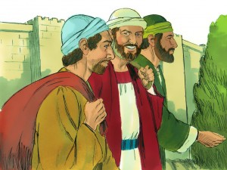
Paul and Barnabaa invited John-Mark to join their team
- Additional, optional activities during worship.
- Before celebrating the Lord’s Supper, ask everyone to confess their sins privately to God.
- Have someone tell the story in Numbers. 9:1-14 and explain the importance of the Passover Feast for the people of ancient Israel and how it corresponds to the Lord's Supper.
- Form groups of two or three persons to pray and to assure, instruct or correct one another in some way. Pray for church planting teams that you have, or will have.

