A Team Helped a Roman Army Officer
and his Friends Know Jesus
Dear Lord, please help our children to work together, helping one another in love, as they serve you and other people.
Choose from any of these children's activities.
- An older child or teacher reads from Acts chapter 10 or tells by memory about Cornelius, an officer who led Roman soldiers.
This story tells how Peter and his co-workers from Joppa worked together
to start the first church of Gentile believers in another city.
After telling the story, ask these questions. [The answers appear after each question.]
What kind of man was Cornelius? [See verse 2]
Who were the team members that went with Peter to tell Cornelius about Jesus? [Verse 23]
What did God teach to Peter through a dream, about Peter’s attitude toward Gentiles (non-Jews)? [Verse 28]
Who was waiting with Cornelius to hear the gospel? [Verse 24]
How soon did the Holy Spirit come upon Cornelius and his group? [Verse 44]
How soon were they baptized? [Verse 48]
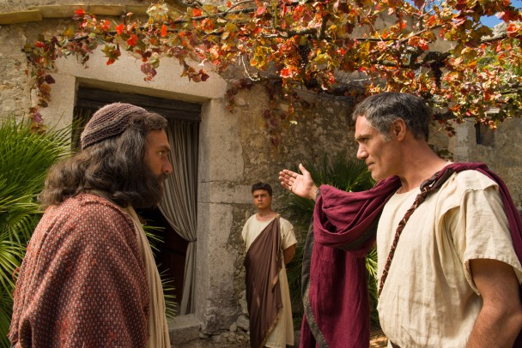
Peter, a Jew would not enter a non-Jewish house, until God showed him a vision.
- Dramatize the story of Peter and Cornelius, from Acts chapter 10.
Arrange with the leader of the main church worship to have the children present this drama.
You do not have to do all the parts of the drama.
Use your time with the children to prepare the drama.
Let the older children help the younger ones prepare.
Older children and adults play these parts:
Narrator
Cornelius
Peter
Voice of God. Voice of God holds a folded bed sheet.
Younger children play these parts:
Animals (in Peter’s dream)
Believers
Soldiers (two): carry long sticks that represent spears.
Let the people who watch the drama be Cornelius’ friends.
Narrator Tell the first part of the story, from Acts 10:1-8. Then say,
“Cornelius is praying quietly. Hear what God says to him.”
Voice of God “Cornelius, I have heard your prayers.
I have seen the way you serve me.
Go and find my servant, Peter.”
Narrator Tell the second part of the story, from Acts 10:9-23. Then say,
“Peter is praying quietly. Hear what God says to him.”
Voice of God Hold up the bed sheet for all to see.
Then, spread it out on the floor. Then say,
“Peter, I know that you are hungry.
Kill and eat these animals.”
Animals Crawl around on the sheet, on hands and knees.
Some makes loud pig’s noises.
Others hiss like snakes.
Peter “I cannot, Lord!
It would break our Jewish customs to eat snakes and pigs!”
Voice of God “Do not call anything unclean that I have made clean.
Kill and eat.”
Peter and Voice of God
Peter says two more times that he cannot eat unclean meat,
and each time the Voice of God answers,
“I have made the animals clean. Kill and eat.”
Soldiers Go to Peter and say,
“Come to Cornelius’ house in the city of Caesarea.”
Peter “God has told me to go with you, even though my culture forbids me
to enter the house of a Gentile like Cornelius.
Come inside and spend the night here.”
Believers “Peter, since we, too, believe in Jesus,
let us go with you to Caesarea and help you.”
Narrator Tell the third part of the story from Acts 10:24-48. Then say,
“All of you who are watching this drama now represent
Cornelius’ family and friends.
Listen to what Peter says.”
Peter “Cornelius, you sent for us to tell you about Jesus.
God showed me in a dream that He accepts you and your culture.
Jesus died and rose from the dead to save you!”
Cornelius “The Holy Spirit has convinced us that we are sinners and we need Jesus!”
Peter Point at Cornelius’ friends (all who are watching the drama). Say,
“Look, brothers, they have received the Holy Spirit!
Let us baptize them now!”
Narrator Thank everyone who helped with the drama.
- If the children dramatize this story for the adults, then let them also ask the adults the questions under #1 above.
- Draw a Picture of a pig. (If your culture does not allow pigs, then do not draw this picture.)
Let the children copy it and show their pictures to the adults at the next worship time.
They can explain that this illustrates how God calls people of all cultures to be saved, no matter what they eat.
Some children might like to colour the picture found at the end of this lesson.
Jews do not eat pork.
- Ask the children to give other examples of things that make it hard to talk with people of other cultures or castes about Jesus.
Older children might draw a Roman soldier, to remind them of how Cornelius, a good man, believed and helped his friends to hear about Jesus.
- Memorize 2 Chronicles 16:9 (first part)
“The eyes of the Lord move to and fro throughout the earth, that He may strongly support those whose heart is completely His.”
- Let four children each recite one verse from Psalm 67:1, 2, 3 & 4.
- Older children write poems, songs or a short drama, during the week, about working together as a team to tell people of other cultures about Jesus.
- Let an older child pray:
“Lord, we praise you for saving people of all nations from sin and death. Help us to love them and tell them about Jesus, even if they have different cultures from us.”
A more detailed drama, dealing with Peter taking the gospel to non-Jews:
http://biblestoryskits.com/008-peter-takes-the-lord-jesus-christ-to-non-jews-2/

