Help Anyone who Needs Help
A Good Samaritan Helped a Stranger
“Our Father, help us to love our needy neighbors in a useful way.”
Choose activities that fit your children's background, and local customs.
- Learn from Luke 10:25–37 how God expects us to treat other people,
even if we do not know them or like them.
Let a teacher or older child tell the story of the Good Samaritan, Luke 10:25–37.
Explain that the injured man was a Jew, and the person who showed real love was a Samaritan from a different community.
The Jews and the Samaritans lived in the same general area but did not like each other.
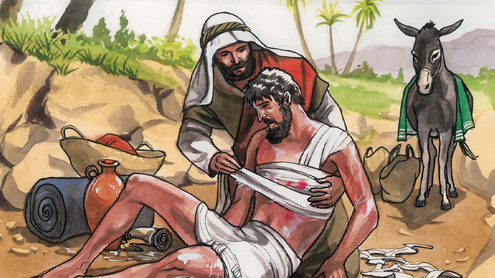
Robbers had beat a traveler and had left him to die.
Ask the children:
- How many people passed the injured man before the Samaritan came along?
- The priest and Levite were religious people of the man’s own race.
Why do you think that did they not stop to help him?
- The Samaritan was of a different race that did not like the people of the injured man. What did he feel for the man?
- What did the Samaritan do for the man?
- Whose example in this story did Jesus say we are to follow?
- Children may like to copy or colour the picture found at the end of this lesson.
- Act out without words this story of the Good Samaritan from Luke 10:25-37.
Rehearse it first and present it to the adults during worship time.
Simply act out the actions. You might ask adults to help.
Younger children play these parts (They have no spoken dialogue. They simply act out
what they do without talking):
Thieves (any number)
Injured Jew,
Priest
Levite
Older children or adults play these two parts:
Samaritan
Your only conversation is at the end when the Samaritan tells the innkeeper,
“Take care of him; and whatever more you spend, when I return I will repay you.”
You may act it out without dialogue also, simply going through the motions.
Donkey
- If you have materials to do so, then put a blanket on the donkey’s back as he bends down.
- You might have two boys be the donkey, one is the front end; the other, bent over, is the rear. Put a blanket over both. Practice walking this way.
- Pin on a tail (old rags or straw).
- Fasten to his head long ears made of cardboard or cloth.
- Let the donkey bray, “hee-haw,” once in a while.
To practice, simply read through the story and have the actors do what it says.
To act parts without speaking, let your feelings show on your face
and in your movements.
Do not tell the adults at first what story you are dramatizing.
Ask the adults to guess which story it is.
- Draw a donkey to illustrate how we help one another carry each other’s burdens or troubles.
- Let three children each recite one of these three verses from Psalm 41:1–3:
Blessed is he who has regard for the weak;
The Lord delivers him in times of trouble.
The Lord will protect him and preserve his life;
He will bless him in the land
And not surrender him to the desire of his foes.
The Lord will sustain him on his sickbed.
And restore him from his bed of illness.
- Demonstrate letting our light shine, with a candle.
Light a candle and place it on a table.
Put a large basket or box upside down over it, to hide its light.
Do not use anything that might easily catch on fire.
Read Matthew 5:14–16, then uncover the candle.
Explain that sincere love for God moves us to serve needy people.
- Memorize Matthew 5:16:
“Let your light shine before men in such a way that they may see your good works, and glorify your Father who is in heaven.”
- Let an older child pray:
“Father, help us to see the needs of the people around us. Help us to be quick to help them, whether or not we know them. Help us to show love in useful ways to them. Help us to love those who are not friends or family, even enemies. In Jesus’ name, Amen.”

A more detailed drama, showing how a good Samaritan showed practical love to his neighbor:

http://biblestoryskits.com/011-a-samaritan-shows-practical-love-to-an-ailing-enemy-2/

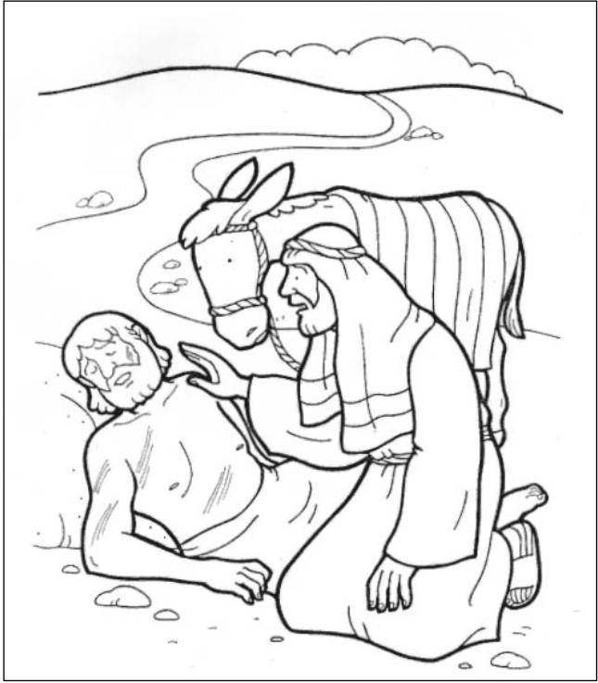
A despised Samaritan showed himself to be a good neighbour to an injured man.

