Greek Christians Gave to Help
Poor Judean Christians
Teach children to meet needs of others wherever they live
“Dear Lord, help us to be wise and generous when we work together to help needy people.”
Choose any of these children's learning activities that fit their ages and needs.
- An older child or teacher tells how the Corinthians helped poor people far away.
Background:
- Paul was serving as a missionary when he heard that believers in Judea were hungry because of a famine. He asked believers in other countries to help those people.
- Their giving project was a big one, and many congregations collected money for it for a long time.
- The believers also made sure that the right people took it and provided for the needs of the starving Christians in Judea.
Read 1 Corinthians 16:1-4 or tell by memory what the apostle Paul wrote to the Corinthians about how to collect their offering. Then ask:
- What other churches besides in Corinth gave for the poor? (Answer: See verse 1)
- In what way did the believers give for their collection? (Verse 2)
- Did the people give their offering all at once? (Verse 2)
- How did the church carefully supervise how the money was sent? (Verse 3)
- How important was this offering in Paul’s opinion?
(Verse 4. Paul was busy starting new congregations, but he took time to care for those who suffered in Judea and to make sure that offerings were well managed.)
Explain what Paul told the Corinthians about how believers responded to his plea to give:
- Paul wrote a second letter to them and told how many believers were giving generously (2 Corinthians 8, verses 1-7, 10-11 and 19-21).
- Very poor believers in Macedonia, a small country north of Greece, gave very sacrificially.
- The poor Macedonians begged the apostles with much urging to let them give.
- The Corinthians gave a little each week, setting it aside for the apostles to take to Judea.
- Paul told them to name trusted men to help take their gifts to Judea, to avoid suspicion.
- The purpose of the offering was not only to feed the starving people, but also to glorify God.
- Dramatize parts of the story of the “Great Offering”.
Let older children help the younger ones.
Arrange for the children to present the drama during the main worship time.
Older children or adults play these parts: Narrator. Summarize the story and help children to recall what to say and do. Paul, Titus, Enemy
Younger children play these parts: Poor People, Corinthians. Have pebbles or coins for the offering. Macedonians. Also have pebbles or coins for the offering.
Narrator Tell the first part of the story (what Paul wrote in 1 Corinthians 16:1-4). Then say, “Hear what the poor people in Judea say.”
Poor people (Some say) “Our crops failed.”
(Others say) “Within a year we will starve to death.”
(Others say) “May God help us!”
Narrator “Meanwhile, far away in Corinth, hear what Paul says to the Christians.”
Paul “We must give help to those who are starving in Judea.
Set aside a little money each week, and give it as an offering each Sunday.
After a time, I will come and take the offering to them.”
Narrator “Hear what the Enemy of Christ tells his demon helpers.”
Enemy “Oh no! The congregations are cooperating!
We must stop them from working together!
They are giving too much and helping each other.
We must discourage them.”
Corinthians Pass around a box to one another; pretend to give offerings.
(One says) “I am so glad we can help a little each week!”
(Another says) “I kept an egg each day from my hens, and sold them.
Here is the money for the offering.”
(Another says) “I made some shawls and sold them.”
Enemy Stomp your foot angrily, and say,
“Curses! We failed to cause them to give a huge offering.
So, we will tempt them to be careless with the money.
I will create suspicion about the persons who take it to Judea.
They might steal some of it! Ha, ha, ha!”
Corinthian Point to two of the Corinthians.
(One says) “You two people will handle the money.”
(Another says) “We trust you to take the money.”
(Another says) “Please keep a careful record of everything we give you!”
Narrator Tell the second part of the story,
“A long time later Paul visited Macedonia. Hear the Macedonians.”
Macedonians “Paul, you said that our brothers and sisters in Judea are starving.”
”We are poor, but we, too, want to help them.”
”Please let us give also for the Great Offering,
like the Corinthians are doing!”
Paul “May God bless your sacrifice and generosity.
I will send Titus to get your offering.”
Narrator “Titus visits the Macedonians. Hear what he says.”
Titus “You Macedonians will be happy to finish this great project that all the congregations have begun together.
I have come for the offering with other trusted brothers.
Do you have men ready to go with me to take the money to Judea?”
Macedonians (One says`) “Yes. We want to do our part to help the people in Judea.”
(Another points to two Macedonians.)
“These two brothers are trustworthy. They will go with you.”
(The two designated Corinthians and the two designated Macedonians go to the Poor People, and pretend to hand them the gifts.)
Poor people “Oh, we thank you, and we thank God!
Now we will not starve to death!”
Enemy “Curses! We failed!
They handled the money too wisely to stir up suspicion.
But I will try again!”
Narrator Thank those who helped.
- If the children present the drama to the adults, then let the children ask the adults the questions under #1 above.
- Ask the children to give other examples of projects that congregations can do together to serve God, and discuss their answers.
- Let older children draw an accounting book with columns “Income” and “Expenses.”
- Under ‘Income’ write things they might sell to earn money to give the poor.
- Under ‘Expenses’ in the second column write things they might buy for the poor.
- Some children might like to copy or colour the picture found at the end of this lesson.
- Younger children draw a hand holding coins (like the picture at the top of this study).
Let the children explain to the adults at worship time that the pictures show how congregations work together wisely and generously to help people in great need.
- Memory work.
Older children memorize 2 Corinthians 9:6-7:
“He who sows sparingly will also reap sparingly, and he who sows bountifully will also reap bountifully. Each one must do just as he has purposed in his heart, not grudgingly or under compulsion, for God loves a cheerful giver.”
Younger children memorize only the last part,
“God loves a cheerful giver.”
- Let three children each recite one of the verses from Matthew 6: 2-4.
- An older child prays:
“Lord, you give to us many good things. We want to give to needy people and to those who take your Word to faraway places. Help us work together to honor you with what we have.”

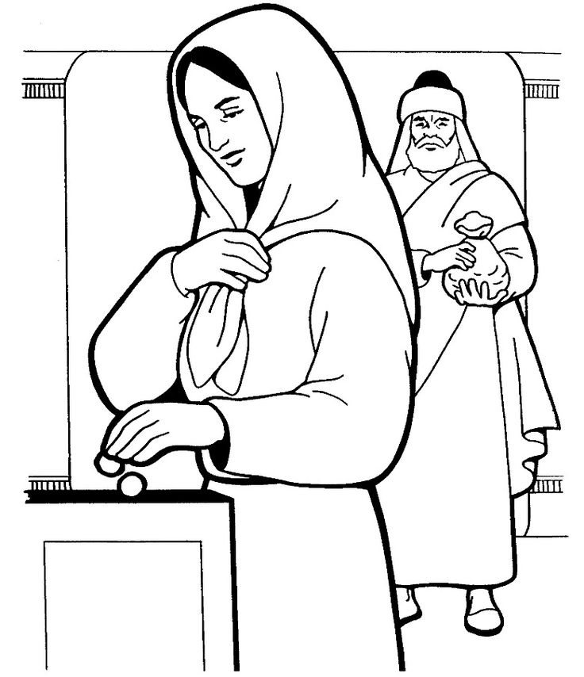
Macedonians brought gifts each week to give to the poor in Judea.

