Appoint Deacons to Serve the Needy
Anchor command. “Let us not love with word or with tongue, but in deed and truth.” 1 John 3:17-18
Anchor story. Jesus’ parable about sheep and goats. Matthew 25:31-46
Anchor verse. “Select from among you seven men of good reputation, full of the Spirit and of wisdom, whom we may put in charge of this task.” Acts 1:3
Learning goal. Find what Jesus and the apostles taught and did concerning the needy.
Growth goal. Hearts are moved with the compassion of Christ for those in need.
Skill goal. Care for the needy in a way that does not cause them to become so dependent on the church’s help that they fail to try to help themselves.
Outcome goal. Believers and congregations are showing love in a practical way by caring for both believers and nonbelievers who are in need.
Lord Jesus, raise up deacons in your Body and help us to appoint them and encourage them as they serve the needy

Basic Study
Learn from Jesus’ parable of the sheep and goats. Matthew 25:31-46
- When will Jesus judge the people of all nations, to assess their works on earth? Verse 31
- To what two animals does Jesus compare those whom he judges? 32
- Which of the two animals will Jesus put to the place of honor on his right? 33-34
- What had the “sheep” done that got Christ’s approval? 35-36
- How do we know that when people serve the needy, they are actually serving Jesus? 34-40
- How do we know that when people neglect the needy, they are actually neglecting Jesus? 41-45
- What is the fate of those who neglect the needy, and thus neglect Jesus? 46
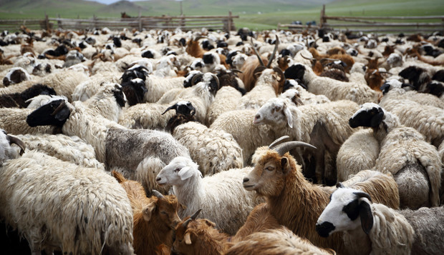
Sheep and goats
If you want to act out this story, then download a script from www.biblestoryskits.com. Click on “Jesus’ Life,” then on “Jesus Parts Sheep from Goats.”

Good works are essential to salvation – not as its cause but as its effect:
True faith in Christ results in good works. We are not saved by doing good works. Rather, our salvation results in our doing of good works:

“By grace you have been saved through faith; and that not of yourselves, it is the gift of God; not as a result of works, so that no one may boast. For we are His workmanship, created in Christ Jesus for good works, which God prepared beforehand so that we would walk in them.” Ephesians 2:8-10

During the week…
- Pray with your colleagues that the Lord will raise up deacons who will serve the needy with joy and strength from the Lord.
- Plan with your co-workers to appoint and encourage deacons who will take the lead in serving needy people.
- Assess the practical needs of the believers and the community that could be met by your congregation.
During worship…
- Tell the story of the sheep and goats, and ask the same questions as above. Urge the believers to discuss the answers.
- Explain Acts 6:1-7.
- Have the congregation commission deacons, if they have not already done so.
- Ask the children to present what they have prepared.
- Memorize together Mark 10:45. “For the Son of Man did not come to be served, but to serve, and to give His life a ransom for many.”

Advanced Study
Congregations have two kinds of servants: elders and deacons like Stephen and Phoebe.
Find in Acts 6:1-6 [Answers are in italic]…
- The main work of elders and the main work of deacons.
[Elders serve the Word of God; deacons meet practical needs.]
- How believers get appointed as deacons.
[The congregation chooses them and the leaders lay hands on them.]
Find in Romans 16:1-2 what the Apostle Paul thought about deacons.
- Can a woman become a deacon? [16:1.]
- What kind of reputation did Phoebe have? [16:2.]
Find in Philippians 1:1-2 two kinds of workers in the church of Philippi. [Elders and deacons]
Him Find in 1 Timothy 3:8-13 …
- Some qualifications for choosing deacons [Verses 8-11.]
- Some rewards of serving as deacons [Verses 12-13.]
Find in 1 Peter 4:8-11 …
- Two classes of spiritual gifts. [Speaking and serving.]
- What command of Jesus do deacons obey. [Love.]
- What God gives to those who serve as deacons. [Grace and strength.]
- You and your co-workers discuss how to put into practice what you have learned.
- If you have heard complaints from some believers, such as happened among the Jerusalem believers in Acts 6, then talk together about what could be done to solve their problem, and who will help.
- Talk together about practical things the members can do for the congregation. For example, what can deacons do, to give you and your co-workers time to learn the Bible and, to pray for all the believers, and to plan how to help the congregation to grow.
- Talk together about believers who have gifts and passions to help others. Then pray for those believers by name.
- Contact those believers and talk with them about their vision and intention to help meet practical needs of believers and community members.
- Be careful: do not plan how to get the believers to work without pay in your garden or business.
- Plan with your co-workers additional activities for the up-coming worship time.
- Read or tell the story of the first deacons in Acts 6:1-6.
- Explain 1 Timothy 3:8-13:
“Deacons likewise must be dignified, not double-tongued, not addicted to much wine, not greedy for dishonest gain. They must hold the mystery of the faith with a clear conscience. And let them also be tested first; then let them serve as deacons if they prove themselves blameless. Their wives likewise must be dignified, not slanderers, but sober-minded, faithful in all things. Let deacons each be the husband of one wife, managing their children and their own households well. For those who serve well as deacons gain a good standing for themselves and also great confidence in the faith that is in Christ Jesus.”
- Read or tell the story of Dorcas, Acts 9:36 – 42. Talk about how the Lord Jesus loves to serve his people through those who enjoy serving the needy.
- Let the believers share testimonies about how they have been served by other believers.
- If a believer has accepted to serve as a deacon, then you and the elders can lay your hands on them during the worship meeting and pray for them.
- To introduce the Lord’s Supper, read or cite from memory, Mark 10:43-45.
- Form small groups of two or three people, to pray, confirm activity plans and encourage one another.
- Those who teach children should read study #71 for children.

