Spread of Christianity from 1600 till Now
Note: Please, read studies 66 and 67 about the ancient history of Christianity, before you read this study. Those who teach children should read children’s study 68.
Anchor command. Go to neglected communities: “I aspired to preach the gospel, not where Christ was already named, so that I would not build on another man's foundation.” Romans 15:20.
Anchor story. The Apostle Paul’s first missionary journey. Acts chapters 13 and 14.
Anchor verse. “May your way be known on the earth, your salvation among all nations. Let the peoples praise you, O God; let all the peoples praise you.” Psalm 67: 2-3
Learning goal. Grasp the scope and different methods of missionary outreach during the last four centuries.
Growth goal. Contribute continually in some effective way to mission outreach’
Skill goal. Plant or train others to plant the kind of congregations that multiply rapidly.
Outcome goal. Believers and congregations fervently support mission work among neglected people, praying and sending workers
Lord Jesus, please help me and my flock to learn what you have been doing in the world, and what part we should play in taking the Good News to others.

Basic Study
Learn from Paul’s first missionary journey, Acts chapters 13 and 14. Pray for God’s help.
- What people sent Paul and Barnabas on their missionary trip? 13:1-3
- What was the response of the people in general in Antioch of Pisidia to the gospel message? 13:42-44
- Why did Paul and Barnabas turn from the Jews to the Gentiles? 13:44-46
- What happened in the city of Lystra that caused the people to start worshiping Peter and Barnabas as gods? 14:8-15
- What did unbelieving Jews who had come from Antioch and Iconium do to Paul in Lystra? 14:19
- Paul and Barnabas had proclaimed the gospel in several cities, and later returned to them. What was their purpose for this second visit? 14:21-23
- When Paul and Barnabas returned to their own congregation in Antioch, what did they do? 14:26-28
During the week visit people who have never heard the gospel in a meaningful way, pray for them and their needs, and tell them about Jesus.

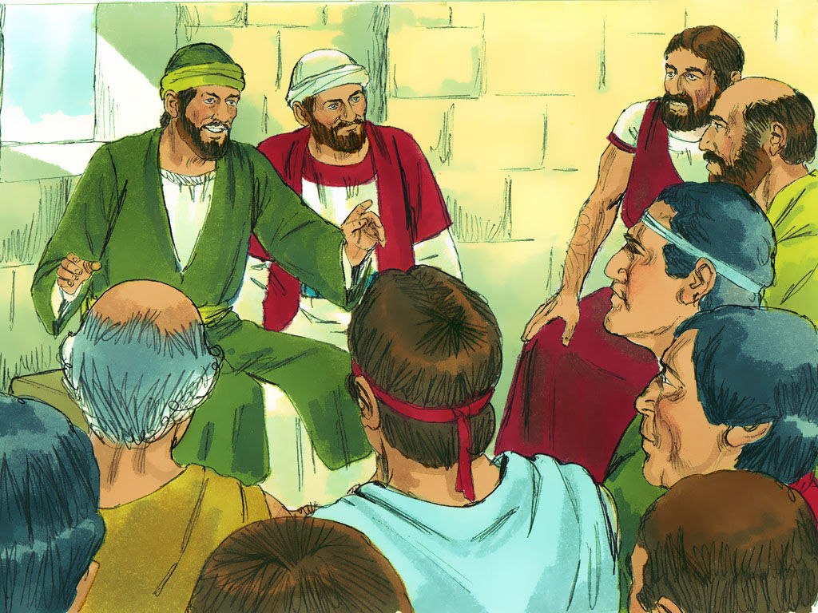
Barnabas and Paul recount the Good News to willing hearers.
During worship…
- Relate the story of Paul’s first missionary journey, and ask the above questions. Urge believers to discuss the answers.
- Ask the children to present what they have prepared.
- Memorize Mark 4:31-32. Explain that Jesus was talking about the Kingdom of God.

Advanced Study
- More people are coming to Christ around the world now, in the beginning of the 21st century, than ever before in history.
- Many of the foundations for this massive movement to Christ was laid by missionaries during the 20th century.

Learn from Scripture effective ways to spread the gospel widely.
Find in Acts 6:5-7 what happens to the Good News when leaders empower ordinary Christians. [Answer: They take it farther and many more people will become believer s.]
Find in Acts 8:1-8 what often happens to the Good news when authorities turn hostile towards Christians.
Find in Acts 12:24 through 13:5 what the Holy Spirit asks congregations to do, so that other people groups can learn the Good News.
Find in Acts 14:21-23 the main activities of workers who penetrate neglected people groups.
- What do they talk about? [Verse 21]
- To what kinds of places do they go?
- What do they do for new believers? [22]
- What kind of leaders do new Christians need? [23]
- Who will lead the new congregations after the missionaries leave them?

The years AD 1600 – 1900.
Spiritual and cultural reformation in Europe allowed Christians to obtain and read the Bible. This had several effects:
- Thousands of Europeans discovered true faith in Jesus and freedom from many church traditions.
- Northern Europeans revolted against Rome and the pope, destroying monasteries and starting the Protestant Reformation.
- Protestants in Germany and England sent missionaries to many coastal areas of the world.
- While Catholic armies conquered South America, many Protestants migrated to North America where they started many denominations.
- However, Rationalism (relying on human reason) slowly replaced Christian faith among most Europeans.

The 20th Century.
Free from European domination, North Americans translated the Bible in more than 1000 languages and planted their denominations in most nations, with several effects:
- They started many independent, evangelical missionary organizations.
- National churches in many countries became independent, indigenous and evangelistic, sending their own missionaries.
- House church movements in China, although persecuted by authorities, spread rapidly.
- Evangelical Christianity is now the fastest-growing religious movement in the world.
- The great majority of Christians live in China, southern Asia, Africa, South America and Indonesia.
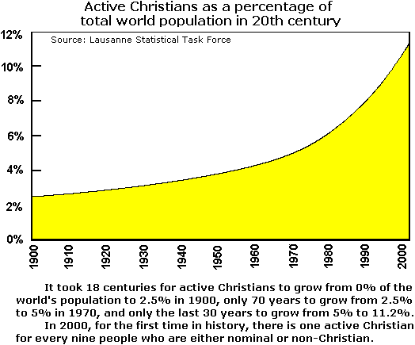

At the start of the 21st Century
Churches from many countries are now seeking to penetrate all remaining, neglected people groups. This is having several effects on Christianity:
- Spontaneous, independent “church planting movements” have started in most areas that are hostile to Christianity.
- Most Christians learn the Bible in their own language.
- Many believers are free from old church traditions, to obey Jesus in love, prayer, communion, mercy and evangelism.
- Many congregations choose their own spiritual leaders.
- Worshipers use forms and practices from their own culture.

Plan with co-workers additional activities of the coming week
- Find out which believers do not have the Bible in their own language; make plans to find Bibles that they can purchase.
- Find out which believers cannot read; make plans for them to learn to read their Bibles.
- Discuss which church traditions may be preventing believers from obeying Jesus freely and from helping others do the same. Most such traditions come from foreign cultures.
- Discuss how your congregation may be depending on money donated by outsiders, and make plans for it to support itself. God blesses flocks that trust Him for their needs.
- Find out which people groups near you do not have enough Christians and congregations. Pray and plan for some of your members to go as missionaries to help them.
- Help other congregations whose shepherds you train to cooperate with missionary outreach.

Plan with co-workers additional activities for the up-coming worship
- Let believers read and discuss the Scriptures cited under #2 above, about how the Good News spreads.
- Explain how believers shared the good news in the last 400 years of Christian history.
- Let believers who have done missionary work testify about what God has done.
- Have believers testify about how God has helped during home group and cell meetings.
- Let small groups of two and three plan, pray and encourage one another.
- To introduce the Lord’s Table read Acts 20:7. Explain that from the beginning most believers have followed the example of the earliest churches of serving the Lord’s Supper regularly.
- Those who teach children should read study #68.

