Martin Luther Let Everyone
Read the Bible
A Historical Study
Dear Lord, please help the children to embrace the great biblical truths that Martin Luther proclaimed to correct bad teaching among millions of believers.
Choose activities that fit available time and the children’s ages.
- An older child or adult tells what Jesus told the Pharisees, Mark 7:1-13.
Ask the children:
What did the Pharisees, who were religious leaders,
teach instead of the commands of God?
Why should we teach the Bible instead of the commands of men?
The devil says:
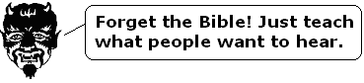
If we taught the traditions of men instead of the Word of God,
then we would make Satan happy.
- Dramatize the story of Martin Luther, a great defender of the Bible.
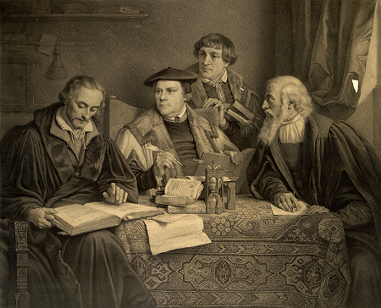
Martin Luther and helpers translated the Bible into German,
so that everyone in Germany could read it.
Arrange with the worship leader for the children to present the drama.
You do not have to use all the parts of the story.
Let older children help the younger ones to prepare.
Children need not memorize their lines:
read them; the aim is to relive events, not to perform.
Older children or adults play these parts:  Luther,  Helper  Official  Narrator. | Younger children play these parts:  Peasants  Soldiers.

Narrator “Luther was a Roman Catholic monk in Germany.
We can learn about him from history books and not from the Bible,
because he lived a long time after the Bible was written.”
Peasants Walk around, acting as if you are drunken.
Some fall down.
Helper (To Luther) “Martin Luther, do something! You are our priest!
Those drunken peasants do any bad thing they want now,
because of Tetzel!”
Luther (Angrily) “Who is Tetzel?”
Helper “He came from Rome to get money to build Saint Peter’s Cathedral
for the Pope. He tells the people that if they give generously,
then the church will grant them full pardon of all sins.”
Luther “No! People cannot buy their salvation with money!
God’s grace and forgiveness does not flow down to us from heaven
through the Pope of Rome.
I will write a protest and nail it to the door of the chapel
for everyone to see”.
(Pretend to write on a paper and nail it to a door or a wall.)
Helper Look at the paper. Then say,
“I cannot understand a word of it. It is written in Latin!”
Narrator “Someone copied Luther’s protest and printed it.
Copies went all over Europe.
Hear what a church official later told Luther.”
Official (To Luther) “The Pope in Rome is furious.
The Emperor of the Holy Roman Empire also demands
that you renounce everything you wrote.”
Luther “All that I wrote is from the Bible. I cannot renounce it.”
Official “Then the Pope will exclude you from the church.
And if you continue, then the Emperor will burn you to death.”
Luther Hear what Jesus said in Mark 7:6-9:
“Rightly did Isaiah prophesy of you hypocrites, as it is written,
‘This people honors me with their lips, but their heart is far from me.
In vain they worship me, teaching as doctrines the precepts of men.
You neglect the commands of God, holding to the tradition of men.”
You are experts at setting aside the commands of God
in order to keep your tradition’.”
Narrator “The authorities forced Luther to attend a meeting
in the presence of the Emperor.”
Soldiers Hold Luther’s arms and bring him to the Official.
Official “We have copies of all your writings.
You must renounce them. Now!”
Luther “Unless you can show me my error from Scripture, I cannot deny the truth.
Here I stand. May God help me!”
Soldiers (Some shout “Kill him!”
(Others say) “Burn him in fire!”
(Others say) “Cut out his tongue.”
Narrator Thank everyone who helped with the drama. Then explain:
- After his trial, Luther’s friends hid him in a castle,
so the Emperor could not kill him.
- There he translated the Bible into the language of the people;
they could read the Bible in their own language for the first time.
- Believers in other countries followed Luther’s example
and taught that God lovingly saves people who believe in Jesus.
- This message spread rapidly in most of Europe,
and the Evangelical movement was born.
- Memorize Psalm 119:11:
“Your Word I have treasured in my heart, so that I may not sin against you.”
- Let the children draw a picture of the Bible inside a heart.
Some children might like to copy or colour the picture found at the end of this lesson.
Let them show their pictures to the adults during worship time, and explain
that the best way to keep the Word of God is to learn it by heart.
- Three children each recite a verse from Psalm 119:9-11.
How can a young man keep his way pure?
By keeping it according to your word.
With all my heart I have sought you;
Do not let me wander from your commandments.
Your word I have treasured in my heart,
That I may not sin against you.
- Older children write a poem or song from Mark 7:1-23 about Jesus’ conversation
with the Pharisees.
Jesus said to obey God’s commands and make sure that the words
that come from our mouths are pure.
The children might do this during the week.
- Let an older child pray:
“Dear Lord, help us to be brave like Martin Luther and others who taught that you save us because you love us, and not because we earn our way into heaven by our own works.”
A more detailed, twenty-minute drama dealing with the Lord’s abounding grace:
http://biblestoryskits.com/gods-river-of-grace-cancels-religious-legalism/

