Christianity Spread during its First 400 Years
Anchor command. “The overseer must… hold fast the faithful word… so that he will be able both to exhort in sound doctrine and to refute those who contradict.” Titus 1:7-9
Anchor story. Athanasius struggled under the Roman Empire to affirm the truth of the Trinity.
(See Basic Study, below.)
Anchor verse. “Blessed are those who have been persecuted for the sake of righteousness.”
Matthew 5:10-12
Learning goal. Describe major events in church history of the first four centuries following Christ.
Growth goal. Appreciate the tremendous efforts and sacrifices made by the early Christians.
Skill goal. Defend biblical truth as ably as the Christians did in the early church.
Outcome goal. Believers wisely and effectively site examples from early history to defend and confirm their faith.

Basic Study
Lord Jesus, help us to learn from history what you are doing on earth.
Learn from early church history…
- In the first 400 years after Jesus died and rose to life, Christian faith spread to most of the cities and provinces of the Roman Empire in Asia and Europe.
- Often, the Roman authorities opposed the Christians and killed many of them. However, the Good News about Jesus kept on spreading, just as Jesus had said that it would.

In the year 321, in the city of Alexandria, Egypt, Athanasius, a Christian deacon, opposed the Bishop, Arias, who denied the truth of the Trinity. Arias said that Jesus was not fully God and that God, being one, could not be three ‘persons.’
Constantine, Emperor of the Roman Empire, sided with Arias and imprisoned Athanasius. Next, the Bishop of Alexandria excommunicated Athanasius as a heretic.
Bust of Emperor Constantine (born 272, died 337)
Some years later, Christian scholars examined the Scriptures carefully and came to believe that Athanasius had rightly defined God’s existence as three divine Persons in one God. Constantine eventually became convinced of the truth of the Trinity, and began to defend the teaching of Athanasius.
Christ is repeatedly called God in Scripture, and the Holy Spirit is also called God, as in Acts 5:3-4.
Find in Matthew 24:14; 28:18 and Acts 1:8 what Jesus said about his Good News:
- Which nations and peoples would hear the good news? (Matthew 24:14)
- What must happen before the end of the world? (24:14)
- Who has authority to send us believers to other people groups? (28:18)
- Where are we to go and make new followers of Jesus? (28:19)
- How long will the good news keep on spreading? (28:20)
- Where did Jesus say to go as witnesses? (Acts 1:8)
- Jesus said in Matthew 24:14, “This gospel of the kingdom shall be preached in the whole world as a testimony to all the nations, and then the end will come.”
Tibetan monks have become followers of Jesus
During the week read together some of the above truths that are most meaningful to you, from the First 400 years of the life of the church.
During worship…
- Relate how Athanasius defended the truth of the Trinity, and how many Christians died as martyrs during the first 400 years of Christianity.
- Read and discuss 1 Peter 3:15 “Sanctify Christ as Lord in your hearts, always being ready to make a defense to everyone who asks you to give an account for the hope that is in you, yet with gentleness and reverence.”
- Ask the children to present what they have prepared.
- Memorize

Advanced Study
- The Spread of Christianity during its first 400 Years
Find in Matthew 24:14; 28:18 and Acts 1:8 what Jesus said about his good news?
- Which nations and peoples would hear the good news? (Mt 24:14)
- What must happen before the end of the world? (24:14)
- Who has authority to send us believers to other people groups? (28:18)
- Where are we to go and make new followers of Jesus? (28:19)
- How long will the good news keep on spreading? (28:20)
- Where did Jesus say to go as witnesses? (Ac 1:8)
Find in Acts 7:59 – 8:5 how Christianity spread without missionaries:
- What happened to some Christians, like Stephen? (7:59 & 60)
- What happened to the congregation in Jerusalem? (8:1)
- Where did the Christians go? (1)
- What did Saul do to the house church members? (3)
- What did the Christians do in other cities? (4 & 5)
Note: Saul later became a Christian and a missionary, changing his name to Paul. Persecution has two forms: criminal violence against Christians done by hateful persons and legal prosecution of Christians because they love Jesus.
Find in Acts 14:21-23 how missionaries spread Christianity:
- To what kinds of places did the missionaries go? (21)
- What did they do in those cities? (22)
- What was the topic of their message? (23)
- What kinds of new communities did they start in every city? (23)
- What kinds of leaders served those new communities? (23)
Find in Romans 15:18-21 what the Apostle Paul wrote about his missionary work:
- Who became obedient to Christ? (18)
- What was Paul’s activity? (19)
- Where did he go from Jerusalem? (19)
- What kinds of places did he seek to go to? (20)
- What is God’s promise about neglected people groups? (21)
- The good news about Jesus spread to all parts of the Roman Empire.
It spread into neighbouring peoples because Christians were taken as captives. Even though Christians were persecuted by hostile officials, much of the empire became Christian because:
- Christians opposed abortion, protecting women's health.
- Christians opposed infanticide, so had more children.
- Christians nursed the sick, helping many to survive.
- Christians respected women, granting them dignity and protection.
- Christians welcomed widows and orphans.
- Christians promoted ethnic harmony, uniting urban populations.
- Christians remained faithful in marriage, increasing fertility and life-span.
- Christians showed regard for life, raising human dignity.
- Christians followed the New Testament, living by grace and the Holy Spirit.
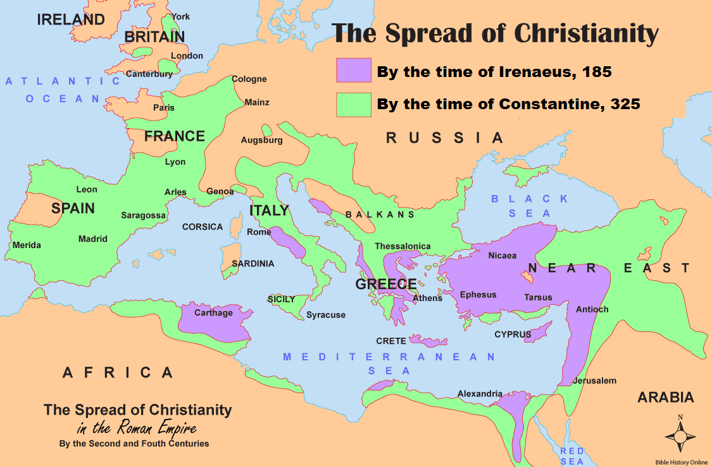
- Ulfas and the Goths
During the first four centuries, non-Roman peoples began migrating into the Roman Empire. Robbers from the Goths captured a young Roman named Ulfas and carried him to their territory near the Danube River in Romania. There he became a Christian.
Later, the Goths allowed him to study, and he was consecrated as a bishop at Constantinople in Turkey. Ulfas returned to the Goths, adopted their life style and spent 40 years evangelizing them, travelling from city to city by wagon. Before he died in AD 382, he gave the Goths an alphabet and translated much of the Bible for them.
In AD 410, when the Goths over-ran the Roman Empire, they were mostly Christian. Even the pagans commented that the Goths respected others’ property and had high moral standards.
- The year AD 313
By the year AD 300, there were so many Christians in the Empire that the Roman government decided to stop persecuting them. Emperor Constantine issued his Edict of Toleration, making Christianity a legal religion. This had bad effects on Christianity:
- Many non-believers joined churches, which caused churches to become lifeless.
- Christian churches adopted Roman cultural forms.
- Non-Roman nations became suspicious of their Christians as traitors.
- Church leaders required non-Romans to adopt Roman culture to be baptized.
- Church leaders argued about theology and political power.
- Plan with your co-workers additional activities for the up-coming worship.
- Have believers read discuss how the apostles spread the Good News about Jesus, and explain how believers shared the good news in the first 400 years of Christian history.
- Let the believers testify about how they learned the Good News.
- Let the children present the drama that they have prepared.
- To celebrate the Lord’s Table, read Revelation 3:20 and briefly explain the ‘door’.
- Let small groups of two and three plan, pray and encourage one another.
- Those who teach children should read study #66 for children

