Jesus’ life-giving Resurrection
Anchor command. “If you confess with your mouth Jesus as Lord, and believe in your heart that God raised Him from the dead, you will be saved.” Romans 10:9
Anchor story. Jesus’ return to life. Matthew chapter 28
Anchor verse. “Do not be afraid; for I know that you are looking for Jesus who has been crucified. He is not here, for He has risen, just as He said.” Matthew 28:5-6
Learning goal. Know the importance of Christ’s life-giving resurrection, after he lay in repose over the Sabbath day of rest.
Growth goal. Grasp the truth that we humans’ only hope for eternal life come from rising from death with Jesus, sharing in his resurrection.
Skill goal. Communicate by the Holy Spirit’s power the importance of Jesus’ life-giving resurrection.
Outcome goal. Many come to believe that Jesus rose from the dead, understanding how important this is for humans.
Basic Study
Heavenly Father, you sent your Son, Jesus, to die for us. We thank you for giving to us new life through Him, by raising us together with Him. Please use this study to reveal the power and authority of your Son Jesus, which you showed when you raised him from death.
Learn from Matthew 28 about Jesus’ resurrection:
- On what day of the week did Jesus rise? Matthew 28:1
- What did the angel tell the women who came to the empty tomb? Matthew 28:5-7
- How did the chief priests keep the Roman soldiers who guarded the tomb from telling what happened? Matthew 28:11-15
- What were Jesus’ final instructions to his disciples, when they met with him on a mountain in Galilee? Matthew 28:16-20
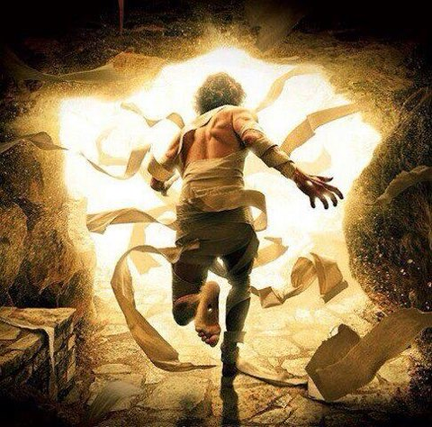

Plan with coworkers to proclaim Jesus life-giving resurrection during the week, to those who still do not know.
During worship…
- Tell the account of Jesus’ resurrection, from Matthew chapter 18, and ask the same questions as above. Encourage the believers to discuss the answers.
- Explain that those who believe in Jesus will share in his resurrection. They are raised in Christ’s body in the same way that Noah and his family were raised in their boat above the waters of death. 1 Peter 3:19-2; Romans 6:4-10
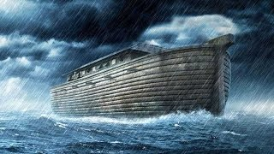
Ask the children to present what they have prepared.
Memorize John 11:25.
Advanced Study
- Start several weeks before Easter, the resurrection day, to prepare to celebrate Jesus’ life-giving resurrection. You should plan special activities to help believers learn the events surrounding Jesus’ death and victory over death.
Learn from the Gospels the events leading to Jesus’ resurrection, during the previous week.
Day 9 before Jesus’ death.
In John 12:1-11 find what Lazarus’ sister Mary did to prepare Jesus for His death.
Day 8 before Jesus’ Resurrection
In Matt. 21:1-13, find what Zechariah 9: prophesied long before, that Jesus fulfilled in His “triumphal entry” into Jerusalem.
Day 7 before Jesus’ Resurrection
In Mark 11:15-18, note what Jesus did that moved religious leaders to try to kill Him.
Day 6 before Jesus’ Resurrection
In Mark 11:27-33, discover why religious leaders refused to answer His question about John the Baptist.
Day 5 before Jesus’ Resurrection
In Mark 13 : 1-10 &21-27, discern what Jesus foretold about His final coming.
In verse 10, learn what all nations must hear before Jesus returns in glory.
In verses 32-33, notice who alone knows when Jesus will return.
Day 4 before Jesus’ Resurrection
In Mark 14:12-36 find the new ceremony that Jesus instituted during Passover
that replaces it for believers.
In verses 32-42, consider his moving prayer of submission.
In 60-64, why the High Priest tore his robe in fury.
In 60-64, find who denied Jesus and later wept.
Day 3 before Jesus’ Resurrection
In Mark chapter 15, why find who was freed instead of Jesus.
In Verses 12-20, ways by which the soldiers mocked Jesus.
In 21-39, what the Centurion in charge of executing Jesus finally said about Him.
In 40-47, what they did with Jesus’ body.
In John 5:24-29, who will raise from death both the godly and the ungodly.
In Luke 24:1, find on what day of the week Jesus rose.
In verses 2-9, what an angel reminded the disciples, that Jesus had said.
In 10-35, what the risen Christ explained that made two travelers’ hearts burn.
In 36-45, how Jesus proved that He was not a ghost.
In 46-48, what Jesus told His disciples they are witnesses of.
- Results of, and events following, Jesus’ resurrection.
In Acts 1:3, find how many days the risen Christ appeared to His disciples.
In Acts 1:1-9, Jesus’ final promise to His disciples.
In 1 Corinthians 15:12-20, find the hopeless state that believers would have, if Jesus had not risen from the dead.
In verses 21-26 and 45-50, find why Jesus is called ‘the last Adam’ ().
In verses 27-44, find to what degree our new body will be entirely different.
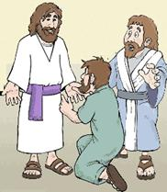
Find in Acts 2:22-36 what importance Peter gave to the resurrection of Jesus when he proclaimed the Good News on the day of Pentecost.
(Jesus’ resurrection was the truth that the apostles emphasized most, when they witnessed for Christ. Examples: Acts: 3:12-21. 4:1-3. 13:15-41. 17:2-3. 26:1-23.)
Find in Acts 1:1-9 Jesus’ final promise to His disciples.
Find in 1 Corinthians chapter 15 …
What hope do believers have, if Jesus did not rise from the dead (12-20)?
Why Jesus is called ‘the last Adam’ (verses 21-26 and 45-50).
In what way our new body will be different (27-44).
Find in Acts 2:22-36 the importance Peter gave to the resurrection of Jesus when he proclaimed the Good News on the day of Pentecost.

Plan with co-workers additional activities to do before and following Easter
- Visit friends and relatives to explain the joyful news of Jesus’ resurrection, and how they may participate in it.
- Help each believer to testify, as Paul did in Acts 22:1-22, how meeting the risen Christ changed Paul.

Important facts about the resurrection, which many believers have not yet learned:
- God bases our eternal life on one historical fact: that Jesus rose from the dead and will raise repentant believers as part of His body, Ephesians 2:4-6; 1 Cor. 12:27;
Romans 6:5-11.
- Jesus’ resurrection, like His death, was part of His saving work. His blood bought our forgiveness. His resurrection and our participation in it ensure our eternal life, 1 Corinthians 15:17-26.
- After death, we will not be ghosts nor will we be reincarnated. Rather, we will rise to eternal life in Christ’s glorious presence where we will see Him face to face. Revelation 22:3-5 & 1 John 3:2. In God’s view of things, this has already happened. John 5:25

