A Valley of Dry Bones
Lord, give to our children assurance that you will raise them from the dead, in Jesus, to live forever in glory with Him.
Choose any of these children's learning activities.
- Let an older child or teacher read or tell by memory the vision that God gave to Ezekiel about a valley covered with dry bones (Ezekiel 37:1-14).
First ask the children to listen carefully to find how God gave to the people of Israel hope that he would save them, as He promised by the prophet Ezekiel.

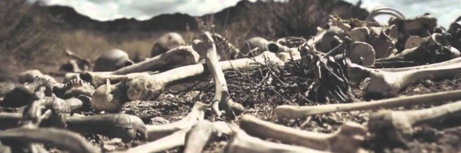
A valley covered with dry bones. Can these bone live again?
- Ask these questions after relating the story. (Tell answers only if needed.)
Who showed to the prophet a valley covered with bones? [Answer: See verse 1.]
What did Ezekiel hear when he prophesied to the bones? [Answer: See verse 7.]
What did God’s breath cause the bones to do? [Answer: See verse 10.]
Whom did the bones represent?
Answer: See verse 11. These were the bones of God’s people.
What did God promise to give to his people so that they could live again? [Answer: See verse 14.]
- Dramatize parts of the story of The Valley of Dry Bones, Ezekiel 37:1-14.
- Arrange with the congregation’s leader for the children to present this drama.
- Use your time with the children to prepare it.
- You do not have to use all the parts.
- Children need not memorize lines. Let them read their lines. The aim is to relive sacred events, not to perform.
- Older children or adults play these parts:
Narrator. Summarize the story and help the children remember what to say and do.
Voice of God
Ezekiel
Younger children play these parts:
Bones. Lie on the floor with your eyes shut.
Wind.
Narrator: Tell or read The Vision of Dry Bones from Ezekiel 37:1-14. Then say,
“Hear what God says.”
Voice of God: “Ezekiel, I will show you the future of my people.
Look at this valley covered with dry bones.
Do you think` the bones can live again?”
Ezekiel: “Only you know that, Lord.”
Voice of God: “Tell the bones that I will gather them together and give them breath.”
Ezekiel: “Dry bones, you will live!”
Bones: “Rattle, rattle, rattle.”
(Crawl together while still on the floor, with your eyes shut.)
Ezekiel: “Now the Lord will breathe His Spirit into you and you will live. Wind, blow!”
Wind: Blow hard toward the bones.
Bones: Jump up and stand straight like soldiers.
(Some Say) “The Lord has given us life!”
(Others say) “We praise the One and Only Almighty God!”
(Others say) “The Almighty raises the dead to live with Him in Glory, forever!”
Narrator: Thank all who helped with the drama.
- If the children present this story to the adults…
- Let the children ask the adults the same questions as under #1 above.
- Ask for other examples of promises that God has made to us that will be fulfilled in the future. (Let children or adults give examples.)
- Draw a big picture of bones or of a skeleton, and cut it into large pieces.
- Let the children put the pieces together again, like a puzzle, and then copy the picture.
- Let older children help the younger.
- Some children might like to colour the picture found on the last page of this lesson.
- Let the children show their pictures to the adults at the next worship time, or at home.
- The children can explain to the adults that the bones illustrate how God’s Spirit can change any person, no matter how bad they are.
- The bones also remind us that God will raise us from the dead to be with Him forever in glory. We receive eternal life only through Jesus because He alone took our place, paid the penalty for our sins and took our shame upon Himself. Then Jesus rose from the dead, and made the one way for us to follow him into eternal glory.

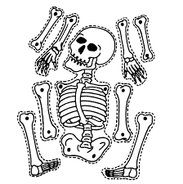

- Memorize John 5:21:
“Just as the Father raises the dead and gives them life, even so the Son also gives life to whom He wishes.
- Let four children each recite one of these verses from 1 Corinthians 15-: 41-44:
“There is one glory of the sun, and another glory of the moon, and another glory of the stars; for star differs from star in glory.
“So also is the resurrection of the dead. It is sown a perishable body,
it is raised an imperishable body.”
“It is sown in dishonor, it is raised in glory;
it is sown in weakness, it is raised in power.”
“It is sown a natural body, it is raised a spiritual body.
If there is a natural body, there is also a spiritual body.”
- Let older children write poems, songs or dramas about how the Holy Spirit gives us life.
- Let an older child pray:
“Dear Lord, you alone are powerful enough to make dry bones get up and walk again. You will breathe life into us after we are dead. We have been spiritually dead in our sins, but you have given us new, holy life that lasts forever.”

An additional drama depicting additional events related to the resurrection:

http://biblestoryskits.com/031-jesus-destroys-satan-
and-creates-a-new-heaven-and-earth/

