Let the Holy Spirit Change us and Guide us
Anchor command. “Do not be conformed to this world, but be transformed by the renewing of your mind.” Romans 12:2
Anchor story. Jesus’ kindness leads Zacchaeus to repent. Luke: 1-10.
Anchor verse. “He saved us, not on the basis of deeds which we have done in righteousness, but according to His mercy, by the washing of regeneration and renewing by the Holy Spirit, whom He poured out upon us richly through Jesus Christ our Savior.” Titus 3:5-6
Learning goal. Grasp how the Holy Spirit powerfully applies Christ’s transforming grace to repentant believers.
Growth goal. Seek with your whole heart, and help others to seek, God’s transforming grace.
Skill goal. Convince others that the Holy Spirit can transform them into Christ-like sons of God.
Outcome goal. Many believers receive the transforming, sanctifying work of the Holy Spirit.
Basic Study

Learn from the story Zacchaeus of God transforms even the worst of sinners. Luke 19:1-10
- What town did Jesus enter? Verse 1
- What kind of man was Zacchaeus? verses 2 and 7
- What did the Holy Spirit move Zacchaeus to do, in order to see Jesus? 3-4
- What did Jesus say when he saw Zacchaeus? 5
- What was Zacchaeus’ reaction? 6
- Why did the people grumbled about what Jesus did? 7
- What did Zacchaeus declare that showed his heartfelt repentance? 8
- What blessing did Jesus bring to Zacchaeus and his family? 9
- Did Zacchaeus earn this blessing by his own good works, or was it purely of God’s grace?
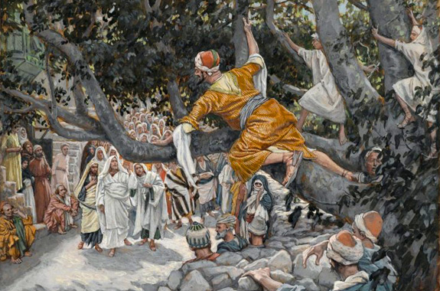
Zacchaeus climbed into a tree from which better to see Jesus.
Plan with coworkers to visit believers during the week who are struggling to live a holy life, and prayerfully help them to surrender to God’s Holy Spirit and be made holy in Christ.
During worship
- Tell the story of Zacchaeus, Luke 19:1-10.
- Ask the same questions as listed above; encourage the believers to discuss the answers.
- Pray for the Holy Spirit to transform us and make us faithful servants.
- Praise God for victories and healing that people received by the Holy Spirit last week.
- Memorize together John 14:15–16.
Advanced Study
Dear Holy Spirit, we ask you now to renew our minds and make us to be more like Christ.
- Know what Scripture says about the Holy Spirit.
- The Holy Spirit is God. (Acts 5:3-5)
- In John 14 – 16, Jesus said that He would return to Heaven and send another Helper to take his place.
- The Holy Spirit has no earthly body like Jesus had.
- Where is the Holy Spirit? In you!
He lives in us (1 Corinthians 6:19 & John 14:17).
- He guides you. He helps you when you teach others. He shows you what is right and what is wrong (John 16:8–13).
- The Holy Spirit does eight things for us who believe in Christ. Find in…
1) John 14:26, how He helps us to understand.
2) John 16:8, what He shows us about ourselves.
3) Acts 1:8, what He gives us power to do.
4) Romans 8:11–14 what He does for us.
5) Romans 8:15–17, of what He assures us.
6) Ephesians 1:13–14, how He guarantees our eternal salvation.
7) 1 Corinthians 12:13, where He places us forever.
8) 1 Corinthians 12:1–12, how He equips us to serve.
[Answers:
1) The Holy Spirit teaches us all things (illuminates our minds).
2) He convinces us of our sin.
3) He gives us power to witness effectively for Christ.
4) He gives us new, holy life (rebirth, the new, holy life in God).
5) He assures us we are God’s children and heirs of heavenly riches with Christ.
6) He seals us, guaranteeing us of our heavenly inheritance.
7) He baptises us into the universal Body of Christ.
8) He gives us different spiritual gifts by which to edify the body of Christ.]
- Plan with co-workers what the believers will do next week
- Visit any believers who are not sure that they have really received the Holy Spirit. Pray for them and ask them to pray to receive the Holy Spirit.
- If anyone does not yet understand the work of the Holy Spirit, then explain to them more fully the eight things listed above that he does for us.
- Demonstrate how the Holy Spirit changes our hearts.
- Ask two adults to play the parts of Seeker and Gatekeeper.
- Seeker fastens a drawing of a serpent to the front of his shirt.
(Copy this picture and cut the paper in the shape of a heart.)
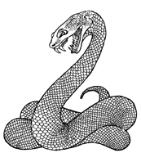
Gatekeeper (Stand on one side and speak in a loud voice)
Seeker: Walk towards Mr. Gatekeeper. Let everyone see the serpent. Say loudly, “Mr. Gatekeeper, please let me enter the Kingdom of heaven.”
Gatekeeper: “Mr. Seeker, you cannot bring that evil thing in your heart in with you.”
Seeker: “But how can I get my sins out of my heart?”
Gatekeeper: (Read in a loud voice 1 John 1:7–9.)
Seeker: “I confess my sins and ask Jesus to forgive me.” (Point to the serpent.) “But how can I remove this ugly thing inside me?”
Gatekeeper: “Even though your sins are forgiven, you cannot enter heaven while you still desire to follow Satan, the old serpent. God will not allow even the thought of evil in heaven. You must let the Holy Spirit change your heart. ” (Read Galatians 5:16–24.)
Seeker: “Mr. Gatekeeper, I asked Jesus to cleanse my sins by his blood. The Holy Spirit now helps me to crucify my old sinful nature a produces in me love and goodness.” (Throw away the picture of the serpent.)
Gatekeeper: “Enter the Kingdom of Heaven!”
- Discuss the list of eight things the Holy Spirit does for us (above).
- Explain that the night before Jesus died, he told his sad disciples that he was leaving them. Then ask, “How would you feel if the person you loved most were leaving you?”
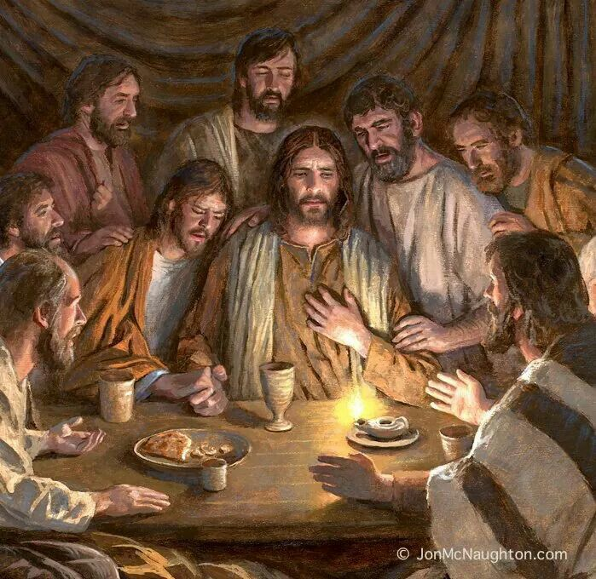
Jesus announces to his twelve apostles that he must leave for a while.
- Explain the mystery of Jesus’ identity with the Holy Spirit. Read John 14:15–17.
- Jesus told them he would not leave them alone. He would send the Comforter.
- Jesus promised, “I will not leave you as orphans; I will come to you.” (John 14:18).
- Read John 16:13–15. Jesus had said, “I and the Father are One” (John 10:30). He also could have said, “I and the Holy Spirit are One.” God the Father, God the Son and God the Holy Spirit, although separate Persons, are one in essence, united in the One God, the Trinity.
- To introduce the Lord’s Supper, explain how the Old Testament priests served the holy Bread of the Presence on a table before God in the tabernacle (Exodus 25:30). We also will eat bread in God’s presence now, and will do so again in the “marriage feast of the Lamb” in the coming Kingdom.
- Ask a creative person to write a poem listing the nine virtues of holiness that the Holy Spirit produces in us believers. Those are listed in Galatians 5:22–23. One might set it to a common tune that the believers can sing.

