God’s Holy Spirit Changes us
and Makes Us Better
Dear Father, please use this study to help children know you better. Use it so that they will let your Holy Spirit change and guide them.”
Select activities that fit the children’s needs and local customs.
- Read or tell by memory the account of Stephen’s martyrdom, Acts 6:8–15 and 7:51–60.
Notice how God’s Spirit made Stephen a brave witness for Christ, what Stephen said; and the Jewish leaders’ reaction to it.
- Prepare an older child to tell the story. Then ask the children:
- What kind of man was Stephen?
- Why did some leaders secretly persuade people to tell lies about Stephen?
- What did Stephen’s face look like before He died?
- Whom did Stephen see before he died?
- Why were some people so angry with Stephen?
- What were Stephen’s last words?
- Discuss the pain of false accusations.
- Ask the children to think of a time when somebody told lies about them, saying they did something that they did not do.
- Ask how the children felt when falsely accused, and what they did.

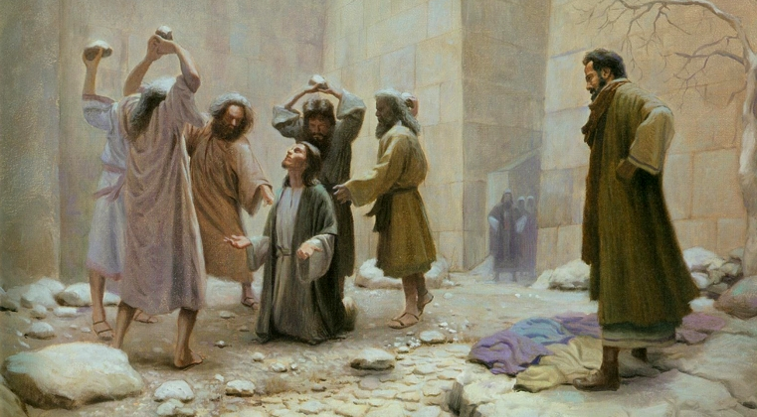
Religious zealots stoned Stephen to death, because he told the truth about them.

- Dramatize how the Holy Spirit empowered Stephen to endure martyrdom, Acts seven.
- Rehearse the story and present it to the adults during worship.
- Older children play these parts:
Saul
Stephen
Younger children play the part of Accusers.
Saul “I am the Apostle Paul. Let me tell you something I saw before I knew Christ, when I was called ‘Saul’.” (Read Acts 6:8-11)
Stephen (Stand to one side)
Accuser #1 (Shout angrily, and point at Stephen.)
“We heard Stephen blaspheme against Moses and against God!”
Saul (Read Acts 6:12-13.)
Accuser #2 (Shout angrily)
”This man incessantly speaks against this holy place and the Law;
for we have heard him say that this Nazarene, Jesus, will destroy this place and alter the customs which Moses handed down.”
Saul (Read Acts 6:15 and 7:1.)
”Now hear what Stephen says.”
Stephen “Hear me, brothers and fathers! The God of glory appeared to our father Abraham when he was in Mesopotamia, before he lived in Haran, and said to him, 'Leave your country and your relatives, and come into the land that I will show you’.”
Saul “Stephen then summarized briefly the history of Israel.
Hear his courageous conclusion.”
Stephen “You men who are stiff-necked and uncircumcised in heart and ears are always resisting the Holy Spirit; you are doing just as your fathers did.
Which one of the prophets did your fathers not persecute?
They killed those who had previously announced the coming of the Righteous One, whose betrayers and murderers you have now become.”
Saul (Read Acts 7:54–55.)
Stephen (Point up and shout.) “Look! I see the heavens opened up and the Son of Man standing at the right hand of God.”
Accusers Silence him! Silence him!
(Cover your ears, run and drag Stephen to the other side of the room.)
Saul (Read Acts 7:57–58.)
“The young man, Saul, was me. That was before I knew Christ and God changed my name to Paul.”
Accusers Pretend to throw stones at Stephen.
Saul “They went on stoning Stephen as he called on the Lord and said,
‘Lord Jesus, receive my spirit!’
Then falling on his knees, he cried out with a loud voice,
“Lord, do not hold this sin against them!’
Having said this, he fell asleep.”

- Children ask the adults questions they have prepared about what the Holy Spirit enabled Stephen to do. They might use the questions under #1 above.
- Poem. Coach three children to recite these three parts of Isaiah 61:1-2.
They might also recite it for the adults.
The Spirit of the Sovereign Lord is on me,
Because the Lord has anointed me
To preach good news to the poor.
He has sent me to bind up the broken-hearted,
To proclaim freedom for the captives
And release from darkness for the prisoners.
To proclaim the year of the Lord’s favor
And the day of vengeance of our God.

- Illustrate the Holy Spirit’s work.
- Let the children draw a broken chain or shackles, to illustrate what the Holy Spirit frees us from.
- Let the children show their pictures to the adults and explain that the Holy Spirit fills us with God’s power and frees us from the chains of sin and evil, and the fear of death.

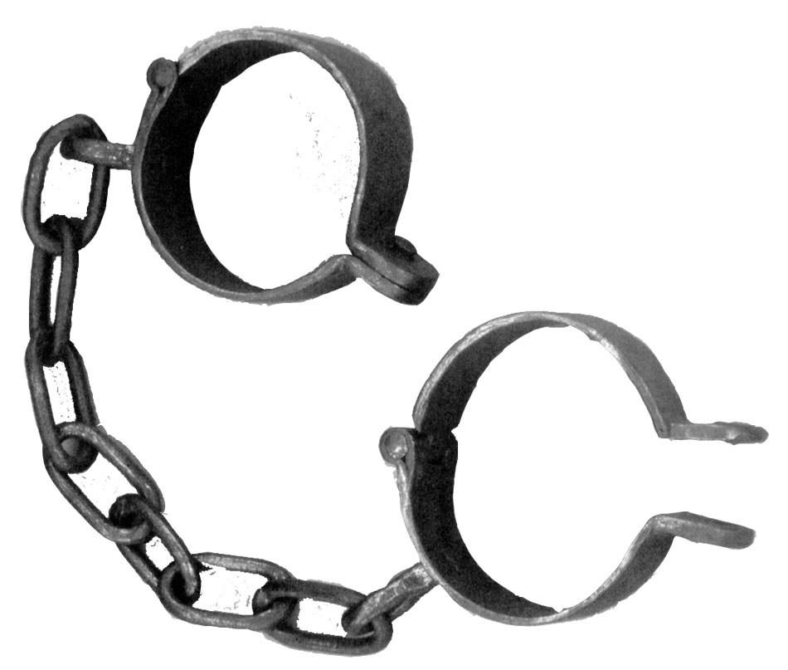

Shackles to put on captives’ wrists or ankles.
- Memory work.
Younger children memorize John 20:22:
”He breathed on them and said to them, ‘Receive the Holy Spirit’.”
Older children memorize Ephesians 1:13, 14.
”In Him, you also, after listening to the message of truth, the gospel of your salvation—having also believed, you were sealed in him with the Holy Spirit of promise, who is given as a pledge of our inheritance, with a view to the redemption of God's own possession, to the praise of His glory.”

- Explain the Fruit of the Spirit.
- Read Galatians 5:19-25.
- Explain the examples below of the bad works of the flesh (sinful acts),
and the opposite virtues that the Holy Spirit produces in the same persons later.
Works of the Flesh and Fruit of the Spirit
Works of the flesh: evil things people want to do because of sin.  Gal. 5:19-21 |  | Fruit of the Spirit: good things the Holy Spirit helps us to do,  Gal. 5:22-23
Sexual immorality. David wanted another man’s wife |  | Love. David later repented, loved God sincerely. 2 Sam. 11; Ps. 51
Impurity, debauchery. The wasteful son lived badly. |  | Joy. The wasteful son found joy when he repented and returned, Luke 15:11-32
Idolatry, witchcraft. Ezra’s people sought peace from stupid idols. |  | Peace. Ezra helped his Jews find peace in God. Ezra 9
Hatred. Saul hated believers and persecuted them. |  | Patience. Saul learned to endure mistreatment. Acts 9.
Discord, jealousy. Judah in envy sold his brother Joseph as a slave. |  | Kindness. Judah later showed great kindness. Gen. 37 & 44
Fits of rage. John wanted fire to destroy his enemies. |  | Goodness. John later showed much goodness. Acts 3:1-9
Selfish ambition. Jacob tricked Esau to get his inheritance. |  | Faith. Jacob later learned to trust God to help him. Gen. 25:29-34 & chapters 27 & 47
Dissensions, factions, envy. Believers in the first churches were divided. |  | Gentleness. Those believers found unity in Christ through the Holy Spirit. Acts 15
Drunkenness, orgies. Corinthians had these vices |  | Self-control. Corinthians were washed and sanctified by the Holy Spirit. 1 Cor. 6:9-11

A longer drama, about God’s Holy Spirit coming at Pentecost to empower believers:
http://biblestoryskits.com/001-gods-holy-spirit-comes-at-pentecost-to-reside-in-believers-3/

