How Children Can Serve God

Teach Children to Serve God by Serving Other People
Choose any of these children's learning activities.
- Let an older child or teacher read or recount Matthew 25:14-30, about faithful servants.
The story shows that God gives each one of us a job to do for him. We are his servants;
we are to serve him with everything he gives us.
- Explain that a “talent” was an extremely valuable golden coin.
- After relating the story, ask these questions.
(Answers, if needed, appear after each question.)
- How many talents did the man give to each of his three servants? (See verse 15)
- What did each servant do with his money? (16-18)
- What did the master say when his servants used their money wisely? (21)
- What did the lazy servant do with his one gold coin? (25)
- What happened to this servant? (30)
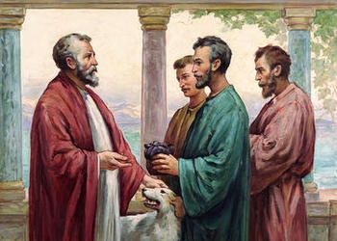
A rich man distributed money to three of his servants, according to their ability.
- Dramatize parts of the story of the faithful servants.
- Arrange with the leader of the main congregational worship to present this drama.
- Use your time with the children to prepare the drama.
- You do not have to use all the parts of the story.
- Have the older children help the younger ones prepare.
- Have the children prepare fifteen big coins. They can cut them out of paper.
Older children or adults act out these roles:
Narrator. Summarize the story and help the children remember what to say and do.
Master of the House. Carry a travel bag and hold eight coins.
Younger children act out these roles:
Faithful Servants #1 Has five of the coins and a sheet of paper in a pocket, for the second part of the story.
Faithful Servant #2. Has two of the coins in a pocket’ and two sheets of paper for the second part of the story.
Lazy servant
Merchants. Have ready: (1) Three sheets of paper; (2) Things that represent a business, such as tools or boxes. (3) Seven of the large coins.
Narrator: Tell the first part of the story, Matthew 25:14-18. Then say,
“Hear what the Master of the house says.”
Master of the House: Put your bag on your shoulder and say,
“Servants, I am going on a long trip.
Come. I will give each of you some money to invest while I am gone.”
Count out aloud five of the coins and hand them to Servant #1,
Count out aloud two coins for Servant #2.
Count out aloud one coin for Lazy Servant.
Faithful Servant #1: Go to the Merchants and say,
“I want to buy this large piece of land that you have for sale.
Here are five gold coins.”
(Hand the merchants your coins.)
Merchants: (Some say) “You made a very wise purchase.”
(Others say) ”Here is the title deed.”
(Hand Faithful Servant #1 a sheet of paper.)
Faithful Servant #2: Go to the Merchants and say,
”I want to buy these two houses that you have for sale.
Here are two gold coins.” (Hand Merchants your two coins.)
Merchants: (Some say) “That is a wise investment.”
(Others say) ”Here are the title deeds.”
(Hand Faithful Servant #2 two sheets of paper.)
Lazy servant: Look around to pretend that you make sure nobody is watching.
Pretend to hide your coin somewhere on the floor. Say,
“I am hiding my one coin to keep it safe!”
Narrator: Tell the second part of the story, Matthew 25:19-23. Then say,
“Hear what the Master of the house says.”
Master of the House: “I have returned from my journey.
Servants, come show me what you have done with the gold coins that I gave to you to invest for me.”
Faithful Servants #1 Go to the Merchants again and tell them,
“I am selling back my land, along with other lands that it earned.
Here are their title deeds.”
(Hand the merchants two sheets of paper.)
Merchants: (Some say) “You have made a good profit from your investment”.
(Others say) “Here are the ten gold coins that you have earned.”
(Hand Faithful Servant #1 ten coins.)
Faithful Servants #2 Go to the Merchants again and tell them,
“I am selling back the houses I bought,
plus more houses that I bought with the rent money”.
(Hand them back the four sheets of paper that represent title deeds.)
Merchants: (Some say) “You have doubled your investment.”
(Others say) “Here are four gold coins.”
(Hand Faithful Servant #2 four coins.)
Faithful Servant #1: Return to the Master and say,
“I bought land and farmed it, and have doubled your money.
You gave me five coins; here are ten.”
(Hand the Master the coins.)
Faithful Servant #2: Give the master the four coins and say,
”I bought houses and have doubled your money.
Here are four gold coins.
(Hand the Master the coins.)
Master: “Well done, faithful servants. Come live with me.
But where is the other servant?”
Narrator: Tell the third part of the story, Matthew 25:24-30. Then say,
“Hear what the lazy servant says.”
Lazy servant: Go get the one coin that you hid, and give it to the master. Then say,
“Sir, here is your money back. I did not do anything with it.
I was afraid of losing it, so I hid it in the ground.”
Master: “Lazy servant! You did not invest the coin I gave you.
Leave my house forever!”
Narrator. Thank everyone who helped with the drama.
- Draw a picture of five big gold coins and let the children copy it.
- Let the older children help the younger. Some children may like to copy or colour the picture found at the end of this lesson.
- Children show their pictures to the adults during worship time or to parents at home. Let the children explain that the coins illustrate how God gives to us gifts and blessing to use to serve him, instead of storing them up for ourselves.
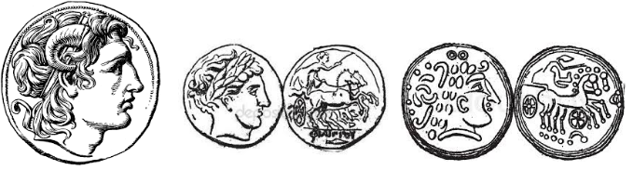
- Memorize Matthew 6:24.
“No one can serve two masters; for either he will hate the one and love the other, or he will be devoted to one and despise the other. You cannot serve God and wealth.”
- Poem: let three children each recite one of the verses from Psalm 65:4, 5 and 9.
- Let older children write poems, songs or drama about using God’s gifts to serve others.
- Let an older child pray:
“Dear Lord, you are very generous. You give us many gifts and blessings. Help us to use these gifts to serve you. Help us to be faithful in serving others in your name. Forgive us when we fail to use our gift for you.”

More detailed drama, illustrating another of Jesus’
parables, Sheep and Goats, about serving others:

http://biblestoryskits.com/021-jesus-parts-sheep-
from-goats-that-lack-practical-love-3/

