We Are Stewards of All that
God Entrusts to Us
Anchor command. “As each one has received a special gift, employ it in serving one another as good stewards of the manifold grace of God.” 1 Peter 4:10
Anchor story. Two Stewards. Matthew 25:14-30
Anchor verse. “It is required of stewards that one be found trustworthy.” 1 Corinthians 4:2
Learning goal. Discern our duty to carry out the work that that God has entrusted to us to do
Growth goal. Have a heartfelt desire to be daily an active servant of Christ.
Skill goal. Mobilize believers to serve Christ selflessly throughout the week.
Outcome goal. Believers conscientiously and wisely serve Christ as faithful stewards.

“Father God, You own everything, and all we have comes from you. Please, give us strength to care for all we have and to honor you with everything. Amen.

Basic Study
Learn from the story the three stewards. Matthew 25:14-30.
The master of the three stewards corresponds to Christ. The three stewards correspond to those whom God holds accountable to use wisely the gifts and talents that God has given them.
- How many talents (very valuable coins) did the traveling man in the parable entrust to each of three servants? Verses 14-15
- What did the first two servants do with the money that had been given to them? 16-17
- What did the third man do with his chair of the money? 18
- What did the master tell the two servants who had invested their coins wisely? 19-23
- What did the master say to the third man who did not invest the money? 24-28
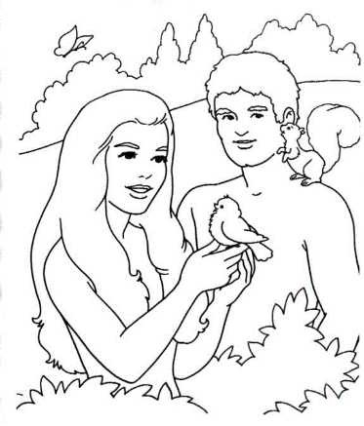
From the very beginning until now, God has entrusted humans with things that He created.
During the week… Ask the Lord to help you serve him daily more faithfully, and then start doing some service for the Lord that you haven’t done before.
During worship
- Tell the story of the three stewards, and ask the same questions as above. Let the people discuss the answers.
- Ask the children to present what they have prepared.
- Memorize together 1 Corinthians 14:2, “It is required of stewards that one be found trustworthy.”

Advanced Study

Learn more about Christian stewardship.
Find in Genesis 1:26–28 how people are to rule the earth.
Please seek the answer from the biblical text before reading it below.
- From whom do people get their authority to manage their land?
- From whom do people get their authority to manage their animals?
- To whom will people give account for how well they managed the land and animals?
[Answers: a) from God, b) from God. c) to God.]
Find in Genesis 39:2–5 how Joseph became manager of an Egyptian man’s estate.
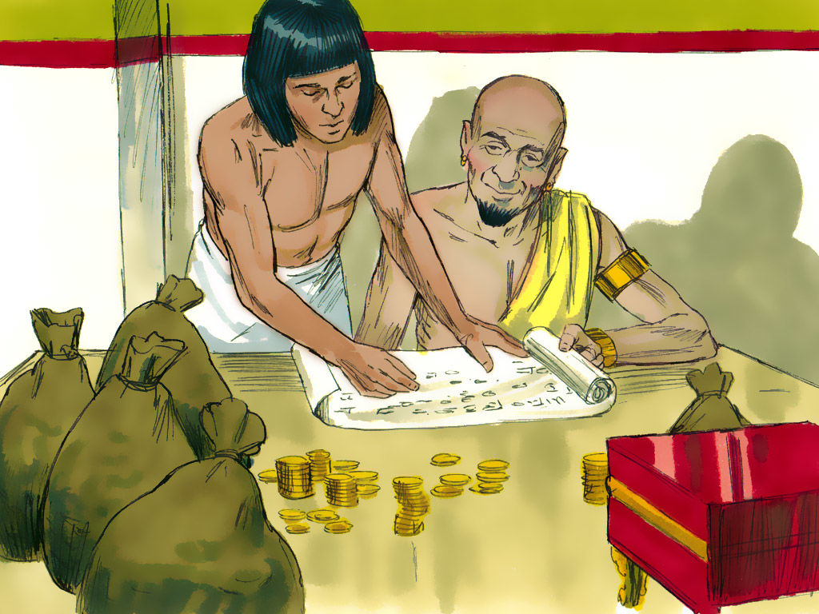
Potiphar entrusted his possessions to Joseph, because he proved trustworthy.
Find in Luke 12:42–48 how Jesus said we are to manage material possessions.
- How will Jesus reward good stewards when he returns? [Answer: verses 42–44]
- How will Jesus treat people who disobey him with their possessions? [Answer: verses 45–47]
- What does Jesus expect from people who possess much? [Answer: verse 48]
Find in 1 Corinthians 4:1–4 what God says about stewards of His truth.
- What does God require of us stewards? [Answer: We must be found trustworthy]
- Who examines us who are stewards?
[Answer: Others, courts and the Lord Himself]
Find in 1 Thessalonians 4:1–8 how we are to manage our bodies.
- Who has authority over our bodies? [Answer: verses 1 & 2]
- How are we to use our bodies during our life on earth? [Answer: verses 3–5]
- What will the Lord do, if we deceive others with our bodies? [Answer: verse 6]
- What does God give to us to enable us to manage our bodies? [Answer: verses 7 & 8]
Find in 1 Peter 4:10–11 how to manage your spiritual gifts.
- Which of us has received a spiritual gift from God? [Answer: Each of us]
- For what uses are the two kinds of spiritual gifts?
[Answer: Speaking for God, serving for God]
- From whom do we gain strength to use our spiritual gifts? [Answer: From God]
- Who is supposed to get glory, when we employ our spiritual gift? [Answer: Jesus Christ]

Plan with your co-workers additional activities to do during the week.
- Talk together about how well you and they have been managing
1) your possessions,
2) the possessions of others,
3) God’s truth,
4) your bodies and
5) your spiritual gifts. Let each one tell how he could manage these things better.
- Visit believers who need to be better stewards. Read some Bible verses like those above, and pray with the believers for God to help them to be faithful.

Plan with your co-workers additional activities for the up-coming worship.
- Read and explain Bible passages that talk about stewardship, like those cited above.
- Explain these truths about stewardship:
God is the creator and owner of every good thing.
God entrusts many things to every person. (Life, body, land, animals, possessions, jobs, mates, children, knowledge, money, the Bible, spiritual gifts, etc.).
God is completely faithful to us with the promises He has made.
God wants to help us to be faithful to Him with all that He entrusts to us.
God will judge everybody for how faithful they were.
God will bring chastisement to every believer who deceives others.
God will reward those who were faithful to Him with all that they have.
- Invite the believers to tell about how God has been helping them to be better stewards.
- Mention things that God has entrusted to us as his stewards
Our bodies which we are to feed, protect and keep holy.
Our land which we are to use and to protect from erosion.
Our animals from which we are to live and to treat humanely.
Our money with which we meet our needs and others’ needs.
Our children whom we are to raise, care for, and evangelize.
Our parents whom we are to honour and care for.
Our house and possessions which we are to share as needed.
Our spiritual gifts, by which we are to serve one another.
Our knowledge which we are to pass on to those who need it.
Our faith in Jesus which we are to put into practice every day.
- To introduce the Lord’s Supper, read 2 Chronicles 35:15-19.
Explain that the good king Josiah had God’s people celebrate the Lord’s Passover Feast, which they had neglected. The Lord’s Supper is the Christian’s Passover Feast.
- Have the believers and guest form small groups of two or three. Let them confess needs, express their intention to be better stewards, and pray one for another.
- Those who teach children should read study #60 for children.

Even the poor must steward their possessions.

