Self-supporting, Bi-vocational ’Tentmakers’

Anchor command. Make sure that your character is free from the love of money, being content with what you have; for He Himself has said, “I will never desert you, nor will I ever forsake you” Hebrews 13:5

Anchor story. Aquila, Priscilla and Paul served Christ as ‘bi-vocational’ tentmakers. Acts 18

Anchor verse. “These hands ministered to my own needs and to the men who were with me. … Remember the words of the Lord Jesus, that He Himself said, ‘It is more blessed to give than to receive.’” Acts 20:33-35

Learning goal. Affirm that Paul and other apostles and church planters often served the Lord without pay, supporting themselves by manual labor.

Growth goals. Be willing, even eager, to serve as self-supporting (bi-vocational) “tentmakers,” or, if receiving pay, respect and multiply volunteer, non-paid workers.

Skill goal. Mobilize many bi-vocational pastors and church planters.

Outcome goal. Many volunteer workers support themselves and serve the Body of Christ
Basic Study

Lord Jesus, we love you and want to serve you. Please, prosper the work of our hands, so that we can meet our daily needs, can continue serving your Body, and can extend your Kingdom into neglected places.
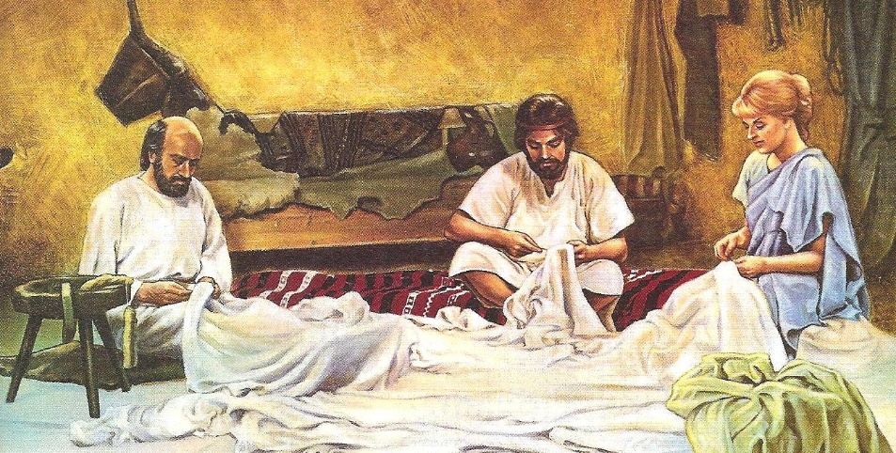

Aquila and Pricilla had a small business and employed Paul.
Learn from the activities of Priscilla and Aquila, Acts 18.
- Why did Priscilla and Aquila have to leave Rome and settle in Corinth? Verses 1-2
- Why did the apostle Paul stay with Priscilla and Aquila? 3
- How did the three workers earn their living? 3
- How did the Lord assure Paul of his safety? 9-10
- How Long Did Paul stay in Corinth? 11
- What people tried unsuccessfully to have Paul arrested for his teaching? 12-16
- Where did Paul, along with Priscilla and Aquila, sail to? 18
- What powerful speaker did Aquila and Priscilla mentor in Ephesus? 24-26
- How did Apollo’s crew to the Jews that Jesus was the Christ? 27-28
Plan with coworkers activities that you and your coworkers will do next week. Ask God to help you find and mobilize several bi-vocational workers to evangelize and gather new churches.
During worship…
- Tell the story of Paul, Priscilla and Aquila, and ask the believers questions about it.
- Ask what the story tells them about the way Christian workers can be supported.
- Encourage the believers to talk about bi-vocational work.
- Let bi-vocational workers give a testimony of how God has blessed their work.
- Encourage the believers to look for ways in which they can serve the Body of Christ while earning their own living.
- Ask the children to present what they have prepared. Those who teach children should read study #58 for children.
- To introduce the Lord’s Supper, read Matthew 22:1-14 about the man who attended a wedding who did not wear the proper garment. Compare that to Aaron who had to wear the special priestly costume when serving at the altar.
Explain that we, too, must “put on Christ” as our spiritual clothing when we come to the Lord’s Table.
- Memorize together Acts 20:33-35.
Advanced Study
- Prepare your heart and mind by prayer and the Word of God to recruit new workers.
In many places shepherds and apostles must have another job to support themselves while serving the Body of Christ, as Aquila and Priscilla did. These places include …
a. Where believers are starting many new congregations and cells.
b. Where you, or the apostles that you send, need to demonstrate a proper attitude toward labour, as Paul did for lazy Thessalonian Christians, 2 Thessalonians 3:6-13.
c. Where civil authorities are hostile towards followers of Jesus.
d. Where believers are too poor to pay their shepherds and must train many new leaders rapidly.
- As your flock reproduces by starting new cells and congregations, you must recruit new leaders and help them to know what they are to do, and to serve steadily. As you start new flocks in other towns and far-away places, perhaps you or the apostles you send can start a small business to support themselves.
- Find in Romans 16:3-5
- How the Apostle Paul described Aquila and Priscilla who supported themselves. (3)
- Whether the place they and Paul worked in together was a safe or was hostile. (4)
- Where the congregation that they attended met. (5)
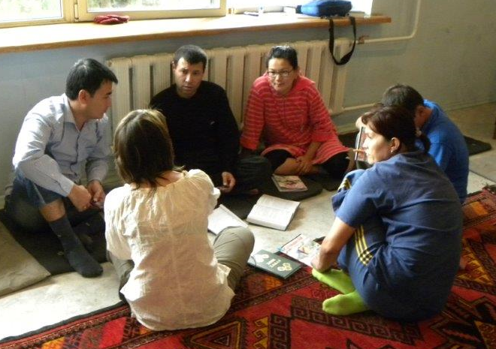

Plan with your co-workers activities for the week and for starting new flocks.
- Review with your co-workers what you learned about Aquila and Priscilla. Explain to your co-workers that they have two jobs, a secular job to earn their living and a pastoral job that they do for the Lord. Discuss with them whether members of the flock should start a small business that would allow them to go start new flocks.
- Describe what kind of small business ‘tentmakers’ should develop.
It should be a business that can be taken to another town or city.
The business should be small enough to manage by themselves.
They should be able to employ a co-worker who also works to start new flocks.
It should be easy to start, using a simple technology and inexpensive materials.
It should provide contact with people of the local community.
It should allow bi-vocational workers to choose their own working hours.
It should enable them to serve the Lord in their own home.
- Pray to discern the Lord’s will about the business.
- Discuss what kind of shepherding work they should do. Since they will not have many resources or a lot of free time, they must…
Lead a new flock in their own home until others open their homes.
Make disciples in small flocks, not in public places or chapels.
Coach new leaders privately or in very small groups.
Obtain training materials like the study you are reading right now.
Studies should be cheap, easily-copied, and menu-driven (having options from which to choose).
- During worship, have the believers form small groups to encourage one another, plan together and pray one for another and for people living in neglected towns.

