Jesus Commanded us to Give Freely
Anchor command. “Give, and it will be given to you.” Luke 6:38
Anchor story. Barnabas and others give generously, whilst Ananias and Saphira lie about their gift.
Acts 4:32 through 5:14.
Anchor verse. “He who sows sparingly will also reap sparingly, and he who sows bountifully will also reap bountifully. Each one must do just as he has purposed in his heart, not grudgingly or under compulsion, for God loves a cheerful giver.” 1 Corinthians 2:6-7
Learning goal. Understand accurately what the New Testament instructs about giving.
Growth goal. Give cheerfully.
Skill goal. Convince believers that by giving now, they are laying up treasures in heaven.
Matthew 6:19-20
Outcome goal. Believers give sacrificially, without being prodded.
Heavenly Father, you gave to us your Son Jesus and eternal life. You give to us all kinds of good things to enjoy. Please, help me and my congregation to share your good gifts with those in need.

Basic Study
Learn from how the believers in the first church in Jerusalem gave. Acts 4:32 through 5:14.
- Why were there no needy people among the Christians? 4:35
- Who set an example of generous giving? 4:37
- What was the lie that Ananias and Saphira told to God? 5:1-4
- What happened as a result of this deception? 5:5-10
- What was the result 5:11
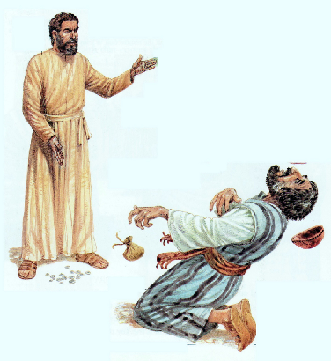
Ananias fell dead, when he lied to Peter about money.

During the week, find out if there are people with urgent needs, and take a collection for them.
During worship…
- Tell the story of how the first Christians gave, and ask the questions above. Let the people discuss the answers.
- Ask the children to present what they have prepared.
- Memorize Matthew 6:20-21: “Store up for yourselves treasures in heaven, where neither moth nor rust destroys, and where thieves do not break in or steal.”

Advanced Study
- Prepare your heart to give generously and to teach your flock to do the same.
- Find in Acts 2:44-45 how the first believers gave to meet needs.
a) Which believers gave?
b) To whom did they give?
[Answers: a) All who had something to give. b) To all who had needs.]
- Find in Acts 4:32-37 how Barnabas gave to help needy believers.
a) What did he have to sell?
b) To whom did he give?
[Answers: a) Land. b) To the apostles to be distributed to the needy.]
- Find in Acts 11:28-30 how congregations should help others in need.
a) How much did the believers give?
b) To whom did they give?
[Answers: a) What they were able to give. b) To needy believers in Jerusalem.]
- Promises that God makes to those who give:
- Find in Proverb 19:17:
a) To whom are we to give?
b) What is God’s promise?
[Answers: a) To the poor. b) The Lord will pay back what we give.]
- Fin d in Luke 6:30-38:
a) To whom are we to give?
b) What is God’s promise?
[Answers: a) To all who ask of us. b) It will be given back to us with the same measure.]
- Find in 2 Corinthians 9:1-11:
a) To whom are we to give?
b) How much are we to give?
c) What is God’s promise?
d) How we should feel about giving
[Answers: a) To needy Christians. b) Whatever we determine in our heart. c) We will always have enough to give. d) Joyful.]
- Find in Philippians 4:13-19:
a) To whom we are to give.
b) What God promises.
[Answers: a) To apostles who start new congregations. b) God will supply all that we need.]
- Find in Matthew 6:19-21 where we should store our treasure.
- Find in Matthew 6:31-33 what we are to seek first.
Jesus warned that we cannot love both God and money.
- During the week, arrange for the believers to care for needy people in the community.
- Plan with your co-workers additional activities for the up-coming worship time.
- Recount or act out how a forgiven woman showed love for Jesus, Luke 7:36-50.
- Recount or act out how a poor widow gave to God her last small coin, all that she had to live on, Mark 12:38-44. Or have the children dramatize this story.
- Have the believers read or recite Bible verses about God’s great gift to us. John 3:16-17; John 6:47-51; 1 John 3:16-17; Romans 6:23.
- To introduce the Lord’s Supper, read 2 Chronicles 35:17-19. Explain that we celebrate the Passover, and that God replaced the Passover lamb with His gift, Jesus, the ‘Lamb of God.’
- Those who teach children should read study #57 for children.
Encouraging Bible Verses on Giving and Receiving
1 Chronicles 29:9–13  1 Corinthians 16:1–4  1 John 3:16-19  1 Timothy 5:3-5  2 Corinthians 9:7–8  Acts 11:28-30; 20:32–35  James 2:14-16 | Luke 7:36-50; 14:12–14  Matthew 6:19–21; 6:31-33; 19:28–30; 25:34-35  Philippians 4:13-19  Proverbs 11:24–28; 19:17; 21:13; 22:9; 28:27  Psalm 39:4-7  Romans 10:13-15; 15:20–25  Deuteronomy 8:15–19; 15:11

