A Poor Widow Gave to the Lord
All She Had
Father, please use this study to encourage the children to give cheerfully to others.
Choose any of the children’s activities below.
- Read or tell the story of the poor widow, Luke 21:1-4.
- Before telling the story, ask the children to listen carefully, to discover the kind of giving that pleases God.
- After telling the story, ask:
What did the poor widow put into the offering?
How much did the widow give out of what she had to live on?
What did Jesus say about the widow’s offering?
Were the rich people sacrificing much to give to God?
Who gave more in God’s eyes, the woman or the rich people?
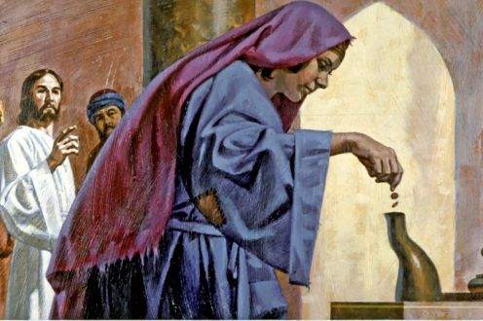
Jesus saw a poor widow give her last few coins to God.
- Draw a picture of old Roman coins; explain that it illustrates how we should give to God.
Let the older children help the younger ones.

- .Explain that we should give freely, joyfully and generously from the heart,
like the widow gave, and not because we are forced to give.
- Some children might like to copy or colour the picture found at the endo of this lesson.
- Let the children explain their picture to the adults during the next worship time.
- Read or tell the story of the generous old man of Gibeah from Judges 19:14-21.
- Dramatize the story of the generous old man from Judges 19:14-21.
Older children play these parts:
Narrator. Read the story and help the other children remember what to say.
Levite.
Old man
Younger children play these parts:
Manservant
Maidservant
Donkeys Walk on both hands and feet (or knees) like donkeys.
Gibeonite

Narrator “This is the story of a Levite who travelled through ancient Israel with his maidservant and manservant.”
(Read Judges 19:14-21.)
Manservant “Master, the sun has set. We should go no farther.”
Maidservant “Let us enter this town and look for a place to sleep.”
(They walk to one side and pretend to knock on a door.)
Gibeonite “What do you want?”
Levite “Please give us lodging. We are travelling and need a place to spend the night. We will pay!”
Gibeonite “I do not want travelers in my house!
Go sleep in the city square, on the ground!”
Narrator “They ask to stay at several houses but no one lets them in.”
Levite “Come. We must sleep in the open square. Keep watch.
It is not safe here.”
(They walk a short distance and sit down.)
Old man “Peace! Where are you going? It is dangerous here.”
Levite “We are going to Ephraim. No one will take us into their house.
But we have enough food for our donkeys, and some bread and drink.”
Old man “Let me take care of all your needs.
Do not spend the night in the open square.
Come to my house. I will give your donkeys some grain.”
Donkeys Make braying sounds like donkeys.
All (Walk off.)
Narrator “The old man fed the donkeys, washed the feet of the travelers,
and gave them bread and drink.”
Thank everyone who helped with the drama, and thank the adults for listening.
Ask the children what good example of giving they saw in the drama.
[Answer: the old man gave freely, even to strangers.]
- Arrange with the worship leader for the children to present what they have prepared.
- Let the children present to the adults the drama of the old man.
- Let the children ask the adults what good example of giving they saw in the drama.
- One of the children may also want to tell about the poor widow,
and then ask the questions listed above under #1.
- Let children recite one or more verses from Psalm 50:1, 9, 10, 12 and 23.
- Older children write a poem, song or short story about giving to others.
- Memorize Luke 6:38:
“Give, and it will be given to you. They will pour into your lap a good measure--pressed down, shaken together, and running over. For by your standard of measure it will be measured to you in return.”
- Let an older child pray:
“Lord, you own everything in this world and you have given us so much. We are grateful. We want to show our thankfulness by giving to you cheerfully like the poor widow did. Help us to give generously and from the heart.”

