Jesus Died and Rose back to Life so that
Children Can Live Forever
Dear Lord, use this study to strengthen the children’s trust in the life-giving resurrection of our Lord Jesus Christ. In his name we pray, Amen.
Choose any or all of these children’s activities.

Third day after he died, Jesus came back to life and left his burial tomb.
- Let an older child read or relate by memory the account of Jesus’ resurrection, Luke 24.
Ask these questions:
- What frightened the women that came to the tomb on Sunday morning?
(Verses 4 & 5)
- What did the Angels tell the women about Jesus? (6)
- Why were Jesus’ disciples frightened when Jesus first appeared to them? (36-37)
- What did Jesus do to prove to the disciples that he was not a ghost? (38-43)
- What did Jesus open the disciples’ minds to understand? (44-45)
- Of what things did Jesus tell his disciples that they would be witnesses to, to all nations? (46-48)
- Where did Jesus go to, when he left disciples in the village of Bethany? (50-51).
- Let a teacher or older child explain to the children:
When your body falls asleep in death, your spirit will not die.
Rather, you will instantly become more alive with Jesus than you ever were.
We live forever by the body and blood of Jesus, who died and rose for us.
- Let the children ask the adults the questions under #1 above during the worship time.
- Dramatize the account of Jesus rising from the dead, Luke 24.
- Actors do not need to memorize their lines: read them, as the aim is not to perform but to relive sacred events.
- Older children help younger ones prepare.
- Arrange with the main worship leader to present the drama to the adults.
- Older children play the parts of Jesus, Angel and Narrator.
Younger children play the parts of Women and disciples.
Narrator After Jesus died, they buried him in a tomb, where he lay in death over the seventh Sabbath day of rest. Hear what happens early on Sunday, the first day of the week.
Women (Some say) Let us take these spices to anoint Jesus’ body,
but we need someone to roll away the huge stone from the entrance
(Others say) Look! Someone has already rolled away that stone!
(Others say) Oh, help! Angels!
Angel Don’t be afraid. You seek Jesus. He is not here; he has risen.
Go and tell his disciples.
Narrator The women told Jesus’ disciples that he had risen, but they did not believe the women. When they were gathered, Jesus suddenly appeared to them,
and they were terrified...
Disciples (Some say) Look! It’s a ghost!
(Others say) It can’t really be Jesus; he is dead.
Jesus I am not a ghost. A spirit does has no flesh and bones like you see that I have. Give me a piece of fish to eat, to prove that I am truly risen from the dead.
Disciples (Some say) It really is Jesus!
(Others say) He really has risen from the dead!
Jesus Now listen to me as I open your minds to understand the Scriptures.
Narrator Starting with Moses and throughout all the prophets,
Jesus showed his disciples how they all spoke about him.
- Children may copy this picture of the empty tomb.
- Older children help the younger.
- Some children might like to colour the picture found at the end of this lesson.
- Show the pictures to the adults during worship, or to parents, and explain that it reminds us that Jesus rose from the dead.

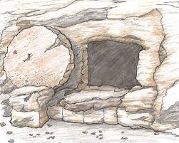
- Memorize 10:9:
“If you confess with your mouth Jesus as Lord, and believe in your heart that God raised him from the dead, you will be saved.”
- Let an older child pray:
“Dear Lord, we thank you with all our hearts that Jesus rose from the dead and promised that all believers will also rise from the dead. Your Holy Spirit has placed us into Jesus’ eternal body, so that we will live with him forever. In his name we pray, Amen.”

Two additional 5-minute dramas with more detail that deal with Jesus rising from the dead:
http://biblestoryskits.com/029-Jesus-appears-to-many-after-rising-from-death/

http://biblestoryskits.com/028-Jesus-rises-from-the-dead,-as-seen-by-angels/

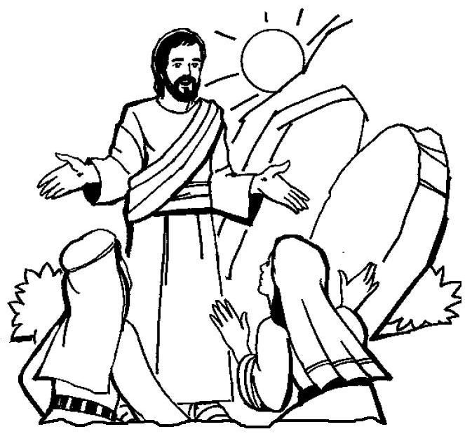

After Jesus died, they buried him in a tomb. Three days later, Jesus came back
to life and presented himself alive to hundreds of folk who knew him.

