Philip rides in a Chariot and
Tells about Jesus

Teach Children to Tell the Good News about Jesus
Choose any of these children's learning activities that fit their needs.
- Let an older child or teacher read the story of Philip and the Ethiopian, Acts 8:26-40.
It recounts how the Holy Spirit helped Philip to tell the Good News about Christ to a man in a chariot. The man was from Ethiopia and, at first, did not understand the Scriptures.
Let the children copy this picture. Some children might like to colour the picture found at the end of this lesson.
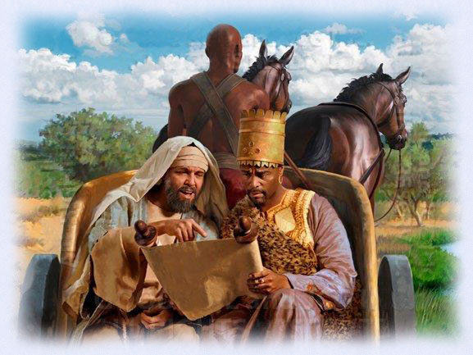
After Philippe explained about Jesus from the Book of Isaiah,
an Ethiopian official asked to be baptised.
After telling the story from Acts 8:26-46, ask these questions.
[Answers are provided at the end of each question.]
- Who told Philip to go on the desert road? [See verse 26]
- How quickly did Philip obey the Spirit’s command to go up to the chariot? [30]
- What was the Ethiopian reading?
[See verse 30. He was reading from the prophet Isaiah, who had lived several hundred years before, Isaiah 5.3]
- Whom was the Scripture talking about in this prophecy of the future?
[See Acts 8: 32; it was about Jesus, who had died like a lamb led to slaughter]
- How soon did Philip baptize the Ethiopian? [See verse 38]
- Dramatize parts of the story about Philip and the Ethiopian.
- Arrange with the leader of the main congregational worship to present this brief drama. Use your time with the children to prepare the drama.
- Older children or adults play these parts:
Narrator. Summarize the story and help the children remember what to say.
Philip
Younger children play these parts:
Ethiopian
Horses (one or two)
Voice (of the Spirit of God)

Narrator: Tell the first part of the story from Acts 8:26-35. Say,
“Hear what the angel says to Philip.”
Voice: “Philip, go on the desert road. Now, do you see that chariot?
Get close to it.”
Horses: Stand in front of two chairs that represent a chariot. Walk like horses.
Ethiopian: (Seated on one of the chairs). Read Isaiah 53:7-8. Say,
”I do not understand this. Who is this lamb?”
Philip: “I will explain it.”
(Sit on the other chair.)
“This ancient prophecy is about Jesus who died like a lamb for us.
Narrator: Tell the second part of the story from Acts 8:36-40. Say,
“Hear what the Ethiopian says.”
Ethiopian: “Look, here is water! What prevents my being baptized?
Philip: “If you believe in Jesus with all your heart, then you may be baptized.”
Ethiopian “Whoa, horses! Stop!”
Horses: Make neighing sounds. Act like horses raising front legs and pawing the air.
Philip: (Walk to the side with the Ethiopian and pretend to baptize him.
Then run and hide.)
Ethiopian: “Where is that man? He baptized me and disappeared!”
Narrator: Thank everyone who helped with the drama.

- If the children dramatize this story for the adults…
- Let the children ask the adults the questions that are listed under #1 above.
- An older child might also ask the adults,
“What are other ways that the Holy Spirit leads us to talk to people about Jesus?”
- Let anyone cite examples.
- Draw or show a picture of a road in the desert like this one.

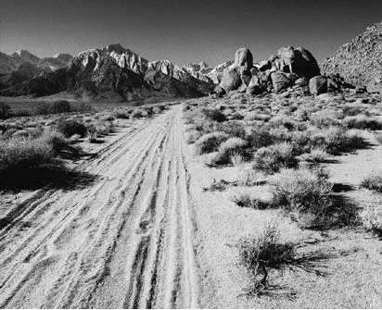
- Let the children copy the picture and show their pictures to their parents,
and to the adults at the next worship time.
- Then let them draw a horse pulling a cart with two men in it.
- Let the older children help the younger ones.
- Memorize John 3:16.
- Let three children each recite one verse from Isaiah 53:6-8.
- Some older children may want to write a poem or song about Philip and the Ethiopian.
- Let an older child pray:
“Father, we want to follow your Spirit when He leads us. Please lead us to the people who are ready to hear the Good News. Help us remember Bible stories to tell them about your Son Jesus. We want everyone to know about the wonderful things you have done.”
More detailed drama to act out, about Philip baptizing the Ethiopian in a desert:
http://biblestoryskits.com/006-philip-baptizes-an-ethiopian-official-in-private

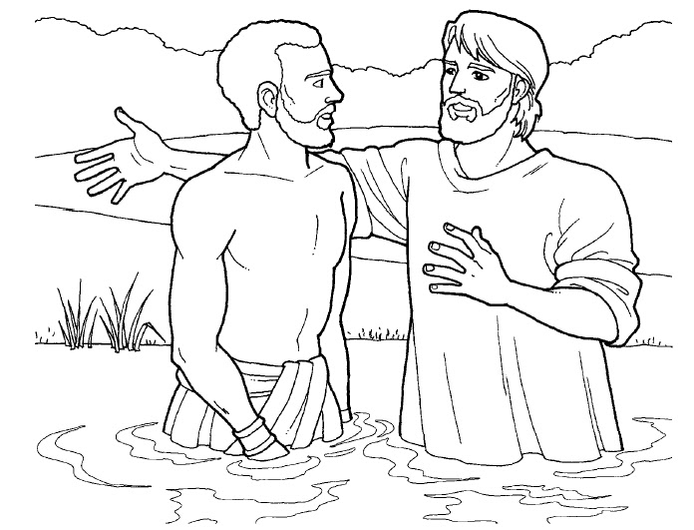
Phillip and an Ethiopian official went down into water to baptise him.

