God Saves All Who Walk with Him
as Noah Did
Anchor command. “Believe in the Lord Jesus, and you will be saved, you and your household.”
Acts 16:31
Anchor story. Noah and the great flood. Genesis 6:5 through 9:1.
Anchor verse. “Having been made perfect, (Jesus) became to all those who obey Him the source of eternal salvation.” Hebrews 5:9
Learning goal. Know accurately what God says about the salvation of sinners.
Growth goal. Learners trust in Christ, and in nothing else, for their eternal salvation.
Skill goal. Assure believers of their eternal salvation.
Outcome goal. Believers are assured of their salvation, and they assure others of their salvation, in the power of the Holy Spirit.
Oh, God our Saviour, please save the people with whom we share your Good News. Save us from evil while we wait for Jesus to come back and save us from death.

Basic Study
Learn from the account of Noah and the great flood, Genesis 6:5 through 9:15.
- Find in Genesis 6:5-13 why God destroyed the people he had created.
- Find in Genesis 6:8-9 why God spared Noah and his family.
- Find in Genesis 6:13-22 how God saved Noah and his family from the great flood.
[Answer: Noah and his family built and entered an ark and so did not drown. The Hebrew word ‘ark’ meant a large box. Noah’s ark was a huge box that floated like a boat.]
- How long did the water prevail over the earth?
- Who, and what, did the ark shelter? 7:7-9
- How long did the water prevail over the land? 7:24
- What is the sign in the sky, reassuring all mankind that God will never again destroy them with a flood? 9:11-15
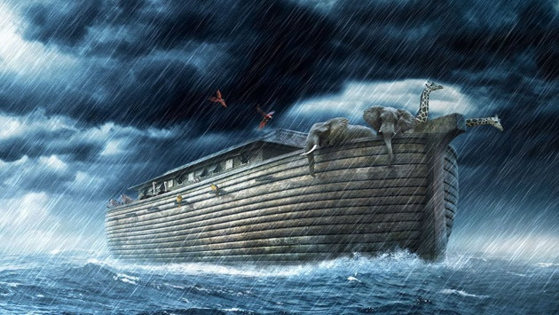
During the week visit those who have visited your congregation and invite them to be saved.
During worship
- Tell the story of Noah, and ask the same questions as above. Let the people discuss the answers.
- Memorize together John 3:16: “For God so loved the world, that He gave His only begotten Son, that whoever believes in Him shall not perish, but have eternal life.”
- Ask the children to present what they have prepared.

Advanced Study

Prepare your flock to enjoy salvation, and to lead sinners to the Saviour.
Find three things in Luke 24:46-48 that the risen Jesus commanded us to tell all nations.
[Answers: Jesus’ death, his resurrection, and God’s forgiveness to all who repent.]
Find in Luke 24:46 two great deeds that Jesus did to save us.
[Answer: 1) by His shed blood God forgives our sins, 1 John 1:7. 2)] by His resurrection He imparts to us new, holy eternal life, Rom. 6:3-14.]
Find In Ephesians 2: 5-6, in whom are we raised to heaven?
Find in 1 Corinthians 12:1-13, who places us in Jesus’ eternal body. [Answer: the Holy Spirit]
Find in 1 Corinthians 15:21-23, through whom our resurrection comes.
Find in Romans 6:3-14, to what we die to be raised to new, holy life.
Find in 1 Peter 3: 18-22, how the ark signified Jesus’ risen body.
Find in 1 Peter 3:21 two aspects of baptism that Peter clarified.
[Answer: 1) washing the flesh-with water, 2) a clean conscience.]
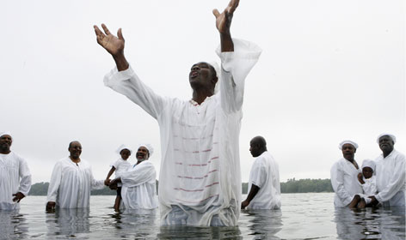
Those who trust in Christ and are baptised gain a clear conscience.
Which of these two aspects of baptism leads to salvation, the physical water or the spiritual cleansing from God?
[Answer: Peter clarified that we are not saved by the physical ceremony of washing dirt from our bodies, but by Jesus’ resurrection in which those with a good conscience toward God share. A ‘good conscience’ requires faith and repentance, John 3:16; Acts 2:38.]
Find in Genesis 17:19-22 how God saved Lot and his daughters from being killed when angels destroyed the towns of Sodom and Gomorrah.
[Answer: Angels sent them out of the town to a safe place.]

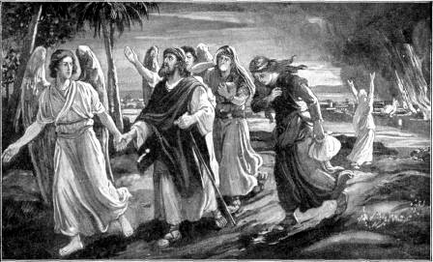
Angels led Job and his household from Sodom to safety.

Find in 2 Peter 2:4-9 the two instances of salvation from physical death that Peter cited to illustrate how God saves us believers from spiritual death and eternal judgement.
[Answers: 1) God rescued Noah and his family from a great flood. 2) God rescued Lot and his family from a great fire.]
Find in Exodus 14:21-31 how God saved the Israelites.
[Answer: He divided the sea so they could escape, and later drowned the Egyptian army that was pursuing them, in the same sea.]
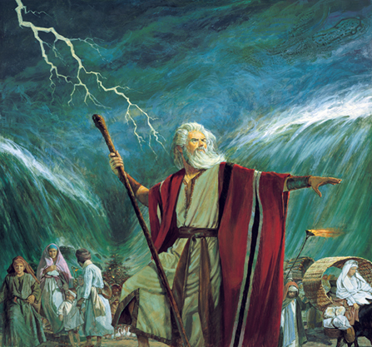
Yahweh opened a dry road across a sea bed for Moses and the Israelites.
Find the things from which Jesus saved people who trusted Him.
(1) Luke 7:36-50, sinful folks.
(2) Matt. 4:23-25, the sick.
(3) Mark 6:34-42, hungry folks.
(4) Mark 5:1-15, the demonised.
(5) Luke 7:11-16, those who died.
(6) Luke 17:12-19, the unclean.
[Answers: 1) He forgave their sins. 2) He healed them. 3) Jesus multiplied a little food and fed many. 4) He delivered folks from evil spirits. 5) He sometimes raised people from death to life. 6) He cleansed lepers who believed in him.
Find things in these texts that Jesus will do for all who believe:
(1) John 6:39-47.
(2) Matthew 25:31-40.
(3) 1 Thessalonians 1:8-10.
(4) Colossians 2:15.
[Answers: 1) Raise dead believers from their graves to eternal life. 2) Reward all believers when He returns. 3)Protect us from the coming wrath of God. 4) Demonic powers.]
Find what we must do so that God will save us forever:
(1) Ephesians 2:8-10.
(2) Acts 2:37-38.
(3) 1 Thessalonians 1:8-10.
(4) Hebrews 5:7-9.
[Answers: 1) believe. 2) Repent. 3) Wait for Jesus to come from heaven. 4) Obey Jesus.

Plan with your co-workers additional activities for the coming week.
Visit the sick, the discouraged, and the oppressed, and pray for them that God may save them from their troubles.

Plan with your co-workers the next worship meeting.
Tell or act out the story of Noah.
Explain how God saved people from many bad things (See part 1, above.)
Explain how people today can be saved forever.
Have the children present the drama they have practised. Let them ask the adults the questions they have prepared.
Have the believers form small groups and let them pray for the salvation of their relatives and friends. Pray that the Lord will save the neglected ethnic groups in your country.
To introduce the Lord’s Supper, briefly recount how the Israelites who painted their doorways with blood were saved from the death angel who killed the first-born children in Egypt, Exodus 12:1-14. Explain how we are now saved through faith in the blood of the Lord Jesus in which we participate through the Lord’s Supper.
Those who teach children should read study #54 for children.

