A Paralyzed Man Got to Meet Jesus

Teach children that Jesus Christ wants to save them.
Dear Lord, we praise your power to overcome the suffering that evil causes. You sometimes heal us and always forgive our sins. Thank you for taking evil from our hearts and giving us a life that will last beyond death. We know that when we are finally with you, there will be no more suffering.
Choose any of these children's learning activities.
- Let an older child or teacher read about the Paralyzed Man Who Met Jesus, Mark 2:1-12.
It tells how we can help our friends to meet Jesus who can save them.
After telling the story, ask these questions:
- What did the sick man’s friends do when they heard that Jesus had come? (See verse 2)
- How did the sick man’s friends get him to Jesus? (4}
- What did Jesus notice about the man’s friends? (5)
- What did Jesus say first to the sick man? (5)
- What did the teachers of the law think of Jesus’ words? (7)
- How did Jesus show that he had power to forgive people’s sins? (10-12)
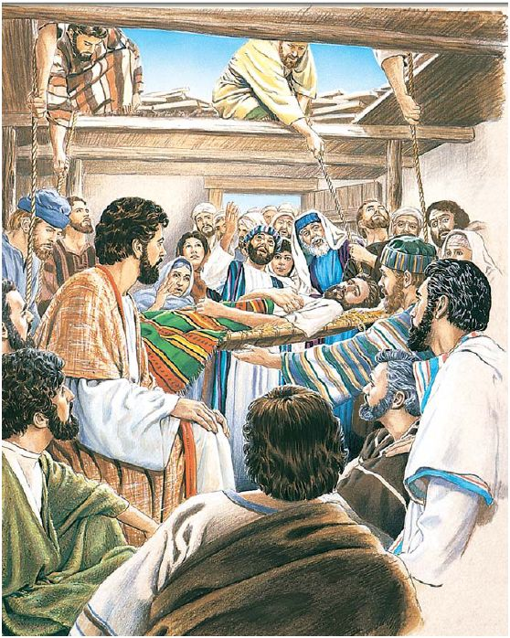
Jesus first forgave a paralytic all of his sins.
Jesus next healed the man and sent him home.
- Dramatize the account of Jesus healing the paralyzed man, Mark 2:1-12.
Use your time with the children to prepare the drama. You do not have to use all the parts.
Older children or adults play these parts:
Narrator (Tell the story and help actors remember what to say.)
Jesus
Younger children play the parts of:
Paralyzed man
Four friends
People
Teacher of the law
Narrator Tell the first part of the story from Mark 2:1-4. Say,
“Hear what the friends of the sick man say.”
Friend 1 “Jesus is in that house. Let us take our paralyzed friend to Jesus.
Jesus can heal him.”
(The four friends pretend to carry the sick man.)
Friend 2 “But there are too many people in the house!”
Friend 3 “How will we get our friend into the house?”
Friend 4 “Let us climb onto the roof and open a hole in it.
Then we can lower him down with ropes.”
Friends (All four) Climb on chairs or a table and pretend to remove tiles from the roof.
Narrator Tell the second part of the story from Mark 2:5-7. Say,
“Hear what the people say.”
People (Some say) “Look! Those men are tearing a hole in the roof!”
(Others say) “There is dirt falling on me!”
(Others say) “Look, they are letting someone down on a bed!”
(Others say) “He’s coming down on my head.”
(Others say) “Move away! Give him some room!”
Paralyzed man Lie down under where the four friends are working.
Jesus Look up and say,
“Friends, I see your faith.”
Look down, touch the man, and say,
“Son, your sins are forgiven.”
Teacher Talk angrily. Say,
“How can this man forgive sins? Who does he think he is?”
Narrator Tell the third part of the story from Mark 2:8-12. Say,
“Hear what Jesus says.”
Jesus Say to the crowd, “I will show you that I can forgive sins.”
Say to the paralyzed man, “Get up and walk!”
Paralyzed man Jump up and say, “Praise God, I can walk!”
(Walk about.) “Look! I am no longer paralyzed! And my sins are forgiven!”
People (Some say) “We praise God!”
(Others say) “We have never seen anything like this!”
Narrator Thank everyone who helped with the drama. Thank the adults for listening.
- Let a child query the adults (if it is appropriate for children to do so in your culture):
“What are other ways that Jesus saves us from the power of evil in our lives?
(Let the people give examples.)
- Arrange with the worship leader for the children to present what they have prepared.
- Ask the adults the questions that are listed under #1 above.
- Present the poem and anything else that they have prepared.
- Draw a Picture of a bed that reminds us of the eternal rest that Christ gives us.
- Ask older children to help younger ones to copy it. They can show it to the adults at worship time. Children may also like to colour the picture found at the end of this lesson.
- Let them explain:
- The empty tomb shows how God saves us from all the results of evil and sickness.
- Although we suffer in this life, Jesus gives us a new, good life that lasts forever.
- Memorize Luke 19:10.
- Let three children each recite one of the verses from Psalm 25:1, 2 and 7.
To you, O LORD, I lift up my soul.
O my God, in you I trust; do not let me be put to shame;
do not let my enemies exult over me.
Do not remember the sins of my youth or my transgressions;
according to your steadfast love remember me,
for your goodness' sake, O LORD!
- Let the older children write a poem, song or short story, or give a testimony about an example of healing that they have seen, or how Jesus came into their hearts.

More detailed drama about Jesus healing the paralytic because of his friends’ faith:
http://biblestoryskits.com/005-jesus-forgives-a-paralytics-sins-because-of-his-friends-faith

