God’s Holy Spirit Gives Us Power to
Tell Others about Jesus
Choose activities that fit current needs and opportunities.
Dear Lord, please give to the believing children power from the Holy Spirit whom your Father sent on the day of Pentecost. Help them to use this power to serve you and other people, and to tell their friends what Jesus has done for them.
- Let an older child or teacher read or relate by memory the account of Pentecost,
Acts 2, verses 1-24 & 36-47.
Note: This great historical event happened when Almighty God’s Holy Spirit came and gave to the followers of Jesus power to serve people and to tell them about Him.
After telling the story, ask these questions. [Answers appear after each question.]
- What things happened when the Holy Spirit first came? [See verses 1-4]
- Why were Jews visiting in Jerusalem amazed when the disciples spoke? [5-6]
- Who stood and explained to the crowd that the Holy Spirit had come? [14-16]
- What did Peter say that Jesus did after people put Him to death? [22-24]
- What did Peter tell the people to do, to be saved and receive the Holy Spirit? [38]
- What activities did the first Christians start to do together? [42-47]
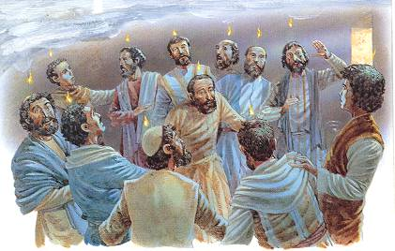
At the Feast of Pentecost, Jesus sent his Holy Spirit upon 120 of his followers,
in the form of flames of file.
- Dramatize parts of the story of Pentecost.
- Arrange with the worship leader for the children to present this brief drama.
- You do not have to enact the whole story. The narrator can explain what you omit.
- Use part of your time with the children to prepare the drama.
- Let older children help prepare the younger ones.
- Older children or adults play these part:
Peter
Narrator (Summarize the story and help children to remember what to say and do.)
- Younger children play these parts:
Disciples
Jews (who came from many countries, listed in Acts 2:8-11: Parthia, Media, Elam, Mesopotamia, Cappadocia, Pontus, Galatia, Phrygia, Pamphylia, Egypt, Libya near Cyrene, Rome, Crete and Arabia).
- If the group is small, then let the same children play the parts of both disciples and Jews.
Narrator Tell the first part of the story from Acts 2:1-13. Then say,
"Hear what Peter says to the disciples who were praying together on the
Day of Pentecost, a few days after Jesus went up to heaven.”
Peter Look up and shout,
“Listen! A loud noise sounding like a mighty wind!
Look! We have flames of fire over us!”
Narrator “Jews from many lands were in Jerusalem celebrating the feast of Pentecost.
They heard the sound and ran to see what it was.
They were amazed, because they heard Galileans, who spoke only Hebrew,
tell them about Jesus in their own languages.”
Jews (Some say) “I hear them speaking in my language. I am from Parthia.”
(Others say) “I hear them speaking in my language. I am from Media.”
(Others say) “I hear them speaking my language. I am from Rome.”
(Others say) “I hear them speaking in my language. I am from Arabia.
Narrator Tell the second part of the story from Acts 2, verses 14-24 & 36-40. Then say, “Hear what Peter says to the Jews in Jerusalem.”
Peter “God approved of Jesus who performed many miracles.
After our rulers killed him, God raised him from death!
Repent and let each one of you be baptized;
then your sins will be forgiven and you also will
receive the gift of the Holy Spirit.”
Narrator Tell the third part of the story, from Acts 2:41-47. Then say,
“Hear what the disciples say.”
Disciples (Some say) Now we love God.”
(Others say) “Now we love each other!”
(Others say) “We want to pray and worship God together.”
(Others say) “We take good care of each other now.”
Narrator Thank everyone who helped with the drama.
- If the children dramatize this story for the adults, then let them also ask the adults the questions that are listed above.
- Let the children tell other examples of how the Holy Spirit helps believers live good lives, and to tell other people what Jesus does for them.
- Draw a picture of a tongue of flame above a person’s head and let the children copy it.
Some of the children might like to copy or colour the picture found at the end of this lesson.
Let the children show their pictures to the adults during worship time, and explain that this illustrates how the Holy Spirit comes to live in us when we repent with faith and are baptized.
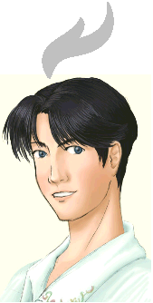
- Memorize John 16:13. Older children might prefer to memorize John 16:13-15.
- Poem. Let three children each recite one or two of the verses from Joel 2:28-32.
- Let older children write poems or songs about the Holy Spirit’s coming and His work in our hearts.
- Let an older child pray:
“Dear Lord, we thank you for sending your Holy Spirit to live in us. We want to use the power that he gives us, to live good lives and to tell other children about Jesus. Thank you for bringing us into your Body in congregations all around the world.”

More detailed drama, the Holy Spirit comes to live in believers at Pentecost, 5 minutes:

http://biblestoryskits.com/001-gods-holy-spirit-comes-at-pentecost-to-reside-in-believers-3/

