Water Baptism
Anchor command. “Repent and be baptized every one of you in the name of Jesus Christ for the forgiveness of your sins, and you will receive the gift of the Holy Spirit.” Acts 2:38
Anchor story. Philip baptizes an Ethiopian in a desert, Acts 8: 26-39
Anchor verse. “We have been buried with him through baptism into death, so that as Christ was raised from the dead through the glory of the Father, so we too might walk in newness of life.”
Romans 6:4
Learning goal. Know accurately what Scripture teaches about baptism.
Growth goal. Appreciate how God uses baptism to confirm repentance and faith.
Skill goal. Baptize, and teach others to baptize, in the same way the apostles did it.
Outcome goal. Believers baptize the newly reborn Christians without delay, as the apostles did.

Father, help us to receive through baptism those whom you draw to yourself and entrust to our congregation. Please use this study so that all believers will die to sin and rise to new, holy, eternal life through baptism, as you instruct us in your Word.

Basic Study
Learn from the story of the Ethiopian’s baptism, Acts 8:36-38
- Whom me did Philip meet on the desert road? 26-29
- What Old Testament prophet did the Ethiopian not understand? 28-31
- What did Philip explain to the Ethiopian, beginning from this text in Isaiah? 32-35
- What did Philip do to the Ethiopian immediately to confirm his salvation? 36-39

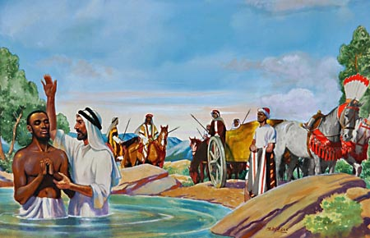
The evangelist Philipp baptised an Ethiopian official.

During the week…
- Arrange to baptize new believers who have not yet been blessed by obeying Jesus this way.
- Visit any believers who do not understand the need for baptism. Explain it to them, and arrange their baptism.
During worship
- Tell the story of Philip and the Ethiopian, and ask the above questions. Urge the believers to discuss the answers.
- Ask the children to present what they have prepared.
- Memorize Acts 2:38: “Peter said to them, “Repent, and each of you be baptized in the name of Jesus Christ for the forgiveness of your sins; and you will receive the gift of the Holy Spirit.”

Advanced Study
- Learn from Noah and others who modelled obedient faith.
Find in Matthew chapter 3:
- What kind of people needs baptism, verses 1-6? (Answer: Bad people.)
- What did John call the religious people who thought they were good enough to be baptized? (Answer: verse 7)
- Why did Jesus received baptism, even though he did not need it?
(Answer: verses 13–15, to do everything right.)

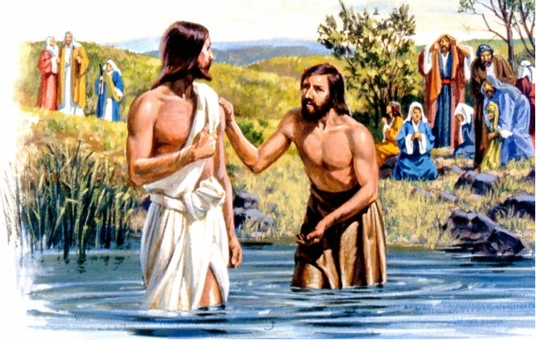
Jesus commanded John to baptise him.

Find in 1 Peter 3:18–22
- How did Peter compare Jesus’ resurrection body to Noah’s boat?
- However, neither a big boat nor an airplane can take us to heaven. Just as God saved Noah and his family in the ancient boat, so God raises us to new life in heaven because we are risen safely in Jesus’ resurrection body.
Find in Romans 6:1–14:
- To what thing does God tell us to die?
- With whom are we buried in baptism as we die to sin?
- Having been buried with Jesus, how are we united with him?
- What has been crucified with Jesus, before we can be united with him in his resurrection?
- After our old self, our old sin nature, has been crucified with Christ, as what kind of instruments do we offer all parts of our body, according to verses 6–14?
Find in Matthew 28:18–20, the final Great Commission of Christ:
- What did Jesus tell his followers to do, to make disciples?
(Answer: baptize them in the name of the Father, of the Son, and of the Holy Spirit, and teach them to obey all his commands.)
- By whose authority do we baptize new believers?
(Answer: verse 18, by Jesus’ authority.)
- Of what ethnic groups are we to make disciples?
(Answer: verse 19, all people groups.)
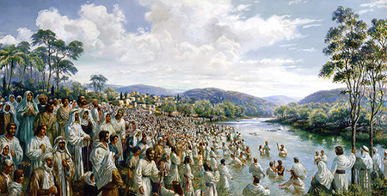
Jesus and his apostles baptised great numbers of new believers

Find in Acts 2:37–47:
- What Peter told the people to do, when they received his message.
(Answer: verses 37–38)
- Two blessings that Peter promised those who repented and were baptized
(Answer: verse 38)
- How soon the apostles baptized those who received Christ and received them into the congregation.
(Answer: verses 41–42)
- What the newly baptized people began doing immediately.
(Answer: verse 42)
Find in Acts 16:13–40:
- Two people whose families joined them in believing in Jesus and being baptized. (Answer: verses 13–15 and 25–31.)
- Why do we try at once to reach the family of a person who responds to Jesus?
(Answer: verse 31. Also, Acts 18:8 gives another example of an entire family being baptized together.)

2. Plan with your co-workers additional activities to do during the week.
- When you tell people the Good News, explain that they must turn from their old beliefs and way of life and be born anew in Christ. Confirm their faith and repentance without needless delay with baptism. You might start a new congregation with them.
- If baptism in public is dangerous, then baptize in private like Philip baptized the Ethiopian (Acts 8:27–40) and Paul baptized the Philippian jailer and his family (Acts 16:29–34).
- At their baptism some people may want to change their names

3. Plan additional, optional activities for the up-coming worship time.
- Explain from Romans 6:1–14 that in baptism we die and rise with Jesus to new life.
- Explain how Jesus says to make disciples, Matthew 28:18–20.
- Explain what Peter told the people to do that sought salvation, Acts 2:37–41\.
- Explain how the apostles baptized entire families, Acts 16:31, and why we try at once to reach the family of a person who responds to Jesus.
- Tell or act out the story of Naaman the Syrian general, from 2 Kings 5. Explain how he learned to obey God. Explain that in baptism the water does not wash away our sins any more than the Jordan River washed away Naaman’s leprosy. God does it.
- To introduce the Lord’s Supper, read Genesis 8:14–22 and explain that Noah’s new world began with the sacrifice of an innocent victim’s blood. Jesus’ sacrifice on the cross fulfilled this need forever.

