Jesus and His Apostles Proclaimed
the Good News
Anchor command. “You will receive power when the Holy Spirit has come upon you; and you shall be my witnesses both in Jerusalem, and in all Judea and Samaria, and even to the remotest part of the earth.” Acts 1:8
Anchor story. Jesus’ resurrection. Luke chapter 24
Anchor verse. “Thus it is written, that the Christ would suffer and rise again from the dead the third day, and that repentance for forgiveness of sins would be proclaimed in His name to all the nations, beginning from Jerusalem. You are witnesses of these things.”
Luke 24:46-48
Learning goal. Know the biblical record of Jesus’ death, burial and resurrection, and their significance.
Growth goal. Increasingly rely on this good news to bring sinners to faith, by God’s grace.
Skill goal. Tell the gospel accounts of Jesus’ death and resurrection, in the Holy Spirit’s power.
Outcome goal. Many people come to faith in Christ through the proclaiming of the Good News, both by learners and by those to whom learners tell the good news.
Basic Study
Prayer. “Dear God, help us through the power of your Holy Spirit to do the kind of evangelism that leads people to repent of their sins and to believe in your son Jesus Christ.”
Learn from Luke chapter 24 the account of Jesus’ resurrection.
- Read and review the story until you can recall it easily enough to tell to others.

Eyewitnesses who know Jesus saw him after he return from death to life.
- Find in Luke 24:5-9 what two angel messengers told women mourners about Jesus:
What sinners did to him.
How he died.
What happened on the third day after he died.
- Find in Luke 24: 36-48:
What Jesus proclaimed about himself, after he had risen back to life.
How he showed that he would come back from death and was not just a spirit.
What we believers are to proclaim to people everywhere (verses 47-48).
- Find in Luke 24:46-48 what Jesus promised to do for repentant believers.
During worship:
- Tell or act out Jesus’ appearances to His disciples after He rose from the dead, and explain what you learned from Luke 24. Ask questions about what you found.
- Have the children present to the adults the drama, or whatever they have prepared.
- Have the believers form small groups to:
Pray for friends and relatives to be saved.
Pray for ways to explain the Good News to them.
Plan when to visit them.
- Memorize together Luke 24:46-48.
- Those who teach children should read study #50 for children.
- Have believers memorize what one must know and do to be saved:
You need to know two things and do two things, to be saved.
TWO THINGS TO KNOW
1) God will send you to Hell because of the shameful things you have done.
2) Jesus came and died on the cross because of your shameful deeds, and He rose back to life to forgive you and to give to you his eternal life.
TWO THINGS TO DO
1) You must be sorry for your shameful deeds and turn away from them.
2) You must believe in Jesus who died and rose again to forgive you

Advanced Study
- Find in Acts 2:21-24 and 37-38, in Peter’s message to Jewish people:
- What Peter said about Jesus’ death and resurrection (2:21-24).
- What the Jews had to do to receive forgiveness and receive the Holy Spirit (2:37 - 38).
- Find in Acts 26:19-23 the message that Paul proclaimed to non-Jewish people…
- What what gentiles (non-Jews) had to do (20).
(Notice that God requires that both Jews and gentiles repent in order to be saved.)
- About Jesus’ death and what his resurrection enabled him to do (23).
- Find in Romans 6:8-14 what happened to us spiritually when we got baptized…
- When Christ died, who else died with him? (8-9)
- When Christ rose to life, who else rose with him?

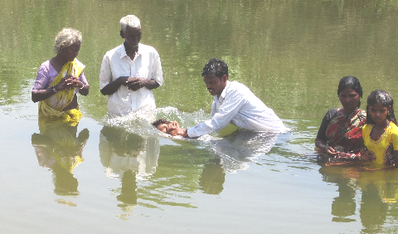
Scripture tells unbelievers to repent and to be baptized.

- Find in Luke 18:31-34 what Jesus foretold about himself before he died and rose back to life:
- Where would he die?
- What would Gentiles do to him?
- What would Jesus himself do three days later?
- With co-workers activities to do during the week.
- Visit unbelievers who have been healed or delivered by the power of Jesus, and explain to them the Good News; tell them the promises of Romans 5:10 and 10:9-10.
- Discuss with co-workers how you and they have been explaining the gospel, and plan always whom to visit to proclaim that Jesus was put to death and returned to life. Explain that people must leave their old life and trust Christ for new life.
- Use pictures. If your culture allows pictures of religious themes, then draw or copy a set of simple pictures that you and the believers can show to people while explaining to them the Good News of Jesus. The simple pictures below are examples.
The Good News in simple pictures
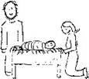 |  | 1. Jesus came into the world as a human, born at the time and place that holy men had promised long before.
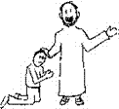 |  | 2. Jesus showed that he was the promised one, by doing good, healing the sick and demonized, and raising dead folks back to life. He also taught how to know God.
 |  | 3. Evil religious leaders condemned Jesus, and evil unbelievers killed him by nailing him to a wooden cross where he died.
 |  | 4. Authorities let Jesus’ friends bury him in a tomb. The Roman governor stationed soldiers by it to keep people away.
 |  | 5. Three days later, Jesus rose from the dead and appeared to many people. He told people everywhere to change their ways and trust him to forgive all their evil deeds and give them his own eternal life.
Prepare the believers to take a simple, powerful message to unbelievers,
like the one under the pictures above.
- Visit baptized believers who are discouraged, tempted or doubting, and explain to them the power of Christ that is in them to lead a righteous life. You might use Romans 6:1-14.

