We Obey Our Great King Jesus
Anchor command. “You are my friends if you do what I command you.” John 15:14
Anchor story. Stephen’s martyrdom. Acts 6: 8-15, 7:1-60, 8:1-4.
Anchor verse. “Do you not know that when you present yourselves to someone as slaves for obedience, you are slaves of the one whom you obey, either of sin resulting in death, or of obedience resulting in righteousness?” Romans 6:16
Learning goal. Know how to glorify Jesus Christ by obeying him.
Growth goal. Love for Jesus increases, making obedience one’s greatest goal.
Skill goal. Make disciples who glorify and obey Jesus above all else out of love.
Outcome goal. Loving obedience becomes contagious. Those whom learner instructs also glorify Jesus by their loving obedience.
Basic Study
Prayer. “Lord Jesus, help us to obey you as faithfully and fearlessly as Stephen did.”
Learn from the story of Stephen, the first Christian martyr. Acts 6: 8-15; 7:1-60 ; 8:1-4. Learn how obedience even to death strengthens God’s people, helping believers stand in persecution, suffering and rejection.
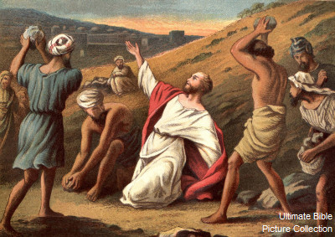
Angry religious leaders killed Steven by casting stones at him.

- Read in Acts 6:8-15 how Stephen’s face appears to those who falsely accused him.
- In Acts chapter 7, Stephen summarizes the history of the people of Israel, showing that they had, throughout the ages, persecuted God’s prophets. Read in verses 7:54-58 how Stephen’s accusers react to this.
- In Acts 7:55-60. whom does Stephen see, and where? What was his final prayer?
- Read in Acts 8:1-4 who was consenting to Stephen’s death.
- What good thing resulted from the widespread persecution?
- Plan with co-workers the upcoming worship time.
- Recount Stephen’s martyrdom.
- Memorize together Romans 6:17.
- Ask believers to give testimonies or reports on how God has blessed them for obeying some command of Jesus recently.
- Let the children present to the adults activities that they have prepared.
Those who teach children should read study #48 for children

Children prepare skits of bible stories that they present to adults during worship.

- Before serving the Lord’s Supper, read Rev. 19:5-10 about the Marriage Supper of the Lamb. Explain that the Lord’s Supper helps us to look forwards to Jesus’ return to earth.
- Form small groups of worshippers to listen to each other’s needs and concerns,
speak encouraging words one to another, and to pray for one another to remain obedient to Jesus. Pray Also for the believers’ enemies and persecutors.

Advanced Study
- Prepare yourself with prayer and the Word of God, to practice and teach loving obedience.
- Find in John 14:15-21 how believers should show their love for Christ, and what Christ will do for them.
- Find in Hebrews 5:8-9 how Jesus Himself learned to obey.
- Find in 1 John 2:3-4 how we can be sure that we have come to know Christ.
- Notice in Acts 5:27-32 the apostles’ courage to reply truthfully to hostile authorities.
- Find in Matthew 28:16-20 with what authority Jesus gave this final command.
- Find in 1 Peter 1:13-22 how obedient Christians lead their lives in this world.
- Find in Revelation 14:12-13 how Christians can remain faithful to Jesus to the end.
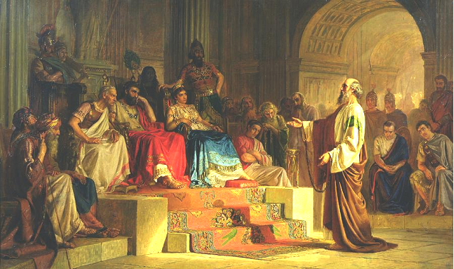
God allowed civil authorities to arrest and imprisonment Paul,
so that he could preach the gospel to kings.
- Plan with co-workers activities to do during the week.
Choose activities that fit current needs. Perhaps you will …
- Go visit believers who are suffering or are in prison because of their faith, and encourage them from the Bible verses you have studied..
- Identify your persecutors by name and pray for them.
Ask God to forgive them, and to make himself known to them, as he did to young Saul (later Paul) in answer to Stephen’s final prayer.
- Discuss how New Testament believers responded to persecution and how we can also remain obedient to Jesus.

