Jesus Is King Over All Kings

Teach Children to Obey Jesus
Our Father, please use this study to help the children to obey Jesus, because they love Him.
Choose any, or all, of these children's learning activities.
- An older child or teacher reads or tells about a soldier who obeyed Jesus, Luke 7:1–10.
A Roman army officer, a Centurion, understood the need to be obedient to the great King.
After telling the story, ask these questions.
- What did the Roman soldier want Jesus to do for him? [Answer: see verse 3]
- Who asked Jesus to help the soldier? [3]
- Why did the soldier not come out to meet Jesus? [Verse 7. He did not think he was worthy.]
- How did the soldier show his faith, believing that Jesus rules over all? [7–8]
- How did the soldier show his obedience to Jesus?
[Verse 7. He accepted the words of Jesus about what would happen to his sick servant.]
Roman soldier
- Dramatize parts of the story of the faithful Roman army officer.
- Use your time with the children to prepare the drama.
- You do not have to use all the parts.
- Children do not need to memorize the lines: they may read them, as the aim is not to perform but to relive sacred events.
- Older children or adults play these parts:
Narrator. Summarize the story and helps the children remember what to say or do.
Centurion
Soldier
Jesus
Younger children play these parts:
Servant. Lie on the floor and act like you are sick and dying.
Jews (friends of the Centurion, any number)

Narrator Tell the first part of the story (Luke 7:1–6). Say,
“Hear what the Centurion’s servant says.”
Servant “Master, I am so sick. I know I am going to die.”
Centurion (Say to the servant)
“Jesus has come to Capernaum. He can heal you. I will send for him.”
(Say to the Jews)
“My Jewish friends, my servant is dying. Please ask Jesus to heal him.
Jesus is too great for me to go to Him myself.”
Jews “We will go for you.” (Go to Jesus.)
(Some say) “Please, Jesus, come with us.”
(Others say) “The Roman Centurion asks you to heal his servant
(Others say) “He is a good man. He cares for us. He built our synagogue.”
Jesus “I will go with you.”
Narrator Tell the second part of the story (Luke 7–10). Say,
“Hear what the Centurion says.”
Centurion “I am not worthy to meet Jesus.
If he says the word, my servant will be healed. Soldier, go to him.”
Soldier (Salute.) “Yes sir!” (Walk toward Jesus.)
Jews (Some say) “The Centurion’s home is not far. Hurry!”
(Others say) “Look! He sent a soldier to meet us.”
Soldier (Go to Jesus) “Jesus, my master knows you are a great man.
He knows that when you give an order, it is to be obeyed without delay.
Please command his servant’s illness to go away!”
Jesus “This soldier’s commander understands what it means to obey orders.
He knows that my commands hold authority.
He is willing to trust my power over this illness.
I have not found such great faith in Israel!”
Narrator At that moment, the Centurion’s servant was healed.
(Thank everyone who helped with the drama.)

- Arrange with the leader of the congregation for the children to…
- Present the drama to the adults during the worship time.
- Pose to the adults the queries listed under #1 above.
- Present the poem and anything else that the children have prepared.
- Memorize what the King of Kings said in John 14:15:
“If you love me, you will keep my commandments.”
- Let the children copy or color the picture of a Roman soldier, above.
- Memorize what the King of Kings said in John 14:15:
“If you love me, you will keep my commandments.”
- Ask the children to tell things in Jesus has commanded us to do, that we will obey.
- Draw a crown, such as kings have worn in some countries, and let the children copy it...
- Let older children help the younger ones.
- Some children may like to colour the picture found on the last page of this lesson.
- Let the children show their pictures to the adults at the next worship time, and explain that this illustrates that Jesus is the King of Kings, and we obey His commands because we love Him.
- Let three children each recite one of these verses from Matthew 28:18, 19, and 20.
“All authority in heaven and on earth has been given to me.”
“Go therefore and make disciples of all nations, baptizing them in the name of the Father and of the Son and of the Holy Spirit,”
“Teaching them to obey everything that I have commanded you.
And remember, I am with you always, to the end of the age.”
- Let older children write a poem or song about why we love to obey Jesus.
- Let an older child pray:
“Lord, we love to hear your words, and we also want to put into practice what you say. We want to obey you, because you are King of Kings and we love you.”

A more detailed drama to act out: Jesus has supreme authority, so we obey him gladly:

http://biblestoryskits.com/029a-our-lord-gives-his-great-commission-and-ascends-to-glory-2/

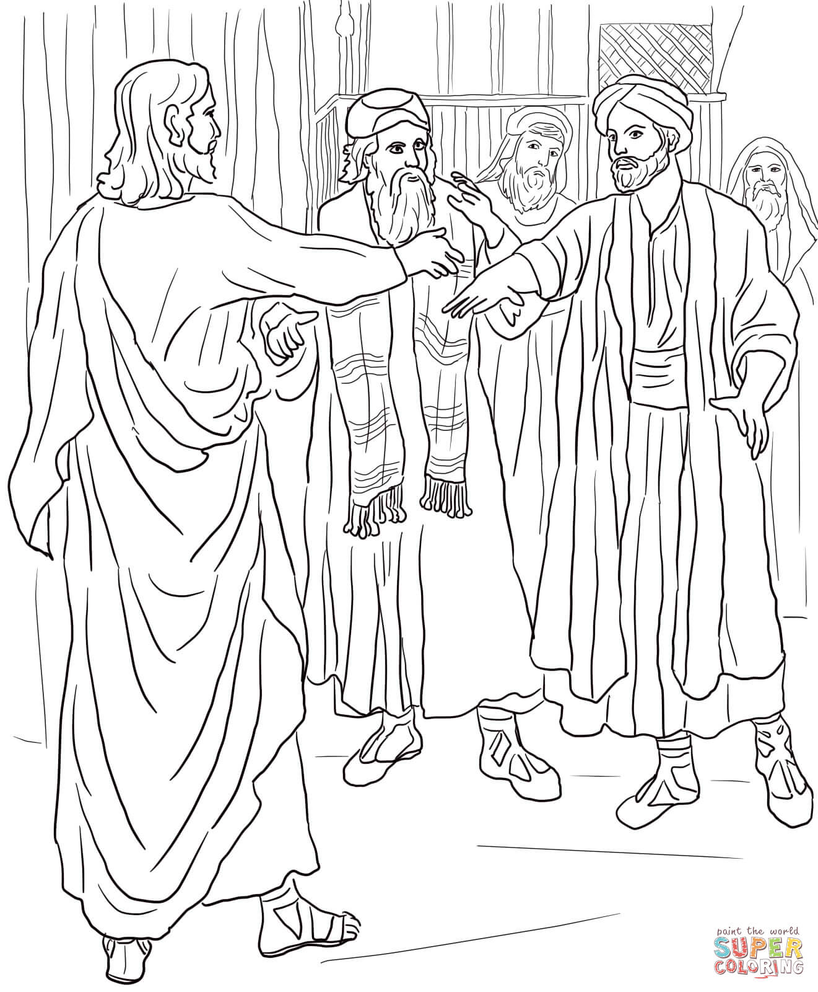
Friends came and told Jesus that a Roman military officer had faith in Jesus’ authority
to heal a sick servant without coming to his house.

