Start New Congregations
Anchor command. “Believe in the Lord Jesus, and you will be saved, you and your household.”
Acts 16:31
Anchor story. Peter and his companions plant churches among folk of another culture. Acts chapter 10.
Anchor verse. “The Lord opened her heart to pay attention to what was said by Paul.” Acts 16:14-15
Learning goal. Discern how the apostles planted churches.
Growth goal. Embrace the apostles’ methods of evangelism and church planting.
Skill goal. Plant the type of churches that multiply, as they did in the New Testament.
Outcome goal. Many new congregations are born, and multiply.

Basic Study
Dear Lord, please help our congregation to obey your command to make disciples, by starting new flocks of believers where there is none, with the power of your Holy Spirit.

Learn from the birth of the first Gentile church…
- What did an angel tell the Roman Army officer Cornelius to do? Acts 10:1-8
- What did a voice from heaven prepare Peter to do, against Jewish custom?
Acts 9-20 & verse 28
- Who were waiting for Peter? 24
- Notice how Peter, when telling about Jesus, emphasized his resurrection; the apostles always did so. 38-43
- How did Peter and his coworkers confirm the salvation of these Gentiles? 45-48
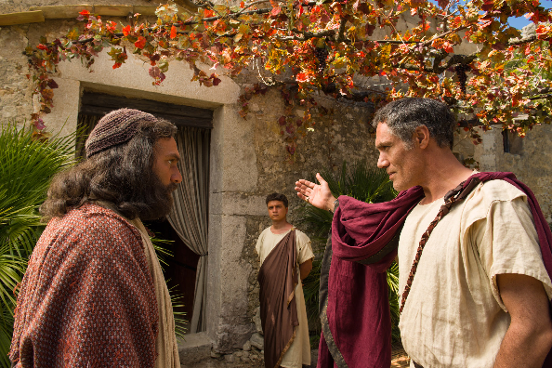
Roman Cornelius welcomes Jewish Peter into his house
During the week start new congregations in neglected communities nearby. Do it as quickly and simply as Peter and his coworkers did.
During worship…
- Tell the story of Cornelius and his people will became a new church, Acts 10; ask the same questions as above and encourage the believers to discuss the answers.
- Ask the children to present what they have prepared.
- Memorize together Ephesians 4:11-12. Those who go to other places to plant churches are modern-day apostles; the word apostle means “sent one.”

Advanced Study

Prepare with prayer and God’s Word to start new congregations and cells.
- A congregation is a gathering of Jesus’ followers.
- Find in Matthew 28:18-20 what you are to teach new believers to do, to become true disciples.
[Answer. They are to be baptized and to obey Jesus’ commands. Seven basic commands include all that He commanded in their simplest forms. The first church obeyed all of Jesus’ commands from the start. Wherever the apostles made disciples in this way, congregations multiplied.]
- Find in Acts 2:37-47 how believers obeyed Jesus’ commands in the first New Testament church:
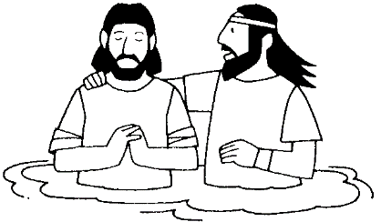
“I baptize you in the Name of the Father, of the Son and of the Holy Spirit.”
- Which command of Jesus did Peter first tell the new believers to obey? [verse 38]
- Which command did repentant sinners obey, to be counted as believers? [verse 41]
- To what four activities did the newly baptized believers dedicate themselves, as Jesus had commanded? [verse 42]
- Which activities in verse 42 (receiving the apostles’ teaching, breaking bread to remember of the Lord’s death, fellowship and prayer) clearly tell how the believers loved each other?
- To which other basic command of Jesus did their loving fellowship lead? [verses 44-45]
- What kinds of people does God promise to give to your flock in Ephesians 4:11-12?
- Which two among those five types of people should normally lead others to start congregations? [Answer: apostles and evangelists.]

Guidelines for starting new congregations and cells
Guideline #1: Apply methods that fit local circumstances. You do not always have to follow the same method. Most flocks begin in one of the following three ways. Select a way that best fits your circumstances.
- Planting. A church planter or small church planting team is sent from a mother flock to start congregations in other areas and among people of other cultures, as in Acts 13:1-3.
- Birthing. Members of a mother congregation do evangelism in a nearby community, make disciples of new believers, and train new leaders in that community. Nobody has to leave their mother flock. Acts 10 provides an example.
- Hiving. A number of believers leave the mother congregation and form the nucleus of a new flock nearby. This works better for large urban churches where transportation is easy, within the same cultural group. There is no example of this in Scripture.
Guideline #2: Work where you have contacts. It is normally far easier to start new flocks when the workers go to where they have friends or relatives.
Guideline # 3: Focus on the most responsive segment of the population. Remember Jesus’ command to ‘shake the dust’ from your feet if the people fail to respond. Some new congregations fail because people have different backgrounds that create misunderstanding. It is better to start several small flocks than one big one in which cultural differences conflict, as happened in Galatia (if you are unaware of this, read Paul’s letter to the Galatians).
Guideline # 4: Keep doing evangelism after the believers start meeting weekly to worship. Some flocks fail because workers thought their job was done when people started gathering.
Guideline # 5: Plan worship well, even though the group is small. Some new flocks cease to exist, because lazy workers did not make the worship meaningful.
Guideline # 6: Define each worker’s role. Make sure that every worker knows what to do. Let each of them do what each one does well. A worker should agree with his wife on what she will do and will not do. Some flocks fail because workers were forced to do what they could not do well, or they felt left out.
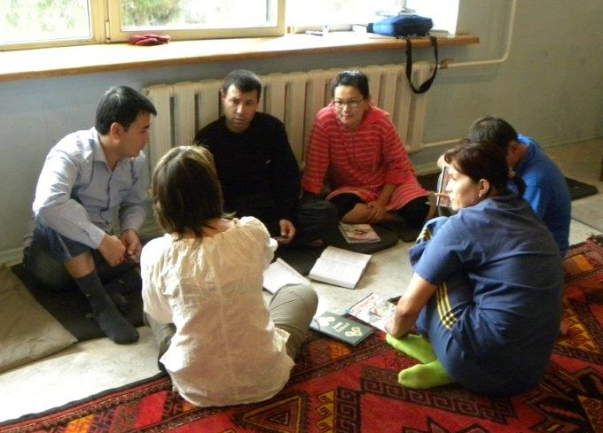
New believers gather in a small group to learn to worship

Plan with co-workers additional activities for believers to do during the week.
Keep starting new congregations in neglected communities nearby.
- A new group becomes a congregation when the believers are doing what the New Testament requires of a flock. This includes the commands of Jesus and other activities that grow out of His commands.
- Mark on the list below any required activities that your congregation, or new congregations that you are starting, have yet to develop. Plan with co-workers what to do, then do it.
[ ] Witness for Jesus and confirm the faith of repentant sinners by baptising them.
[ ] Start new congregations and send workers to neglected peoples.
[ ] Help all believers to participate actively in worship, including the Lord’s Supper.
[ ] Cultivate loving fellowship in the church body and strengthen marriages and family life.
[ ] Help persons and families with problems to forgive and to be reconciled.
[ ] Help the flock to seek holiness, daily renewal and transformation by the Holy Spirit.
[ ] Give generously to meet others’ needs.
[ ] Pray, intercede, wage spiritual warfare against demons, and help families have daily prayer.
[ ] Apply the Word of God to people’s lives, and ward off ‘wolves’ who teach false doctrine.
[ ] Train novice shepherding elders, missionaries and leaders of the new congregations.
[ ] Organise and oversee flocks, so that all believers serve by using their different spiritual gifts.
[ ] Co-operate with other congregations nearby to help them also do these activities.

Plan with your co-workers the upcoming worship.
Tell the story of how the first New Testament church began, from Acts 2:37-47, and ask the questions about it that are listed above.
Explain from Ephesians 4:11-12 that God gives to your congregation people who can lead others to start new congregations, and ask God for helpers to do so.
Explain Jesus’ command, recorded in Matthew 20:18-20, to make disciples who obey Jesus’ commands. Make sure that your flock knows the basic commands of Jesus.
Explain the six guidelines listed above for starting new congregations.
Explain any of the activities that your congregation needs to develop, that you marked above, and help the believers to plan to develop them. Ask workers who are starting new congregations to report their progress.
Let the children present what they have prepared.
Form groups of two and three persons to pray for one another, to plan to start new congregations and to develop some activity that the New Testament requires.
Send workers to start flocks like the Antioch church did (Acts 13:1-3).
To introduce the Lord’s Supper, read Acts 2:42 and 46. Explain that new churches must celebrate the Lord’s Supper from their beginning, and that they may do it in homes.
Those who teach children should read study #46 for children.

