Paul and Barnabas Brought New Believers
into New Congregations
Dear Father, please use this study to show our children how pleased you are when we go and tell other people about your Son Jesus.
Choose activities that fit the children’s age and needs.
- Prepare to teach about Paul and Barnabas on their first missionary journey.
Read in Acts chapter 14 how Paul and Barnabas started new congregations
- Find in Acts 13:1–3 what the Antioch believers did to send off Paul and Barnabas for a new job in another place. [Answers appear below the questions.]
- In what city was the congregation that sent out Paul and Barnabas?
- What did the Holy Spirit tell the believers in Antioch to do?
[Answers:
- Antioch, a city in the area that is now Turkey.
- The Holy Spirit told the believers to ‘separate’ Paul and Barnabas for the work to which He had called them. He wanted them to take the good news of Jesus to people that had never heard it.]

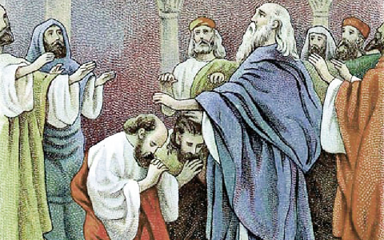
The elders at the church in Antioch laid hands on Paul and Barnabas, sending them
to start new churches in other countries.

- Find in Acts 14:8–23 the things that happened in Lystra:
- What happened that surprised the people?
- Who did the people think that Paul and Barnabas were, at first?
- How did Barnabas and Paul keep people from worshipping them?
- What did a crowd do to Paul, after people came from other cities and stirred them up?
- Did Paul and Barnabas quit telling people about Jesus?
- What did Paul and Barnabas do before they left, so that the disciples would have leaders?
Answers:
- Paul saw that a crippled man had faith to be healed, and God healed the man.
- They thought Barnabas was the pagan god Zeus and Paul the pagan god Hermes.
- Paul and Barnabas told the people that they were human and that they served the living God.
- They stoned Paul and dragged him from the city, thinking he was dead.
- Paul and Barnabas continued to tell the people about Jesus.
- The apostles appointed elders to lead each new congregation.
- A teacher or older child tells the story of Paul and Barnabas healing the crippled man in Lystra, and the events that followed (Acts 14:8–23).
The children might like to colour the picture found and the end of this lesson.
- Ask the children the questions about the story, under #1 above.
- Dramatize what Paul and Barnabas did, from Acts 14:8–23.
The children might also present it to the adults during the main worship time.
You can select parts of the story, or all of it.
Let older children help the younger ones to prepare.
- Older children act as:
Paul
Lame man
Narrator
Younger children act as:
Barnabas
Crowd
Stone throwers.

Narrator Read verses 8 & 9.
Paul & Barnabas Walk to the lame man.
Paul “You are healed in Jesus’ name!”
Lame man Jump up and walk. Shout, “I’m healed!”
Crowd Bow.
(Some shout) “The gods have come down to us in human form!
(Others shout) They are the gods Zeus and Hermes!
(Others shout) Bring wreathes and a bull to sacrifice to them!”
Paul Shout the words of Paul from verse 15.
Narrator Read verses 18 & 19.
Stone throwers. Point at Paul and Barnabas and shout angrily:
(Some shout) “Those men, Paul and Barnabas, they deceive you!”
(Others shout) “They do tricks through the power of demons!”
(Others shout) “They will destroy your temple and your customs!”
(All pretend to throw stones at Paul. He falls down.)
Narrator Read verses 20–23, and then thank everyone who helped with the drama.
- If the children present this drama to the adults, then let the children ask them some of the questions about Acts 14, under #1 above.
- Demonstrate the parable of the farmer who planted grain, Mark 4:1–20.
- Hand each child a grain of rice, or simply hold up a grain for them to see.
- Explain how Jesus used grain to illustrate how His kingdom grows as people receive Him. He said that if we sow grain in good soil, then it will grow and reproduce many times.
- Explain what the good and bad soils are.
- Explain that when Paul and Barnabas went to Lystra and other cities, they sowed the seed of the Kingdom of God. New congregations arose and sent workers to sow more seed in other places.
- Let four children each read one of the four verses of Isaiah 42:1, 4, 6 and 7.
- Memory verse: Acts 1:8
- Let an older child pray:
“Lord, help us to be as faithful and brave as Paul and Barnabas were, as we tell others the good news. Let people in other places know Jesus and become a part of the world-wide Body of Christ.”

Download a more complete drama to act out, of the entire story about Paul and Silas being jailed:
http://biblestoryskits.com/009-paul-frees-a-slave-girl-from-a-demon-inciting-a-violent-mob-2/

At Lystra, after the crowd saw that the apostles were not gods,
wicked men tried to kill Paul by throwing stones at him.

