A Family Worshiped Jesus in their Home
Dear Lord, please help the believers to gather people in their homes, tell them about Jesus and worship you.
Choose any of these children's learning activities.
- An older child or teacher reads or tells by memory the story of a Philippian Gaoler, Acts 16:22-36.
This story shows how a family worshipped God in their home.
After telling the story, pose these queries. [Answers appear after each question.]
- How did the magistrates treat Paul and Silas? [Verses 23-24]
- What were Paul and Silas doing in prison at midnight? [25]
- Why did the gaoler want to kill himself? [26-27]
- How did the gaoler find salvation for himself and his family? [31]
- At what hour of the night was the gaoler and his family baptized? [25 & 32-34]
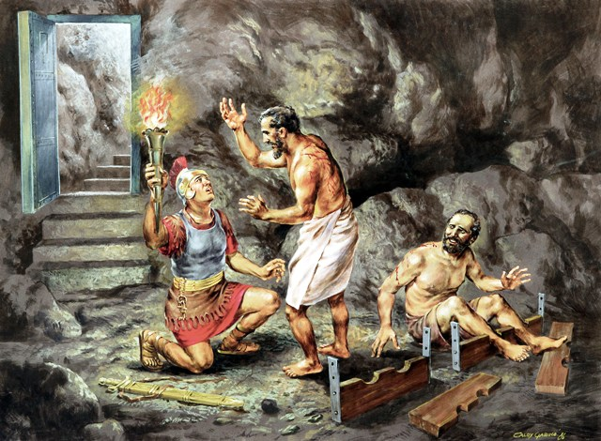
When a Philippian gaoler found the gaol open and all the prisoners still there,
he asked them how to be saved. He then brought the apostles into his home.
- Dramatize parts of the story of the gaoler and his family.
- Arrange with the main worship leader for the children to present this brief drama.
- Use your time with the children to prepare the drama.
- You do not have to use all the parts.
- Let older children help the smaller ones to prepare the drama.
- Older children or adults play these parts:
Paul
Gaoler (Find strings to represent two chains, and something to represent a sword.)
Narrator (Prepare a stack of small rocks or books on the very edge of a table.)
- Younger children play these parts:
Silas,
Magistrate,
Prisoners,
Gaoler’s family (Any number)
Narrator Summarize the first part of the story, from Acts 16:22-28. Then say,
“Hear what the magistrate says.”
Magistrate “Gaoler! Put Paul and Silas in prison. Beat them. And guard them carefully!”
Gaoler Wrap their ankles with the ‘chains’ (Do not tie knots.). Then say,
“I will chain them in the inner cell and guard them with my life.”
Paul and Silas Sit under a table and sing a song.
Gaoler “Earthquake!” (Shake the table so the rocks or books fall.)
Paul and Silas Take off the ‘chains’ and stand up.
Prisoners “We are free! The doors are open.”
Gaoler Raise the sword. Say,
“Oh no! The prisoners got loose. I must kill myself!”
Paul Shout, “No, sir! Do not kill yourself. We are all here!”
Narrator Summarize the second part of the story from Acts 16:29-33. Then say,
“Hear what the gaoler says.”
Gaoler “Bring a light! I want to see Paul and Silas.”
Then kneel before Paul and Silas and ask loudly,
“What must I do to be saved?”
Paul “Believe in the Lord Jesus Christ and you and your family will be saved.”
Gaoler’s family “We want to believe in Jesus, too.”
Gaoler “Please let me clean your wounds. Then we will all be baptized tonight.”
Narrator Summarize the third part of the story from Acts 16:34-36. Then say,
“Hear what the gaoler says to Paul and Silas.”
Gaoler “I am filled with joy because my entire family has believed and been baptized.
Come, we have food for you in my house.”
Magistrate Knock on the table top and say,
“Good morning, Gaoler. You can let Paul and Silas go free now.”
Gaoler “Brothers, thank you for bringing my family the good news of Jesus. Go in peace!”
Narrator When the drama is over thank everyone who helped with it.
- If the children dramatize this story for the adults, let them also pose to the adults the queries listed under #1 above.
- Ask the children to give examples of ways we can worship and serve God in our homes.
- Draw a simple picture of a house that is typical in your town.
Let the children copy it and show the pictures to the adults at the worship time,
and explain to the adults that we can worship God at home or anywhere.
The children may also like to colour the picture found at the end of this lesson.
- Memorize John 4:24.
- Let three children each recite two of the verses from Psalm 136:1-6.
Ask the entire group to repeat after each phrase,” His love endures forever”.
- Let older children write poems or songs about meeting in homes to worship.
- Let an older child pray:
“Dear Lord, we thank you that we can worship you anywhere and at any time. It does not matter if we are a very small group. Thank you that you bring our entire families to you. Help us to worship you with our whole heart.”

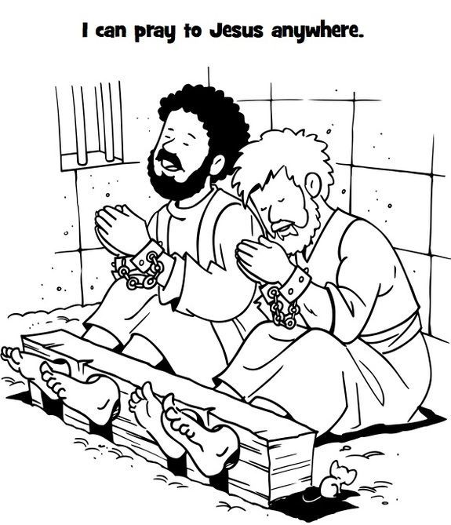
Whilst in a gaol at Phillipi, Paul and Silas sang and worshipped Jesus, till an earth tremor shook the place and their shackles fell off. The gaoler then came asked them, “What must I do to be saved?”

