Welcome into Our Homes those
who Serve Christ

Teach Children to Serve Others in their Homes.
Lord, please help children to find ways to serve you in their homes.
Choose any of these activities that fit the children’s needs and ages.
- A lady made a room for a visiting prophet.
Read 2 Kings 4:8-37 to find how God blessed the lady who showed hospitality to travelers.
Find the answers to these questions. [Answers appear after each question.]
- What did the woman do for Elisha? [See verse 10]
- What did Elisha do for the woman? [16]
- What happened to the child? [20]
- To whom did the woman go for help? [27]
- What did Elisha do before he helped the boy? [33]
- What did Elisha do for the child? [35]

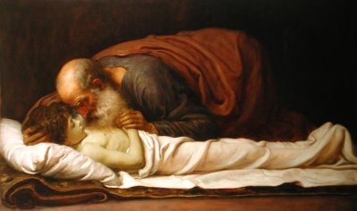
Elisha knelt over a dead boy and prayed. The boy came back alive.
- Let an older child or teacher tell by memory the story of the Prophet’s Room.
- Dramatize parts of the story from 2 Kings 4:8-37.
- Arrange with the main worship leader to have the children present this drama.
- Let the older children help the younger ones to prepare.
- You do not have to present all the parts.
- Older children or adults play these parts:
Elisha [Has a staff that serves as a walking stick.]
Lady
Husband
Narrator [Summarize the story and help the children to recall what to say and do].
- Younger children play these parts:
Boy
Workers [Any number]

Narrator: Tell the first part of the story, from 2 Kings 4:8-16. Then say,
“Hear what the Shunamite lady says to her husband.”
Lady: “I want to do something for the prophet who visits us when he travels.
Can we build him a room, so he will have a place to stay when he is here?”
Husband: “That is a good idea. I will build it upstairs on the roof.”
Elisha: Knock on the door. Say, “I have come to visit.”
Lady: “Welcome, Elisha! Come in! See the room we built for you!”
Elisha: “Thank you. I want to ask God to bless you for your hospitality
. I know you have no son. Next year, you will have a baby boy in your arms.”
Narrator: Tell the second part of the story, from 2 Kings 4:17-25. Then say,
“Hear what the boy says to his father.”
Boy: “Father, I want to go out to the fields with you today.”
Husband: “Yes, my son. Come help me do my work. Bring the donkey.”
(Husband and boy walk to where the Workers are harvesting grain.)
Workers: (Some say) “Good morning, sir.”
(Others say) “May God bless you and your son.”
Boy: Hold your head and complain,
“Oh! Oh! It hurts! Father, my head hurts so much! Ow!”
Husband: (Speak to one of the workers)
“Take the boy to his mother.”
(One of the workers takes the boy to her.)
Lady: Hold the boy.
Boy: (Die. Fall to the floor). Say,
Worker “Oh no! He has died.”
Narrator: Tell the third part of the story, from 2 Kings 4:26-37. Then say,
“Hear what Elisha says to his servant, Gehazi.”
Elisha: “There comes the Shunamite lady. I wonder what is wrong!”
Lady: Keep walking, wiping away tears, without answering. Go to Elisha and say,
“My son is dead. Please help me!”
Elisha: “Let us go to him.”
(Go to the Lady’s house with her.
Kneel by the boy and act like you are praying.
Then lie down over the boy.)
Boy: Sneeze several times and sit up.
Elisha: “Here is your son!”
Narrator: Thank everyone who helped with the drama.

- If the children dramatize this story for the adults, then let them ask the adults the questions listed above, under #1.
- Let the children each draw a different object or person from this story.
- They might draw the room on the flat roof of a stone house, a table, a chair, a lamp,
a bed, the boy holding his head, a donkey, or Elisha’s staff.
- The teacher might draw a room with a bed, a table, a chair and a lamp and let the children copy the picture.
- Older children help the younger ones to draw their pictures.
- Let the children show their pictures to the adults during worship time, and explain that it illustrates how to practice hospitality, especially to the people who serve God.
- The children may like to colour the picture found at the end of this lesson.
- Let the children tell other examples of how we can use our homes to serve God.
Also ask, “To what different kinds of places do people go to worship God?”
- Let four children each recite a verse from Psalm 24: 7-10
- Let older children write a poem or song about serving God in our homes, or using our houses to meet in, to worship God.
- Let younger children memorize Ephesians 2:19, and older ones, Ephesians 2:19-20.
- Let an older child pray:
“Lord the whole earth belongs to you. Our homes belong to you. Thank you for receiving our praise from our homes. May our families offer hospitality as a gift to you.”

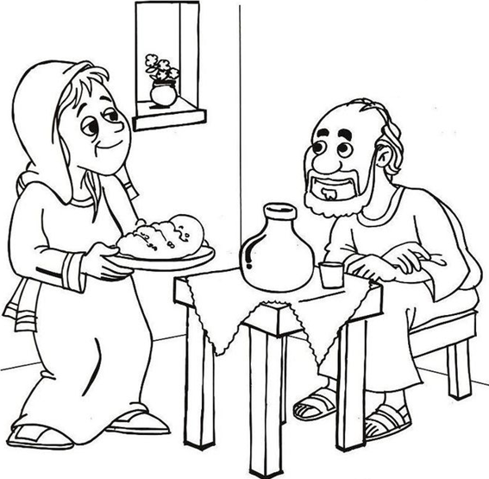
A lady and her husband built a little room atop of their house, where Elisha used to stay when he would come to their town. It was there that Elisha prayed to bring the lady’s little son back to life.

