The New Testament Letters

The Apostles Wrote Letters to Instruct
Congregations and Leaders
Anchor command. “Be diligent to be found by Him in peace, spotless and blameless, and regard the patience of our Lord as salvation; just as also our beloved brother Paul, according to the wisdom given him, wrote to you.” 2 Peter 3:14-16
Anchor story. Paul urges Philemon to receive back a runaway slave as a brother, Philemon 1.
Anchor verse. “I am writing to you, little children, because your sins have been forgiven you for His name's sake.” 1 John 2:12-13
Learning goal. Be familiar with the different authors and topics of the New Testament letters.
Growth goal. Appreciate the great wealth of information, comfort and practical advice written in the apostle’s letters.
Skill goal. Convince believers to solve problems and find vital counsel in New Testament letters.
Outcome goal. Believers read the apostle’s letters often, with understanding and obedience.

Lord Jesus, you love your people very much and want them to understand and obey the letters that your Apostles wrote. Let me help them.

Basic Study
Learn from Paul’s letter to Philemon…
This letter is typical of the New Testament letters: it deals compassionately with people’s lives and service for Christ in a very practical way.
- What was Paul’s relationship with Philemon? Verse 1
- Why did Paul thank God for Philemon? 4-5
- How did Paul described himself? 9
- Concerning whom did Paul write that had received Christ with Paul while he was in prison? 10-11
- Onesimus had been Philemon’s slave, but had run away. At that time, a major proportion of the population in the Roman Empire were slaves. In what way did Paul expect Philemon to receive Onesimus back, instead of as a slave? 12-16
- What did Paul offer to do, if Onesimus owed Philemon any money? 17-19
- How confident was Paul that Philemon would do as he asked? 20-21
During the week visit new believers and encourage them to read the New Testament letters. Read a passage from the New Testament letters with them, to set an example.

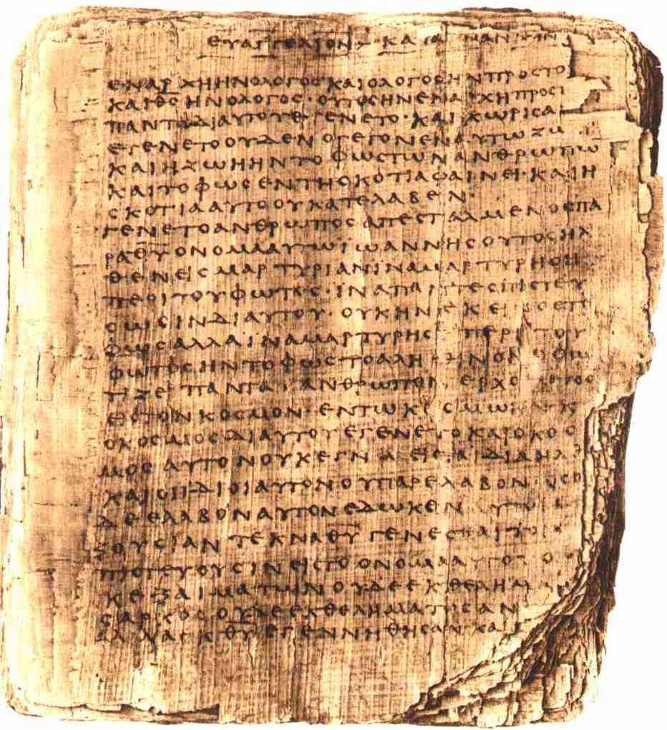
Copy of a New Testament letter, preserved for 1800 years.

During worship
- Tell the story of Philemon and Onesimus, and ask the same questions as above. Let the believers discuss the answers.
- Show new believers where to find the New Testament letters in the Bible, and encourage them to read the letters.
- Ask the children to present what they have prepared.
- Memorize together 1 John 2:12-13.

Advanced Study
- Learn who wrote the New Testament letters, and to whom they were written.
- Find on the map of the Eastern Mediterranean Sea (below) cities to which letters were written.
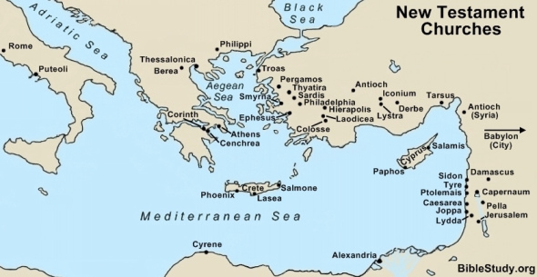
The apostles planted new churches that multiplied rapidly.
- The Apostles wrote in the Greek language, which many spoke in those days. They wrote other letters that were not included in the New Testament. Believers copied the Apostles’ letters and sent them to others (See Col. 4:16).
- Five of Jesus’ chosen Apostles wrote letters to believers and their leaders, which are preserved for us in the New Testament. These Apostles were James, Peter, John, Paul and Jude. All of them saw Jesus. They wrote in the first Christian century. Their letters are also called Epistles.
James, a brother of Jesus, became a believer and led the believers in Jerusalem. He wrote the Letter of James to Jewish Christians from the twelve tribes of Israel scattered across the Roman Empire. Find in James 1:22 what he said to do with God’s Word.
Peter became a follower when Jesus told him to leave his fishing business. Although Peter publicly denied Jesus, he repented and, with James, led the believers in Jerusalem. He wrote the First and Second Letters of Peter to Christians dwelling in various parts of the Roman Empire, encouraging them to remain faithful even when persecuted. Find in 1 Peter 5:10 what God promised through Peter to those who suffer for Jesus.
John had been following another John called the Baptiser, until Jesus called him. John was affectionate toward Jesus, and encouraged others to show their love to God and to each other. He wrote the First Letter of John for all Christians, and Second and Third John to leaders of congregations. Find in 1 John 1:4 and 5:13 two reasons why he wrote his first letter.
Jude, like James, had been a brother of Jesus and became a leader in Jerusalem. He wrote the Letter of Jude to warn false teachers who were deceiving believers and leading some of them into wicked behaviour. Find in Jude 1:3 why he wrote his letter.
Paul (Saul of Tarsus) was appointed as an Apostle by Jesus through a vision. Jesus sent Him to non-Jewish people in many cities of the Roman Empire. The New Testament preserves Paul’s letters to Romans, Corinthians, Galatians, Ephesians, Philippians, Colossians, and Thessalonians, as well as his letters to new leaders including Philemon, Timothy and Titus. Paul may have written the Letter to the Hebrews to encourage Jewish Christians to keep trusting Jesus the Messiah rather than returning to Old Testament animal sacrifices. Find in 1 Corinthians 4:14 why Paul wrote to the Corinthians.

The New Testament Epistles
Written by Jesus’ apostles between the years 50 and 90
James | James
John | 1st, 2nd & 3rd John
Jude | Jude
Paul | Romans, 1st & 2nd Corinthians, 1st & 2nd Thessalonians, Titus, 1st & 2nd Timothy
Peter | 1st & 2nd Peter
Not known | Hebrews

- Plan with your co-workers activities for the coming week.
- Make a list of believers and congregations that you cannot visit very often.
- Discuss together what they need to learn from you.
- Pray for each of them.
- Write a letter to them to encourage them, like Paul did. Let all of you sign the letter.
- Plan with your co-workers the up-coming worship time.
- Let the believers recite from memory favorite verses from the Epistles.
- Let five adults represent James, Peter, John, Jude and Paul.
Introduce yourselves as suggested below.
James: “I am James, the flesh and blood brother of our Lord Jesus Christ. I was an overseer of the believers in Jerusalem, and had a constant struggle with Jewish believers who wanted to go back to the Old Testament Law, instead of trusting in the unearned grace of our Lord’s New Covenant.”
Peter: “I am Peter, the fisherman. I soon saw that Jesus fulfilled the prophecies about the promised Messiah. I saw the Holy Spirit come upon the first non-Jewish believers in the city of Cesarea. That was wonderful! However, it raised serious questions among the Jews in Jerusalem.”
John: “I am John. I wrote so that all people could know for sure the things that I witnessed. I saw the Holy Spirit descend on Jesus like a dove when He was baptized, and heard the Father’s voice thunder from heaven. I saw Jesus after He rose from the dead.”
Jude: “I am Jude. I was Jesus’ brother also and grew up with Him in Galilee. I was amazed when He first worked miracles. Like the other people of Nazareth, I found it hard to believe. But I soon saw that he was the Son of God because of what He said and did.”
Paul: “I am the apostle Paul. I was a strict Pharisee and hated believers in Christ. I persecuted them cruelly, until Jesus revealed Himself to me on the road to Damascus. Seeing Him in His glorified form left me blind for a long time. Now I serve Him only.”
- To introduce the Lord’s Supper read 1 John 1:7-10. Explain that we confess our sins truthfully to the All Holy One before taking the Lord’s Supper, knowing that He washes away our sins with the powerful, cleansing blood of our Lord Jesus Christ.
- Let believers give testimonies of praise about how their lives have been blessed by following the teaching of the Apostles’ letters.
- Form groups of two or three people, to discuss the truths they have just learned about the New Testament letters, pray, confirm activity plans and encourage one another.
- Those who teach children should read study #42 for children.

