The Apostle Paul Strengthened New
Believers with his Letters
Dear Lord, please help the children to appreciate what Paul did for the new churches, and what he wrote to them.
Choose learning activities that fit the maturity and needs of the children.
- Preparation: Philemon, the shortest of Paul’s letters, reveals his wisdom and compassion.
Read it and discover these facts in it:
What did Paul call himself? [verse 1]
What did he hope that Philemon would have? [3]
What was he doing for Philemon? [4-6]
On whose behalf Paul did asked Philemon a favor? [10-14]
What did Paul want Philemon to do? [15-18]
- Tell the children why Paul wrote to Philemon.
Ask questions about the things that you found in answer to the questions above.
Explain why Paul was in prison when he wrote some of his letters:
The emperors of ancient Rome ruled over many nations and were very proud. They put Christians in jail and slew many who refused to worship the emperors’ images.
The Apostle Paul spent many years in Roman prisons, from where he continued to strengthen new congregations by writing letters to them.

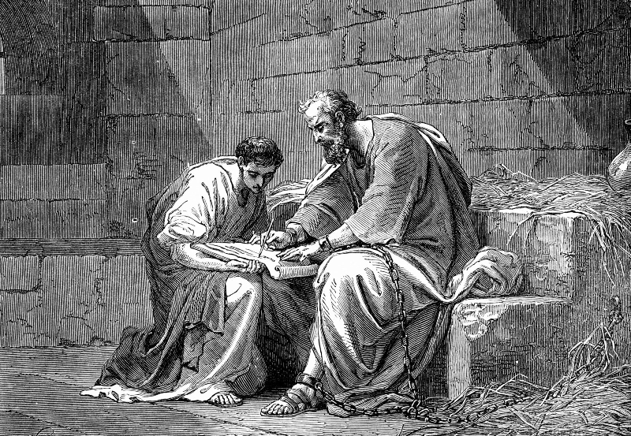
Paul in prison with Onesimus, writing a letter to Philemon.
- Dramatize the letter to Philemon, and other events that Paul wrote about.
You do not have to act out all of the parts.
Arrange with the leader of the worship for the children to present this drama.
Let the older children help the younger ones to prepare.
Older children or adults play these parts:
Narrator
Liar
Philemon
Paul (Carry a Bible and a sack.)
Younger children play these parts:
Stone Throwers
Jailer,
Robbers
Onesimus (Has a letter.)
Narrator “Hear what a slave would remember about one of the letters in the Bible.”
Onesimus Run across the room, away from Philemon.
Philemon “Come back, Onesimus! You are a thieving, worthless slave!”
Narrator “Far away the slave met Paul, who led him to Jesus and sent him back.”
Onesimus Go to Philemon and give the letter to him.
Philemon “Onesimus! So, you have come back!” (Look at the letter.) “Paul wrote this! He wants me to take you back, not as a slave but as a Christian brother! Yes! You are free! We will serve Christ together.” (Hug Onesimus.)
Narrator “While Paul was in jail, false leaders came to Corinth. Hear one of their lies.”
Liar “Paul has not earned the right to be an apostle. But I have!
I am a real apostle and will control your church!
And you will give offerings to me.”
Narrator “Paul wrote to the Corinthians to correct this error. Hear what he wrote.”
Paul Read 2 Corinthians 11:13-14 in a loud voice.
Liar “I serve Satan, but I use spiritual words to deceive believers!” (Laugh evilly.)
Paul Read 2 Corinthians 11:23-24.
Jailer Take the Bible and the sack away from Paul.
Then pretend to tie him up and to whip his back.
Swing your arm as though you were hitting Paul with a very heavy whip.
Each time you swing, shout the number of times you have lashed him.
Start with 35. Stop after 39:
“Thirty five!” (Lash.) “Thirty six!” (Lash.)
[Continue to 39.]
Paul Cry out in pain after each lashing. After the 39th lash, fall down.
Wait a moment and then stand and get the sack and Bible.
Read 2 Corinthians 11:25.
Stone Throwers and Liar
Pretend to throw heavy stones at Paul.
Paul Cry out in pain and fall again.
Narrator “Hear more of what Paul wrote to the Corinthians.”
Paul Stand up with the sack and Bible. Read 2 Corinthians11:26.
Robbers Walk quietly, sneaking up behind Paul.
(Some shout) “He has something in that bag!” “Rob him!”
(Others shout) “Hit him!” “Get the bag!”
(Pretend to hit Paul over the head with clubs. Do not use real clubs.
Grab the bag and run.)
Paul Fall down when the robbers attack you.
Narrator “Hear more of Paul’s letter.”
Paul Stand up and read 2 Corinthians11:27-28.
Narrator Thank everyone who helped with the drama.
- If the children dramatize this for the adults…
Let them also ask the adults questions that the children have already answered, under #1 (above).
Invite adults and children to mention some of the things that Paul suffered,
in order to take the Good News about Jesus to the nations.
- Draw a picture of a prisoner and let the children copy it.
Children may like to copy or colour the picture found at the end of this lesson.
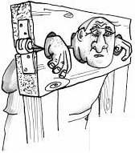
Let the children show their pictures to the adults at the next worship time. Let them explain that this illustrates what Paul, the loving letter writer, suffered in order to serve other people.
- Memorize. Let smaller children learn 1 John 2:12. Let older ones learn 1 John 2:12-14.
- Let three children each recite one of the memory verses, 1 John 2:12, 13 and 14.
- Let older children write poems or songs about Paul and the letters that he wrote.
- Let an older child pray:
“Our Father God in Heaven, we thank you for the wonderful letters in the Bible that your Holy Spirit uses to encourage us, correct us and strengthen us.”

A more detailed drama to act out, about Paul’s dealings with Philemon, 5 minutes:

http://biblestoryskits.com/011-paul-urges-philemon-to-free-his-slave-onesimus-2/print/

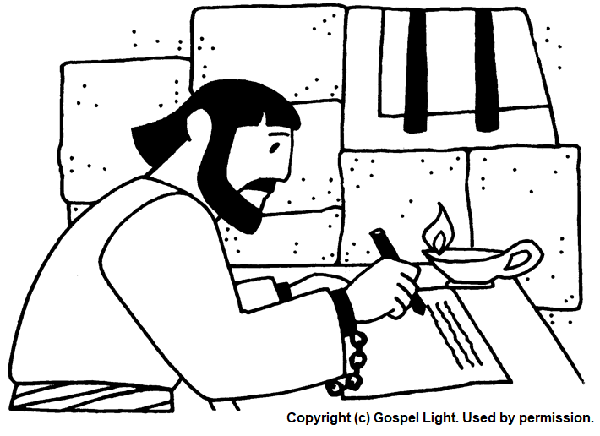
Whilst he was in prison, Paul wrote letters to Christians to encourage them.

